FREDERICK S. PARDEE CENTER
FOR INTERNATIONAL FUTURES
EXPLORE UNDERSTAND SHAPE

Training Manual 2015.4.2

INTERNATIONAL FUTURES (IFs) TRAINING MANUAL

Authors: Barry B. Hughes, Mohammod T. Irfan, Eli Margolese-Malin, Jonathan D. Moyer, Carey Neill, and José Solórzano
April, 2015

Note: If cited or quoted, please indicate 4/2/2015 manual version.

PARDEE.DU.EDU

Table of Contents
1 General Overview 5
2 Introduction to IFs 7
2.1 What IFs Can Do 9
2.2 The Structure of IFs 11
2.3 IFs Philosophy 15
2.4 IFs Vocabulary 18
2.5 Geographic Representation in IFs 19
2.6 Key Features of IFs 20
3 Introduction to Forecasting 23
3.1 Objectives 23
3.2 Stocks and Flows 23
3.3 Potential Training Topics 27
4 Historical Analysis 31
4.1 World Map 33
4.2 World Map Movie 35
4.3 Analyze Across Countries (Cross-Sectional) 38
4.4 Introducing Time in Cross-Sectional Analysis 44
4.5 Analyze Across Time (Longitudinal) 46
5 Display Analysis 54
5.1 Introduction 56
5.2 Flexible Displays 56
5.3 Graphical Forms 66
5.3.1 Line and Bar Charts 67
5.3.2 Radial Diagrams 70
5.3.3 Scatterplots 73
5.4 Geographically-fixed Displays 75
5.5 Basic Report For Countries/Regions 78
5.6 Specialized Displays 80
5.6.1 Specialized Displays: Population 82
5.6.2 Specialized Displays: Education Cohorts 87
5.6.3 Specialized Displays: Health 91
5.6.4 Specialized Displays: Millennium Development Goals 95
5.6.5 Specialized Displays: Performance Risk Evaluation 97
5.6.6 Specialized Displays: Development Profile 99
5.6.7 Specialized Displays: Informal Economy 100
5.6.8 Specialized Displays: Agriculture Focused Analysis 102
5.7 Self-Managed Display (Complete Flexibility) 106
5.8 Understanding the Model 109
6 Scenario Analysis 117
6.1 Understanding Scenario Building and Use in IFs 119
6.2 Quick Scenario Analysis With Tree 121
6.2.1 Basic Scenario Creation 124
6.2.2 Advanced Scenario Creation 136
6.3 Change Selected Functions 145
6.4 Guided Scenario Analysis 147
6.5 Run 149
6.6 File Management 151
7 Extended Features 153
7.1 Introduction 153
7.2 Manage Country Data 155
7.3 Manage Groups/Countries/Regions 157
7.4 Show Computed Functions 161
7.5 Rebuild the Model Base 162
7.6 Rebuild the Historical Base 164
7.7 Procedure for Overriding Historical Data for a Particular Country (or Countries) 165
8 The File System 167
8.1 Root Folder (IFs) 168
8.2 DATA Folder 170
8.3 RUNFILES Folder 173
8.4 Scenario Folder 174
8.5 Code Folder 174

General Overview

International Futures (IFs) is a long-term integrated global forecasting system, designed to facilitate the exploration of global futures. The IFs system allows users to analyze trends and interactions within and across agricultural, demographic, economic, educational, energy, environmental, health, infrastructure, and socio-political subsystems, in 186 interacting countries. Users can simulate potential paths of human development by making interventions that will affect, and even potentially reshape, the entire dynamic system.
This training manual employs a problem-based pedagogical approach that emphasizes the functional utility of IFs for exploring and understanding human development challenges. Each section introduces IFs graphical user interface elements and then proceeds through demonstrations. In addition to examples that touch on a variety of themes, an investigation of poverty runs through the manual. Demonstrations address three related questions: what is the current extent of poverty around the world? How might poverty rates change in the future? And what interventions might we make to reduce those rates? In the following sections, we will use IFs to look at major historical trends and the Base Case forecasts of poverty. We will identify proximate, and deeper, causal factors. Then, we will explore alternative paths to poverty alleviation.
When using IFs, we always begin by asking three questions: where have we been? Where do we seem to be going? And where do we want to be and how do we get there? Together, these questions form the core of the IFs modeling platform’s approach to understanding global futures.
Focusing on the question where have we been?, the first section of this manual discusses display features, used to explore historical patterns longitudinally, cross-sectionally and through map displays. This section of the training manual is designed to provide trainees with tools used to quickly and effectively understand global trends and relationships.
The second section of the manual will address the question, where do we seem to be going? Trainees will be taught how to display IFs Base Case forecasts. And through the demonstration of several specialized displays, this section will provide an overview of the wide range of tools available in the model, tools that users can employ to explore future trends across human systems.
The third and final section discusses custom scenario creation, a method of exploring the question, where do we want to be going and how do we get there? This section of the training manual will highlight the potential impact of different drivers of change on current development trajectories, incorporating lessons from the previous two sections.
This manual is designed to serve as both a guide to organized IFs training sessions, and a standalone learning resource. Given differences in size, duration, and thematic focus, no two trainings are alike. Thus, the sections below offer a flexible guide to the model, for trainers and trainees alike. The overall goal of IFs training is to promote the development of capability to effectively explore questions regarding the historical development of trends, the drivers of those trends, and the range of uncertainty that those trends exhibit within the IFs model. Users of the model need no formal background in modeling, forecasting or econometrics.
Note that this training manual is part of IFs broader support documentation. The following resources expand on the topics raised here, and raise additional, related topics: the IFs Scenario Analysis Guide, IFs Standalone Module Documentation, the IF Help System and the forthcoming IFs Development Manual.

Introduction to IFs

International Futures (IFs) is a long-term global Integrated Assessment Model that, based on historical data, trends and dynamic relationships, forecasts thousands of variables across distinct global systems for 186 countries, from 2010 to 2100. The model has proven to be a useful tool for policy analysis, as evidenced by projects with the United Nations, the European Union, and governmental units within South Africa, Peru and the United States. IFs has been used as a learning tool in undergraduate and graduate international relations courses. And the Potential Patterns of Human Progress (PPHP) series utilizes IFs to analyze historical and future trends in human development. The five PPHP volumes are large-scale, in-depth analyses of poverty, health, education, infrastructure and governance. IFs is freely available for download and use online. The IFs team makes the model code open source and freely available for broader collaboration. Our website includes links to the desktop version, web version and a suite of supporting documentation.
Visit our website: pardee.du.edu

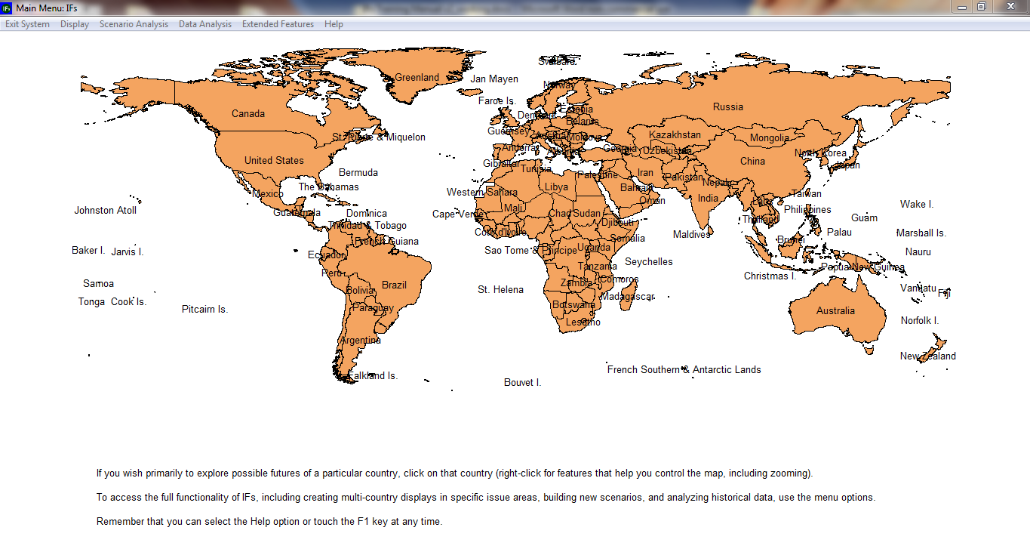
Main Page of IFs

What IFs Can Do

International Futures (IFs) is a tool for thinking about long-term global futures. It assists with:
• Understanding the state of the world
• Exploring trends and considering where they might be taking us
• Learning about the dynamics of global systems
And it helps us think about the future we want to see by:
• Clarifying goals/priorities
• Setting benchmarks
• Developing alternative scenarios (if-then statements) about the future
• Investigating the leverage various agent-classes have in shaping the future
Assumptions that underlie IFs development and use:
• Global issues have become more significant as the scope of human interaction and human impact on the broader environment grows
• Goals and priorities for human systems are becoming clearer and are more frequently and consistently enunciated
• Understanding of the dynamics of human systems is increasing rapidly
• The domain of human choice and action is broadening
What can you investigate with IFs? Examples include:
• Environmental Sustainability: Atmospheric carbon dioxide levels, world forest area, and fossil fuel usage
• Social/Political Change: Life expectancy, literacy rates, level of democracy, the status of women, shifts in values
• Demographic Futures: Population levels and growth, fertility, mortality, migration rates
• Food and Agriculture: Land use and production levels, calorie availability, and malnutrition rates
• Energy: Resource and production levels, demand patterns, the share of energy coming from renewables
• Economics: production by sector, consumption, trade patterns and structural change
• Global System: Country and regional power levels

The Structure of IFs
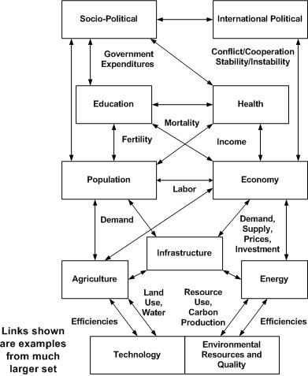
Overview of Systems within IFs

The population module:
- represents 22 age-sex cohorts to age 100+ in a standard cohort-component structure (but computationally spreads the 5-year cohorts initially to 1-year cohorts and calculates change in 1-year time steps)
- calculates change in cohort-specific fertility of households, in response to income, income distribution, infant mortality (from the health model), education levels, and contraception use
- uses mortality calculations from the health model
- separately represents the evolution of HIV infection rates and deaths from AIDS
- computes average life expectancy at birth, literacy rate, and overall measures of human development (HDI)
- represents migration, which ties to flows of remittances.
The economic module:
- represents the economy in six sectors: agriculture, materials, energy, industry, services, and information/communications technology (ICT)
- computes and uses input-output matrices that change dynamically with development level
- is an equilibrium-seeking model that does not assume exact equilibrium will exist in any given year; rather it uses inventories as buffer stocks and to provide price signals so that the model chases equilibrium over time
- contains a Cobb-Douglas production function that (following insights of Solow and Romer) endogenously represents contributions to growth in multifactor productivity from human capital (education and health), social capital and governance, physical and natural capital (infrastructure and energy prices), and knowledge development and diffusion (research and development [R&D] and economic integration with the outside world)
- uses a Linear Expenditure System to represent changing consumption patterns
- utilizes a "pooled" rather than bilateral trade approach for international trade, aid and foreign direct investment
- has been imbedded in a social accounting matrix (SAM) that ties economic production and consumption to representation of intra-actor financial flows.

The agricultural module:
- represents production, consumption and trade of crops and meat; it also captures ocean fish catch and aquaculture, but in less detail
- maintains land use in crop, grazing, forest, urban, and "other" categories
- represents demand for food, for livestock feed, and for industrial use of agricultural products
- is a partial equilibrium model in which food stocks buffer imbalances between production and consumption and determine price changes
- overrides the agricultural sector in the economic module unless the user chooses otherwise
The energy module:
- portrays production of six energy types: oil, gas, coal, nuclear, hydroelectric, and other renewable energy forms
- represents consumption and trade of energy in the aggregate
- represents known reserves and ultimate resources of fossil fuels
- portrays changing capital costs of each energy type with technological change as well as with draw-downs of resources
- is a partial equilibrium model in which energy stocks buffer imbalances between production and consumption and determine price changes
- overrides the energy sector in the economic module unless the user chooses otherwise.
The infrastructure module:
- forecasts physical extent of, and citizen access to, road transportation, water and sanitation, electricity, and information and communications technology
- calculates the public and private financial costs of infrastructure construction and maintenance
The environmental module:
- tracks annual carbon dioxide emissions from fossil fuel use
- represents carbon sinks in oceans and forest land and models build-up of carbon dioxide in the atmosphere
- calculates global warming and links it to country-level changes in temperature and precipitation over time which, with the addition of carbon fertilization, impact agricultural yields
- represents indoor solid fuel use and its contribution to health related variables
- forecasts outdoor urban air pollution and links with respiratory disease
- models fresh water usage as a percentage of total water availability
The education module:
- forecasts rates of intake and completion across formal education levels—primary, lower secondary, upper secondary and tertiary—for both sexes
- captures educational attainment by age-sex cohort
The health module:
- accounts for major causes of disability and death across major World Health Organization categories
- measures the impact of health outcomes on the economy, through human capital’s contribution to multi-factor productivity
The socio-political module:
- represents government finance, social conditions, and attitudes of individuals, and qualitative and quantitative indicators of governance

The international political module:
- traces changes in power balances across states and regions
- allows exploration of changes in the level of interstate threat, both as an index and probabilistic measure
The technology module:
- is distributed throughout the overall model
- allows changes in assumptions about rates of technological advance in agriculture, energy, and the broader economy
- is tied to the governmental spending model with respect to research and development (R&D) spending

For a comprehensive overview of each module consult the IFs standalone documentation files, which include flowchart graphics of each subsystem, and explain key drivers, relationships, and equations.

IFs Philosophy
A number of assumptions underlie the development of IFs. First, issues related to human development systems are growing in scope and scale as human interaction and human impact on the broader environment grow. Human development challenges are not necessarily becoming more threatening than in past eras, or fundamentally insurmountable. However, today, attention to the human development issues must have a global perspective, as well as local and regional ones.
Second, goals and priorities for human systems are becoming clearer and are more frequently, and consistently, enunciated than in the past. The UN Millennium Summit and the 2002 conference in Johannesburg set specific Millennium Development Goals (MDGs) for 2015 that focused on improving the human condition. And, more recently, the Rio+20 summit signaled development of the Sustainable Development Goals (SDGs), an extension and refinement of the MDGs for the post-2015 agenda. Broadly recognized development goals continue to guide a sense of collective human opportunity and responsibility.
Third, understanding of the dynamics of human systems is growing rapidly; understandings of the systems included in the IFs model are remarkably more sophisticated now than they were back when IFs was first created. And our ability to measure aspects of the human condition has improved in recent years, thanks to advances in data and measurement tools.
Fourth, and derivatively, the domain of human choice and action is broadening. The IFs model was created to assist thinking about such intervention and its consequences.
Given two overarching goals, understanding human development systems, and investigating the potential for human choice within them,how do we represent human systems in a formal, computer-based model such as IFs? Human systems consist of classes of agents and larger structures within which those agents interact. The structures normally account for a variety of stocks (people, capital, natural resources, knowledge, culture, etc.) and the flows that change those stocks over time. Agents act on many of the flows, some of which are especially important in changing stock levels—like births, economic production, or technological innovation. Over time, agents and the larger structures evolve in processes of mutual influence and determination.
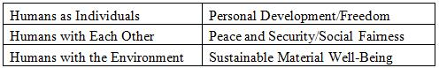
Human Actor Classes and Associated Behavioral Goals

For instance, humans as individuals within households interact in larger demographic systems or structures. In the computer model we want to represent the behavior of households, such as decisions to have children or to emigrate. And we want to represent the larger demographic structures that incorporate the decisions of millions of such households. The typical approach to representing the stocks of such demographic structures is with age-sex cohort distributions, altering those stocks via the flows of births, deaths, and migration. IFs adopts this approach.
Similarly, households, firms, and the government interact in larger economic and socio-economic systems or structures. The model can represent the behavior of households with respect to use of time for employment and leisure, the use of income for consumption and savings, and the specifics of consumption decisions across possible goods and services. It should represent the decisions of firms with respect to re-investment or distribution of earnings. Markets are key structures that integrate such activities, and IFs represents the equilibrating mechanisms of markets in goods and services. Again there are key stocks in the form of capital, labor pools, and accumulated technological capability.

In addition, however, many socio-economic interactions occur outside of the market. IFs increasingly represents the behavior of governments with respect to the search for income and the targeting of transfers and expenditures, domestically and across country borders, in interaction with other agents including households, firms, and international financial institutions. Social Accounting Matrices (SAMs) are structural forms that integrate representation of non-market based financial transfers among such agents with exchanges in a market system. IFs uses a SAM structure to account for inter-agent flows generally. Financial asset and debt stocks —not just flows—are also important to maintain as part of this structural system, because they both make possible and motivate behavior of agent-classes.
At the state level, governments interact with each other in larger inter-state systems that frame the pursuit of security and cooperative interaction. Potential behavioral elements include spending on the military, joining alliances, or even the development of new institutions. One typical approach to representing such structures is via action-reaction dynamics that are sensitive to power relationships between actors. IFs represents changing power structures, domestic democracy level, and interstate threat.
Furthermore, human actor classes interact with each other and the broader environment. In so doing, important behavior includes technological innovation and use, as well as resource extraction and emissions release. The structures of IFs within which all of these interactions occur include a mixture of fixed constraints (for instance, stocks of non-renewable resources), uncertain opportunities for technological change in economic processes, and systems of material flows.
In summary, International Futures (IFs) has foundations that rest in classes of agents and their behavior, and the structures or systems through which those classes of agents interact. IFs is not agent-based in the sense of models that represent individual micro-agents following rules and generating structures through their behavior. Instead, as indicated, IFs represents both existing macro-agent classes and existing structures (with complex historical path dependencies), attempting to represent some elements of how behavior of those agents can change and how the structures can evolve.
In representing the behavior of agent classes and the structures of systems, IFs draws upon large bodies of insight in many theoretical and modeling literatures. While IFs frequently breaks new ground with respect to specific sub-systems, its strengths lie substantially in the integration and synthesis of bodies of earlier work.

IFs Vocabulary
Forecast: Using historical data and trends to extrapolate possible future events. IFs uses mathematical relationships between parameters and variables based on historical evidence in order to forecast general trends. This does not involve linear or even non-linear extrapolation, but rather dynamic, interactive analysis.
Variable: A variable is a concept that is computed within the model and that varies over time. The model contains equations that compute the value of a variable at any given time as a function of other variables and parameters. These are outputs from the model.
Parameter: A numerical element, used in computing the relationship between two or more variables. These are inputs to the model specified by users.
Multiplier: Multipliers are the most common of all parameter types used in scenario analysis. As the name implies, they multiply the result of an equation by the value of the parameter. The default value—the value for which the parameter has no effect and to which multipliers almost invariably are set in the Base Case—is 1. These parameters are usually denoted with the suffix -m.
Scenario File: Identified by its suffix .sce, these files are created by users who change parameters in order to represent uncertainties or policy interventions in the future and then save these changes. Accessed through the Quick Scenario Analysis with Tree feature of IFs, these files can then be run through IFs in order to create run-result-files.
International Futures Model (IFs Model): The engine that takes parameter changes and computes them for all data stored in IFs.

Run Result File: Identified by its suffix .run, these files contain the values for any given scenario of all variables and parameters in IFs, across all countries and years of the forecast horizon.
Base-Run/Base Case: The IFs Base Case, always available when a model session is initiated, is itself a scenario. Sometimes the Base Case is incorrectly referred to as a trend extrapolation or a "business as usual" scenario. More accurately, however, the IFs Base Case is a computation that involves the full dynamics of the model and therefore has very nonlinear behavior, often quite different from trends. It is a good starting point for scenario analysis for two reasons: first, it is built from initial conditions of all variables and on parameters that have been given reasonable values from data or other analysis. These initial conditions and parameters make up the package of interventions that constitute the Base Case scenario; second, the Base Case is periodically analyzed relative to the forecasts of many other projects across the range of issue areas covered by IFs and is to a degree "tuned" for internal coherence and consistency with insights of respected forecasters.
Previously Run: These files vary depending on what version of IFs you are running. They are a set of selected scenarios created about possible emerging future worlds. Because run-result-files are so large, only a handful of these files are packaged with a particular version of IFs.

Geographic Representation in IFs
In the model, users decide whether they would like to display their results by single countries, or larger groups. This is typically accomplished by a toggle switch that moves between Country/Region and Groups. Some results have a three-way-toggle that includes Country/Region, Group and G-list (Geographic List).
Countries/Regions are currently the smallest geographical unit that users can represent. However, the ability to split countries down into smaller regions (such as states or provinces), is available for select countries— of the 186 different countries in the model, sub-regionalization is available for Mexico, India, China, South Africa and Peru. At one time IFs did not represent regions within countries, and the term "regions" referred to aggregations of countries. The user of IFs will see a fairly considerable legacy use of the term "countries/regions" in which "regions" has this country-aggregation meaning. The project is, however, steadily moving toward use of "region" to mean units within countries.
Groups are variably organized geographically or by memberships in international institutions/regimes. Groups can include both countries and regions.
G-lists, or geographic lists, merge both Groups and Countries/Regions. In the future, the G-list distinctions will become even more important as some users may want to place, for example, both the Indian state of Kerala in a G-list with Sri Lanka and Nepal—and possibly also to include the grouping of South Asian countries.
To summarize, geographic representation in IFs has four distinct categories. The image below represents their character and relationship to each other.
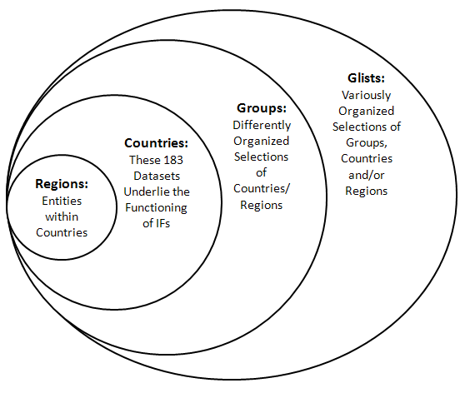

Key Features of IFs
In the standalone version of IFs (as compared to the version available for use online) there are four main functions at the top of the home screen that are very important to understand as we learn about the model. These four features form the backbone of IFs functionality, and represent important conceptual divisions this training manual. The four features, as they appear in the IFs system, are Display, Scenario Analysis, Data Analysis and Extended Features.
The following questions are foundational for the process of forecasting. We will explore these throughout this training:
- Where have we been, and where do we seem to be now?
- Where do we seem to be going?
- Where do we want to be, and how do we get there?
Where have we been, and where do we seem to be now?
The first of these questions is best approached from the Data Analysis feature of the IFs system. From here, users are able to access the large historical database of IFs, comprised of thousands of variables from hundreds of sources, covering the period from 1960 to the mode recent data available for each individual country or group—titled Most Recent Available Data in the model. To forecast any issue, we benefit from first studying relevant historical patterns.
Data Analysis allows users to accomplish three main things: First, users can plot the data geographically and across time using the World Map. Second, users can look at trends in which time is the independent variable using Longitudinal Analysis. Third, regression analysis and dynamic display options become available through Cross Sectional Analysis.
These tools form the backbone of any strong analysis of historical trends within dependent variables. There is also much flexibility within this framework.
Where do we seem to be going?
Answering this question requires a primary exploration of the IFs Base Case. For this, users should access the Display option from the IFs main menu. From here, there are a wide variety of options that are available. (Clicking on countries in the world map also brings up many of the display options.)

Display options range from the very general to the very specific. At the most general, the Flexible Displays menu option provides pre-packaged forecast variables to display for any aggregation of countries or regions within the model. And more specific, Specialized Displays, such as the population pyramid, offer more nuanced analysis tools. The height of IFs functionality can be found in the Self-Managed Display, which requires time to master.
Where do we want to be and how do we get there?
Answering this question requires an analysis of the areas of uncertainty and leverage surrounding important variables within the issue area being explored. Much of this is accomplished through the Scenario Analysis feature located on the IFs main menu. Ideally, the scenario analysis should follow causal analysis, a process which should be coupled with some understanding of the relationships between major dependent and independent variables.
Scenario Analysis requires the alteration of parameters (often including multipliers) that drive different variables within the IFs system. This provides users of the model the ability to change parameters and initial conditions of the model in order to explore a range of uncertainty or to consider policy leverage.
The scenario tree, the primary tool located within the Scenario Analysis menu, provides users with the flexibility to make changes to the model. The tree allows for a number of different interventions. Users can frame uncertainty surrounding: initial conditions (How much oil is really out there?); technology growth rates (What happens if longevity increases?), agent behavior (What happens if people save more and consume less?) and relationships between parameters (What happens if assumptions about elasticity of energy demand to its price are too low?).
The Scenario Tree also allows users to load pre-developed scenarios instead of making their own. Some of these scenarios have been used in work that IFs has done for various governmental organizations, others are scenarios that the IFs team has pre-packaged with the software because they are assumed to be of interest.

Introduction to Forecasting

Objectives
In this section of the training manual, users will become familiar with:
  - with general forecasting strategies and systems thinking
  - the difference between dynamic and static forecasts
  - the difference between stocks and flows
  - basic causal modelling
  - feedback loops

Stocks and Flows
Understanding the difference between stocks and flows is a foundational concept for understanding system dynamics. Stocks are variables with levels that accumulate or decay over time. For example, the number of people living in a given country is a stock of population. Flows, on the other hand, are time-specific values that either add to or take away from stocks. An example flow is the number of births added to a population in a given year. The relationships between stocks and flows form the basic structure of a dynamic system. Causal diagrams are one way to illustrate the relationship between stocks and flows. One basic example of a causal diagram of a system is demonstrated below. Stocks of population within a country are understood as being directly driven by three independent variables. First, there is the flow of new people being added to the population (births). Second, there is the flow of people being removed from the population through death. Third, there is either a net inflow or an outflow of people who immigrate or emigrate. This is a simple demographic model.
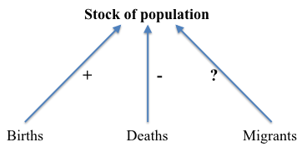

These simple models become more complicated when feedback loops are added and as time is taken into consideration. The model below highlights two of the three drivers of population growth (births and deaths), with their respective feedback loops. Thus, as more babies are born, the population grows. Higher population rates, ceteris paribus, would then lead to larger numbers of births in the future. On the other side of the equation, when people die, they are removed from the total population. As the size of the population shrinks, again ceteris paribus, the number of people who die will shrink as well.

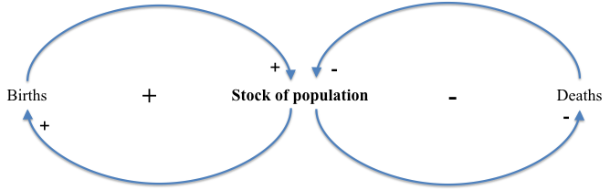

There is much of interest in the simple causal diagram shown above with feedback loops. The three variables are both independent and dependent variables; the three variables simultaneously shape, and are shaped by, the others. Depending on the rates of births and deaths, population levels will grow, shrink, or equilibrate at a stable level. There is, however, much that is missing from the above diagram, and a more nearly complete understanding of population growth would require an analysis of the deeper drivers of each proximate driver of population, such as the affect that education has on the number of children families have.
Integrated Assessment Models, like IFs, are designed to provide deeper understandings of multiple interacting systems, well beyond demographics alone. For example, the slightly more complicated causal diagram below shows the interaction of three systems, building upon the previous analysis of the demographic system. If we start in the upper right, we see the positive feedback loop that we identified in the previous diagram between births and total population.
Demographic, education, and economic systems are related. The size of the population has a direct impact on a variable in the economic system: the size of the labor force. For this example, assume that the economy can employ more labor, although this would not always be the case. A larger labor force then leads to higher levels of overall output (within the economy, the stocks are labor and capital, and the flow is economic output, typically measured as gross domestic product (GDP)). Higher levels of economic output have impacts on other systems as well. In this instance, we highlight their impact on the education system, where higher economic output can help fund higher enrollment rates. Higher enrollment rates lead to more education, which eventually leads to a decrease in births, as well as to an increase in productivity.
Within any closed feedback loop, the total number of negative signs determines whether the loop in aggregate has a negative or positive valence. Positive feedback loops lead the stocks within the loop to grow, while negative loops cause the stocks to slow growth or to decline. Two negative linkages with a feedback loop cancel each other out. Thus an odd number of negative signs (1, 3, 5...) creates a negative feedback loop, but an even number of negative signs (0, 2, 4...) creates a positive feedback loop. In the figure below there is one positive feedback loop wholly in demographics causing population to grow (we have left out deaths, of course, so it cannot shrink); there is a larger positive loop crossing over the education and economic systems and causing the stocks of education and economic productivity to grow; there is one still larger negative feedback loop connecting demographic, economic, and education systems, which dampens the growth of education, population, and labor.

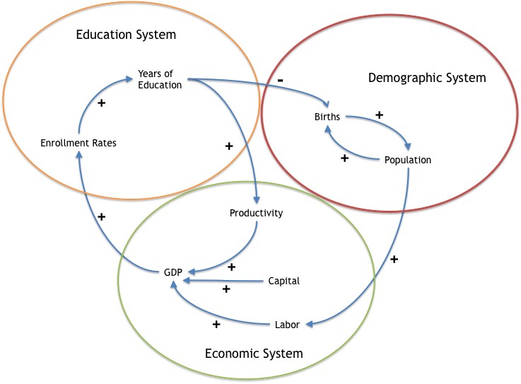

Potential Training Topics
Because IFs is an Integrated Assessment Model, the most important human systems are conceptualized and linked in order to produce outputs relevant to many different kinds of policy challenges—challenges that can be country-specific or global in scope. For example, understanding how economic growth, demographic growth and energy systems interact is crucial for understanding a global policy issue like carbon emissions.
Below is an illustrative list of problems, the first of which this document will return to frequently in our explanation of the model's use. In organized training programs, trainers and trainees are encouraged to use the list below as means of tailoring model tutorials to their interests. These problems and challenges were selected to show the breadth and depth of the features of IFs. See also the IFs Scenario Manual for details on the variables and levers actually available in IFs for their analysis; most often this manual on the technical use of the model will be used in combination with that manual and frequently both will be used in combination with more extended documentation on the structures of the various IFs modules.

- Is the dream of a poverty-free world realistic? Or is it overly ambitious? What seems to be the current state of global poverty and how is it likely to change?
- Many forecasts suggest that global population will reach or exceed 9 billion by mid-century; what are implications of successful efforts to change fertility rates (most analyses may explore their reduction, but others could consider their increase)? How does one affect fertility rates in IFs?
- Currently, millions of children suffer from malnutrition. What are some of the major causes of malnutrition, and what are plausible paths to the reduction of child malnutrition?
- Global climate change is a current and potentially catastrophic future global problem. One way to reduce overall carbon emissions and the rate of climate change is through a reduction in fossil fuel dependency with associated increase in the amount of renewable energy being produced. What kinds of increases in renewable energy production do we need to plausibly make an impact on global carbon emissions?
- Fossil fuel dependency is problematic for a variety of reasons. One key issue that will become relevant in this century is the peaking of global oil production. This will potentially lead to rising oil prices and decreased economic productivity, if alternative sources of energy are not provided. What kinds of impacts does peak oil have on the IFs model? What kinds of increases in energy efficiency are required to delay peak oil?
- As fuel prices climbed in the first decade of the 21st century, one policy solution was to use food to produce fuel. This led to potential reductions in the cost of gasoline, but an increase in the cost of food. What is the range of future impacts on food prices if biofuel policies continue to be promoted? What are the effects on malnutrition?
- In 2008, the sub-prime housing crisis in the US triggered a global recession. What are some of the major effects of this recession, in the short, medium, and long term? Evaluate pre-packaged recession scenarios and frame the uncertainty around recovery from the recession and its impacts.
- The stability of states and societies is always a concern for foreign policy. When societies and their governance crumble, catastrophic events can result. What are some measures of state fragility and failure? What kinds of efforts can realistically be pursued to bring about more stability
- What path is the world taking to meet the MDG goal of universal primary education? Beyond primary, how will lower secondary education develop globally? What needs to be done to meet current MDG for universal primary education and to move the global system toward universal lower secondary at the global, regional, and national levels?
- HIV infection has spread unevenly. In some countries, it has reached a level of epidemic concern. In other places, effective programs of mitigation have been very successful. How might the global epidemic unfold and what are the possible consequences of different paths for the most afflicted countries?
- In 2010 some 0.8 billion people had inadequate access to water and 1.8 billion people lacked even shared access to improved sanitation. What is the global distribution of access to safe drinking water? What are some of the drivers of water infrastructure, and how might the “bottom billion” come to enjoy the human right of sanitary water?
- Global military spending stands at more than 1.4 trillion dollars. Government indebtedness associated with financial crisis will constrain some countries from future spending at historical rates. How do patterns of military spending seem likely to evolve?
Policy interventions in IFs tend to be represented at a quite high level of generality. For instance, IFs includes a lever to affect the total fertility rate of societies, not the quality of health-care and advisory services for prospective mothers. In some cases, the intervention levers will be closer to those that policy makers actually pull, for instance, the extent of usage of modern contraceptives. More often, however, the levers in IFs are the targets of many actual policies and therefore are policy intervention targets rather than specific interventions. For instance, a user of IFs can affect the demand for energy per unit of GDP or the yield per hectare of crop land, but not represent investments in energy-saving technologies or research on improved seeds. Again, see the IFs Scenario Manual for help with variables and levers.
The rest of this manual will proceed much as our analysis often does, first by focusing on the data and historical patterns, then turning to displays of the Base Case and other pre-run scenarios, finally moving to the framing of interventions and new scenarios.

Historical Analysis
Where have we been, and where do we seem to be now?
Objectives

In this section of the training manual, users will learn how to:

- map historical data for geographic comparison
- create movies using the world map display
- explore historical trends for countries and regions
- compare variable sets through cross-sectional analysis
- create movies of bivariate relationships over time
- use the dyadic conflict display

Data Analysis
From the main menu, select Data Analysis. The subsequent drop-down menu includes links to spatial and temporal analysis tools. The five Data Analysis options are:
- World Map
- World Map Movie
- Analyze Across Countries (Cross-Sectional)
- Analyze Across Time (Longitudinal)
- Dyadic Conflict Display

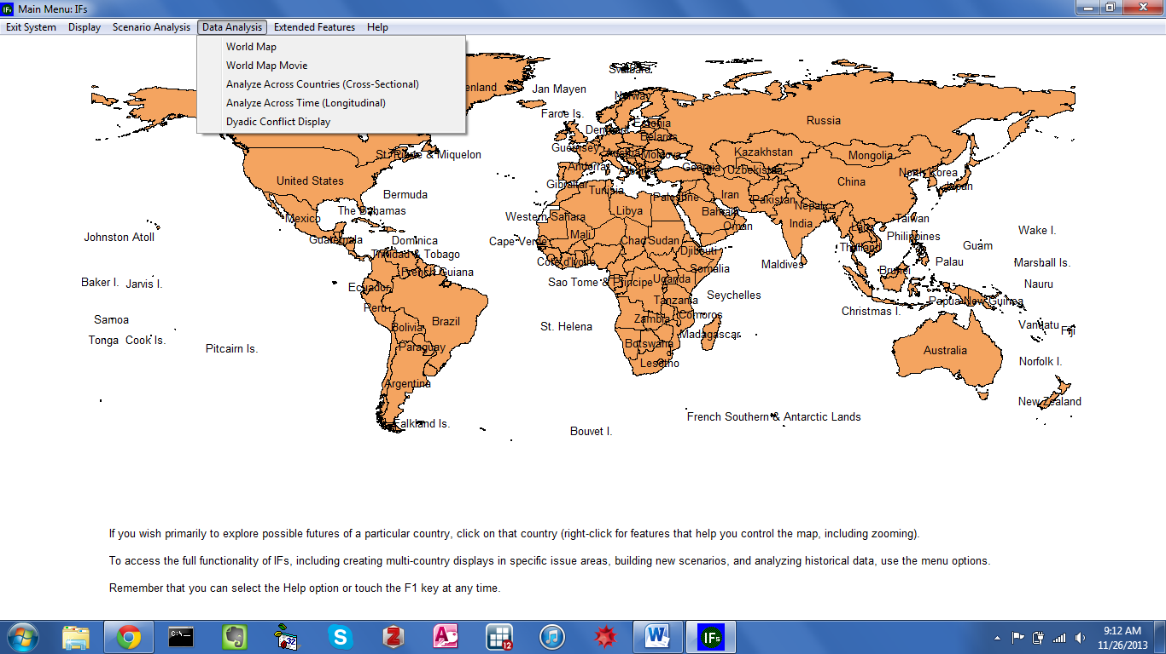
IFs Home Screen: Data Analysis Menu

World Map
From the Data Analysis drop-down menu on the IFs home screen, select the first item, World Map, to reach the following form:

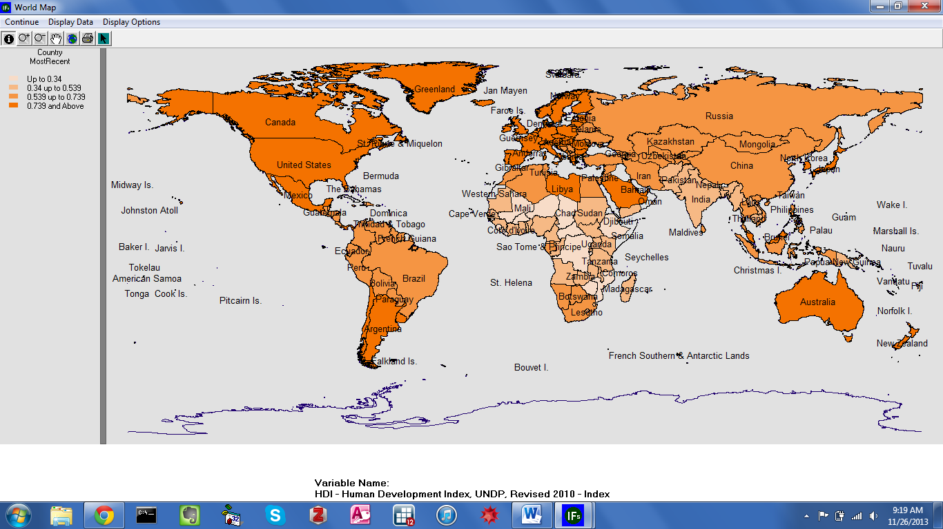
World Map Screen: Human Development Index

By default, the map displays data from the United Nations Development Program’s Human Development Index (HDI). As the legend in the upper left-hand corner indicates, deeper shades of orange correspond with higher HDI scores. A brief glance at the map offers a snapshot of global development, broadly defined. For instance, light shades mark Central Africa as the site of the world’s lowest levels of human development. Zoom buttons on the toolbar provide a closer look at countries in Africa, or any other region. Remaining buttons export the map image to the clipboard, or to a printer. The Display Options menu include several additional features that allow users to: change shading color, remove or add country names, toggle between global cartographic projections, and, add graphical layers such as major cities, waterways and transportation infrastructure.
In order to display a different time series, click the Display Data button at the top of the screen. The subsequent dialogue box is shown below. An option labelled Data Group filters historical data by type. The default filter setting is TimeSeries, a broad group that contains most longitudinal data series in IFs. Boxes labelled Display Type and Categories allow users to customize the map display. Initially, the display type is set to Equal Interval, which divides the total range of values into the number of categories specified. For example, values for RoadsPaved% range from 0 to 100; loading this series, with Display Type set to Equal Interval and Categories set to 4, would create a map with a category for each quartile. Alternative categorizations include: Equal Count, an equal amount of responses in each category; Exact Match, an ordinal categorization that will be incompatible with many series in IFs; and Specify Categories, which allows users to determine the exact boundaries of each category. For any data display option, users can create up to 16 distinct categories, as specified in the Categories box. Another input box, Dimension of Variable, determines the map’s time dimension. Options include, any individual year, most recent year available for each country or earliest year available for each country. Complete data availability statistics, and source information, are available from the Data Information button.

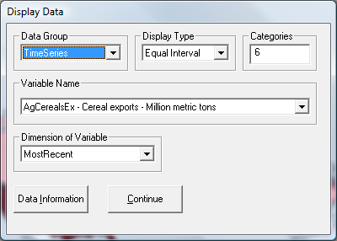
World Map Display Data Default Screen

As a demonstration, change the display from HDI to a poverty variable. Variables are organized alphabetically by prefix, which indicate the type of data series. To search for poverty measures type either the letter “p” and scroll to pov for poverty, or type “i” and scroll to inc for income. Other areas of the model provide more sophisticated search functions for historical variables—these features will be discussed below.
Choose IncBelow2Dollar%WDI2011, which is one of the World Bank’s World Development Indicators. This series captures the percentage of each country’s population living under 2$ per day. Next select Most Recent (the Most Recent option loads the most recent year available for each country, ensuring maximum coverage) as the time dimension, and click Continue. The shading on the map will change to display the new series. Now, darker colors correspond with higher portions of the population living in poverty. The graphic indicates that, today, poverty persists in parts of Africa and South Asia.

World Map Movie
The previous section discussed how to display a variable geographically, on the world map. However, such geographic displays are snapshots, taken at a single point in time. Return to the Data Analysis option, on the home screen, and choose the second option, World Map Movie. The following form adds the passage of time to global data visualization, with a map.

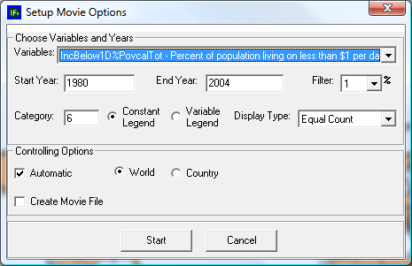
World Map Movie Display Default Screen

Initially, the World Map Movie form will identify as the chosen variable the first data series in the alphabetical list of all series. Input boxes control beginning and ending years, as well as color and filter percent. Like the World Map display, users can specify categorization type—Equal Count, Equal Interval, Exact Match or Custom—and the number of categories. Unique to the World Map Movie, a radio button controls whether category settings will remain constant over time, or adapt to changing values.
Search or scroll through the Choose Variables list to select a new series. For this example, choose GDP2005PCPPP, which is a measure of Gross Domestic Product at Purchasing Power Parity, on a per Capita basis in constant 2005 dollars. Once the data series is specified, and desired options are set, the Start button will play a longitudinal movie. The figure below shows the first year of a movie that tracks change in GDP Per Capita at Purchasing Power Parity 2005$, from 1960 to 2010. Legend categories are determined by equal count, and the default setting, constant legends, has been switched to variable legends. To launch the movie click Play, located next to the Stop button. The form includes zoom in and zoom out tools, a slide bar to control play speed, and a check box titled Automatic. For users wishing to proceed slowly, unchecking this box allows progression forwards and backwards by individual years.
The World Map Movie extends broad trend analysis over time. For instance, the movie displayed below (GDP Per Capita (PPP 2005$)) tells a story of rising global wealth over the last half century. Because categorization is set to Equal Count, the legend reflects fluctuations in per capita GDP levels associated with the richest and poorest countries in the world. Individual development stories appear in the movie as well—see the rise in Chinese per capita GDP since 1960.

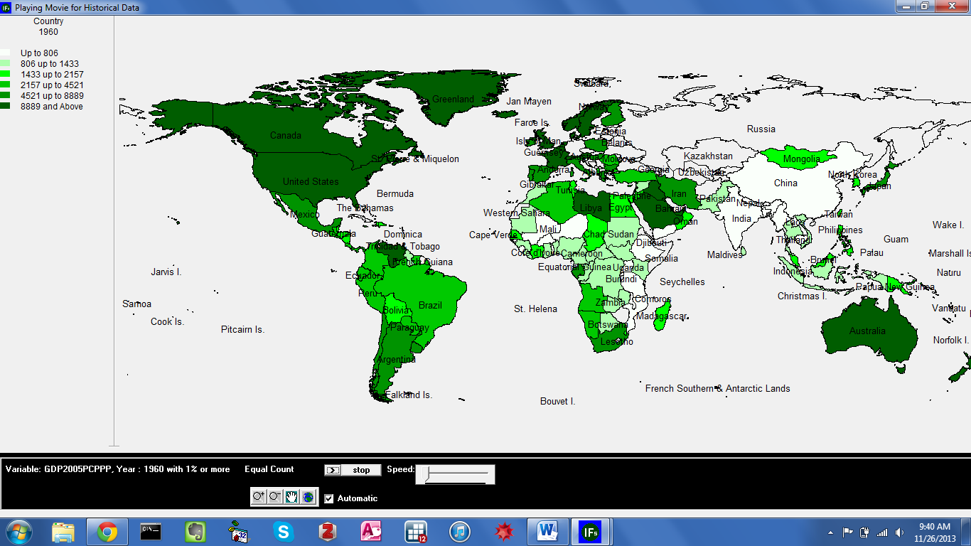
World Map Movie Display Default Screen

Analyze Across Countries (Cross-Sectional)
From the home screen, the third option under Data Analysis provides users with the ability to examine the relationship between historical variables. This powerful part of the IFs system can help users begin to understand the drivers of past and future patterns. From the Data Analysis menu, select Analyze Across Countries (Cross-Sectional) to reach the form displayed below.

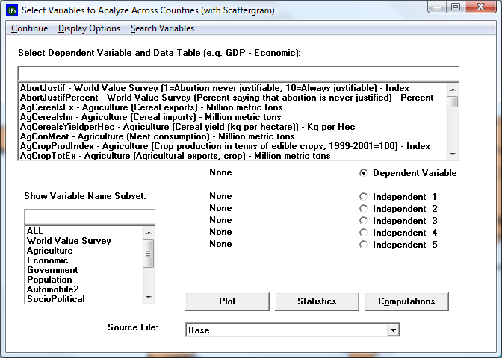
Default Screen for Cross-Sectional Analysis

This form allows users to display cross-sectional relationships between any series in the model. Here, and elsewhere, IFs uses the terms dependent variable and independent variable—terms commonly used in statistics, the social sciences and the physical sciences. Statistical relationships are often described as the effect that a change in the independent variable has on the dependent variable; or the expected value of the dependent variable given the independent variable’s value. And, more simply, on any scatterplot or line graph, the dependent variable will appear on the y-axis, and the independent variable will appear on the x-axis. Initially on the cross-sectional analysis screen, all variables are set to None. To select a dependent variable, scroll through the alphabetized data series list. With the desired series highlighted, left-click and select Load. Alternatively, there is a text box directly above the list that includes a simple search feature. The search will filter series by prefix. For example, the characters “ED” would automatically trigger a jump to the first education series, EdBasicEnrollGross%Female. Most users, however, will prefer a more robust search, available through the menu button Search Variables. From the ensuing form, a search on “solar” would return all series that contain the word, anywhere in the variable name or description. After selecting a dependent variable, either from the variable list or from the search form, a drop-down list will appear, specifying the temporal dimension. A cross-sectional display can include data for a single year, earliest available for each country, or most recent available for each country. The process described here is also used to assign independent variables. And, to reassign any variable, select the corresponding radio button. Then simply load the new series.

As a demonstration, plot a cross-sectional relationship between female education and reproduction rates. For the dependent variable choose total fertility rates, by selecting TFR from the list of variables. Left-click the variable once it is located, and two options will appear: Select and Data Information. The latter provides information about data coverage and source. Choose Select. The ensuing dialog box determines the year for which data will be displayed. For this example, choose 1970. Now the series name should appear next to the Dependent Variable location. Next, choose an Independent Variable. It is reasonable to expect educational attainment to exhibit a relationship with total fertility rates. Choose the level of adult female education, by selecting EdYears15Female for 1970. Click Plot to generate the graph displayed below.

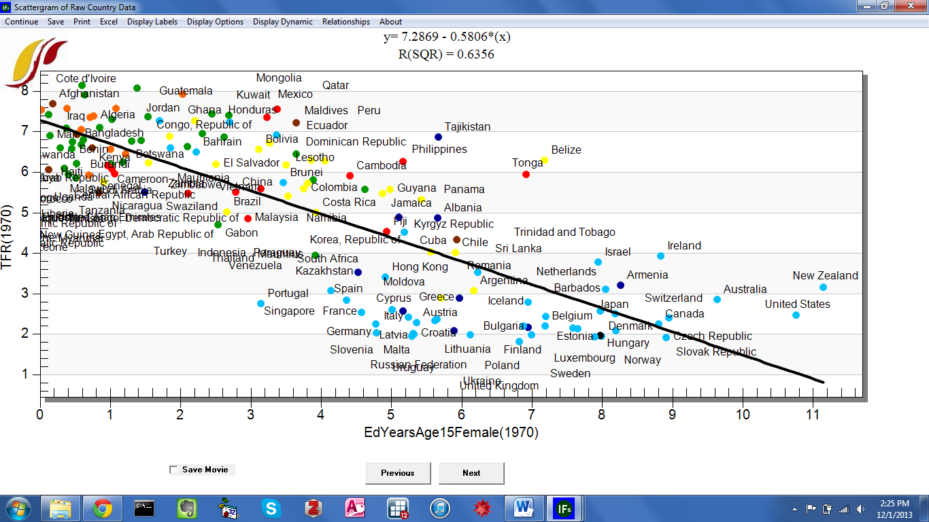
Cross-Sectional Relationship: TFR and Female Education, 1970

To impose a line of relationship on the scatterplot, choose Relationships from the toolbar, and the option Linear. Notice the r-squared value (a measure of fit of data and the line of relationship) and linear equation displayed at the top of the screen. Additional relationship types include: logarithmic, exponential, power, polynomial and logistic. On the graph form, toolbar options allow users to save plots and underlying data to the clipboard, print the screen and export a file. Clicking the Excel button exports all underlying data to an Excel spread sheet, opens Excel and reproduces the cross-sectional graph. The Display Labels menu option contains controls for the plot area, axes and legends. Instead of full names, countries can be represented by three letter codes or no label at all. Users can fully customize titles running along the horizontal and vertical axes. The final sub-option under Display Labels, Select Points and Labels, is especially useful. Users can chose to hide just the label, or the entire data point for specific countries. This technique can facilitate calling attention a single country among many.
Alongside Display Labels, the tools under Display Options control geographic aggregation and additional data dimensions. Specify Geography allows the user to display data by country, group, or geographic list. An additional feature, Bubble Diameter, adds a third data series to the plot. A third set of tools, under the heading Display Dynamic Option, adds a temporal dimension to the plot.

To demonstrate the features located under Display Options and Display Dynamics, create a longitudinal movie of the relationship between total fertility rate and female educational attainment. First, switch from individual countries to a more manageable geographic representation. (When creating a longitudinal movie, geographic aggregation can improve visual clarity). On the cross-sectional plot form, select Display Options, Specify Geography, and then Select Geographic List. From the complete set of geographic lists—referred to in the model as G-lists—select U.N. Regions. Add a population bubble diameter from the Display Options menu. Now, access the tools for advancing the plot across time, under Display Dynamic. Two options begin the movie, Show Movie (Tracing Points Across Time) and Show Movie (One Point at A Time, No Tracing). The tracing option tracks a group’s path clearly, but as the number of countries increases the display becomes cluttered. After selecting either movie type, a further option specifies starting year. For this example, create a movie with tracing on, beginning from the first year. See the graph displayed below for a snapshot.
The Display Options menu includes bubble diameter dimensions for population and GDP. However, from the initial form, users can link bubble diameter to any data series in IFs. To create a customized bubble graph, select a dependent variable and independent variable as usual. Then, to assign a bubble dimension, load any series into the second independent variable location. Note that more than two independent variables cannot be displayed graphically.

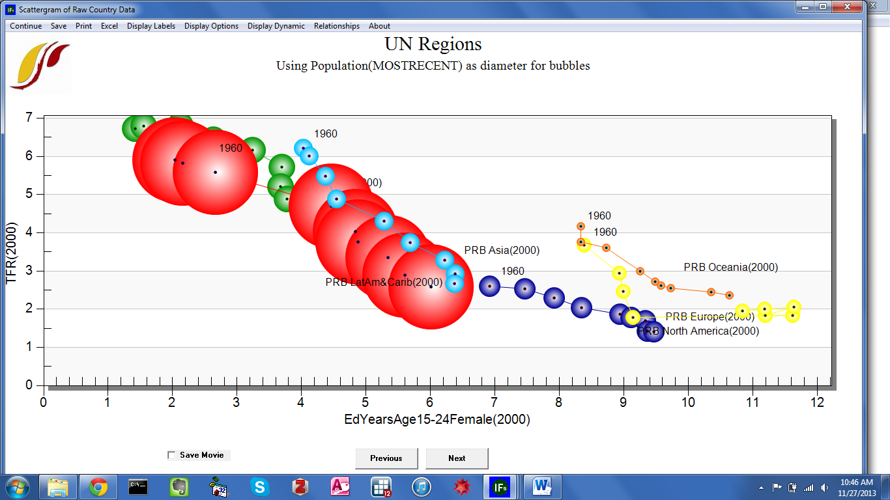
Cross-Sectional Relationship: TFR and Female Education by UN Regions, 1960-2000

Introducing Time in Cross-Sectional Analysis
This brief exercise will introduce a method used to display historical trends between variables in IFs, using geographic lists. From the Data Analysis menu on the IFs home screen, select Analyze Across Countries (Cross-Sectional). Then, load TFR as dependent variable and EdYearsAge15Female as the first independent variable. Assign each series the year 1960 as the time dimension. To add a new element to the cross-sectional display, aggregation level must be set to geographic lists. Click the Display Options menu and then Select Geographic List. The ensuing dialogue box contains all geographic lists—or G-Lists—that are currently defined in the model. For this example select a single list, WB Regions. Now click Plot to display the relationship between fertility rates and female education, as it stood in 1960, across World Bank geographic regions. The display option Add Year in G-List/Group facilitates longitudinal trend analysis. Use this option to add points for two additional years, 1980 and 2005. As a final step, open the Relationships menu and select Logarithmic. The figure below shows the relationship between female education and fertility at three points in time: 1960, 1980, and 2005.

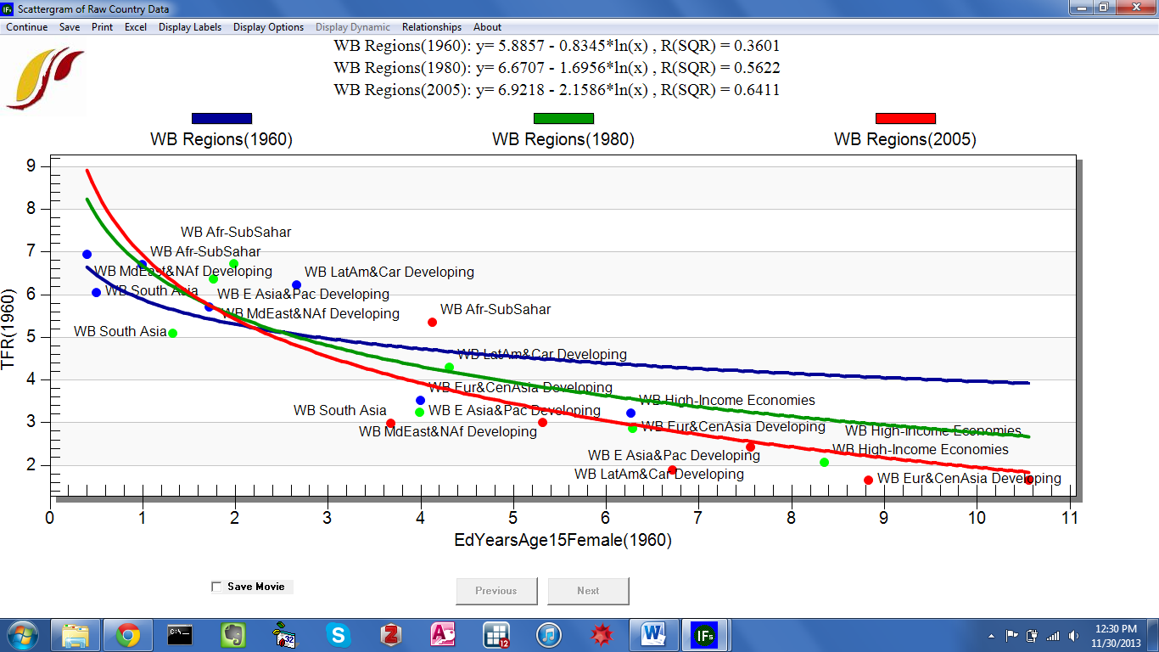
Cross-Sectional Relationship: TFR and Female Education, 1960, 1980 and 2005

We can see that the relationship between the two variables has strengthened over time, and for values above 2.5 years of completed education, fertility has declined. What, then, has caused the downward shift of the function over time? Two reasonable hypotheses are improvements in contraceptive technology (making it easier to use, more effective, and cheaper) and the advent of a global regime around family planning (the idea has spread over time that family planning is acceptable practice, good for families and countries).

Analyze Across Time (Longitudinal)
From the main menu, the fourth Data Analysis feature is Analysis Across Time (Longitudinal). Whereas cross-sectional analysis concerns historical relationships, the primary purpose of the longitudinal analysis is to trace historical trends in individual data series.
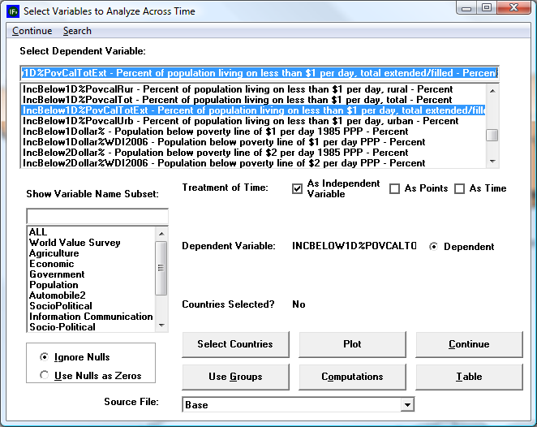
Longitudinal Analysis Screen with Income Variable Selected

The longitudinal analysis form contains settings for a dependent variable, geographic representation and the treatment of time. With the radio button active, select any data series to load a dependent variable. Similar to the cross-sectional form, users can locate series in the text box by scrolling, using the simple search function or with the more sophisticated, separate search option, located along the toolbar. Given the large number of countries and years represented in the database, historical data series in IFs will rarely have complete coverage. Two radio buttons in the lower left-hand corner control whether to interpret nulls as zeros or blank spaces. Buttons on the bottom of the form control data aggregation rules. Click Select Countries to specify the data that will appear in graphs. (Note that the button beneath Select Countries is a toggle, switching from country to group selection or visa-versa; e.g. if groups are selected the toggle will read “Use Countries”). From the country selection screen, radio buttons switch aggregation to groups or decomposed groups—see the form displayed below. Three distinct longitudinal displays are available in the model: treatment of time As Independent Variable, As Points and As Time.

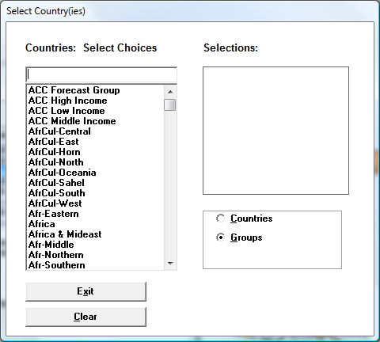
Select Groups Default Screen in Longitudinal Analysis
.
To demonstrate the three options, create a series of longitudinal line graphs that explore trends in global poverty. In the variable list, search on the prefix ‘INC’ and load IncBelow1D25c%WDI2011 as the dependent variable. One of the keys to using Longitudinal Analysis is understanding how to load the countries or groups for analysis. Click Use Groups, which toggles the Select Countries button to Select Groups. Then click Select Groups and add OECD and non-OECD for display. Once both regions are in the Selections box, click Exit. The first setting, the default, treats time as an independent variable, displayed along the x axis. Click the "Plot" button to produce the graph shown below:

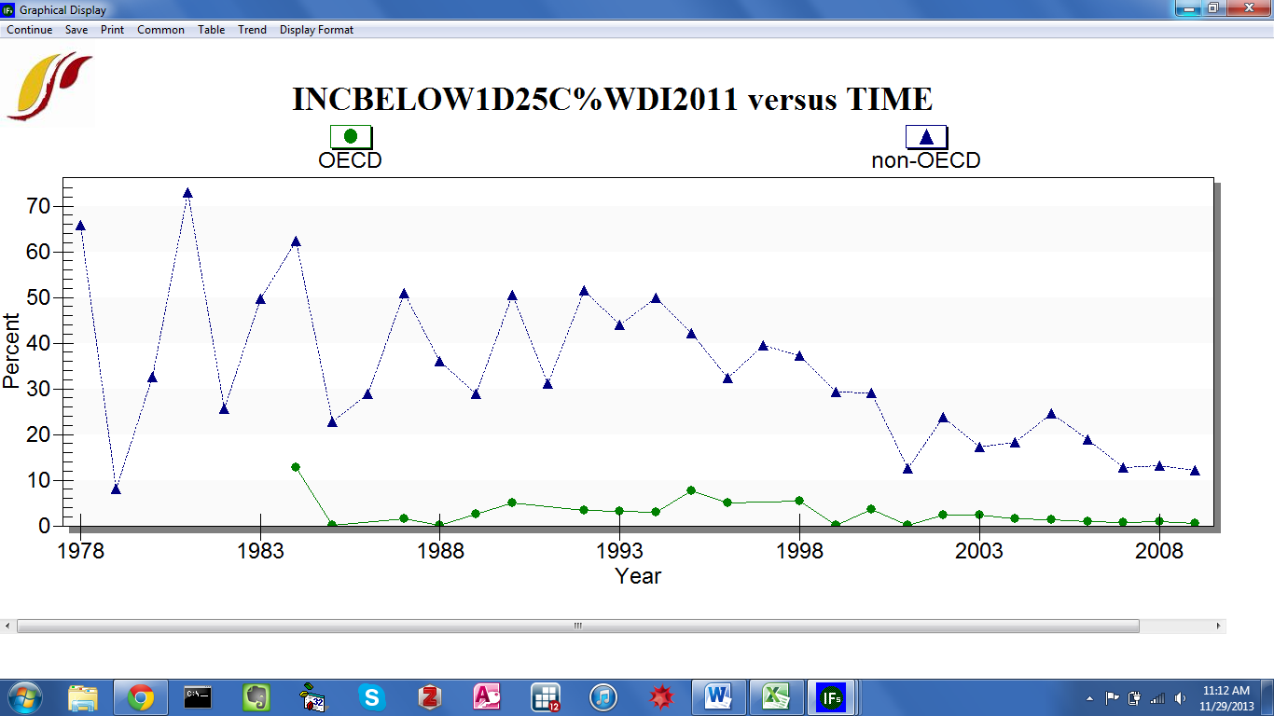
Graph of OECD and Non-OECD Groups Living on 1.25$ a Day or Less

This graph begins to tell us a few things about our data. First of all, we can see that this data series is not as smooth as we would probably like it to be. Secondly, there is a clear gap between the share of the population living on less than a dollar a day in OECD countries as compared to non-OECD countries, as would be expected. Thirdly, we can see that non-OECD country poverty rates have been steadily decreasing. (High rates of variation in earlier years, before 1990, are the result of fluctuations in data availability.) Menu options allow users to save or print the image, alter the scale, display a table, format titles and explore future trends. Through the trend feature, we can begin to think about where poverty might be heading in the future. Under the Trend menu, users can impose extrapolations—linear, polynomial, logarithmic, exponential and s-curve—onto the chart. The sub-option, Extrapolation Setup, features customization options for polynomial, exponential and s-curve trend lines. A simple extrapolation of historical data is crude, but it provides a foundation for thinking about the future of global poverty. It may be interesting to compare a simple extrapolation with IFs integrated forecasts—discussed in the Scenario Analysis section. The graph below displays a linear trend of poverty in non-OECD and OECD countries, extended 25 years into the future.

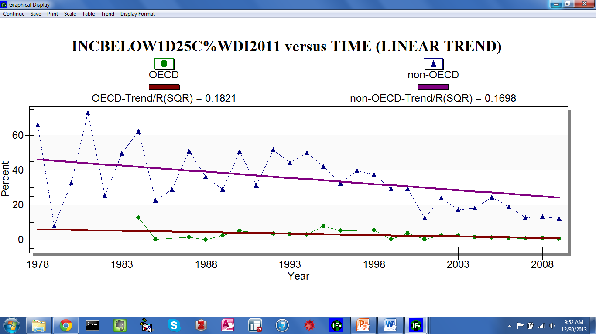
Linear Extrapolation of the OECD and Non-OECD Population Living on 1.25$ a Day or Less

The second display option adds an additional data element to the longitudinal display. Once the Treatment of Time check box labelled As Points is active, an independent variable field appears on the form. Returning to a previous example, load TFR as the dependent variable and EDYEARSFEMALE15-24 as the independent variable. Using groups, select the OECD and non-OECD countries. Click plot to generate the graph displayed below. Recalling the previous section—cross-sectional display—this graph is a snapshot from a cross-sectional movie across time.

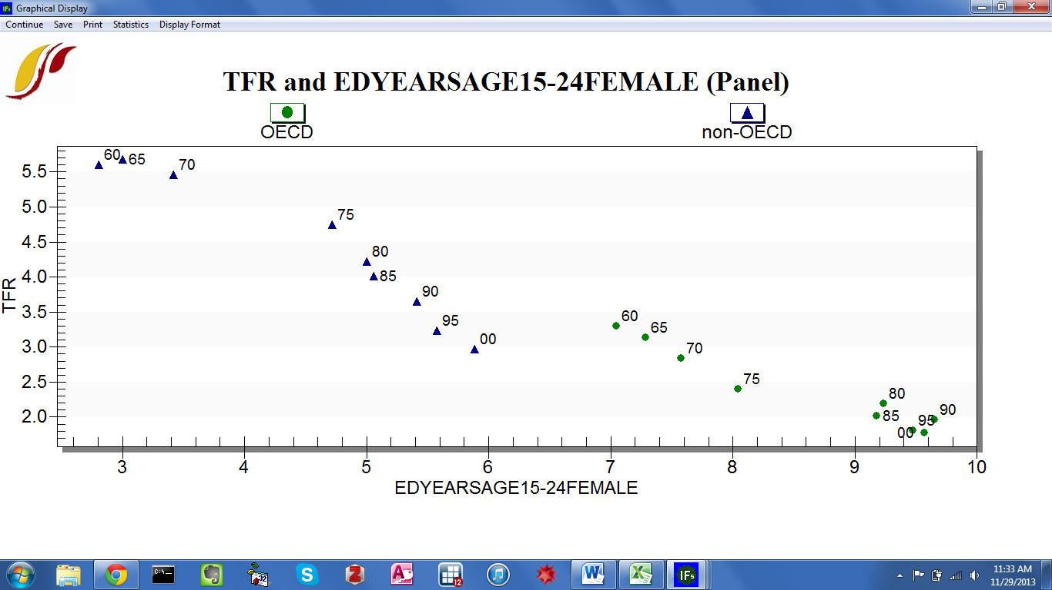
TFR and Female Educational Attainment in OECD and non-OECD Countries
The third display option, treatment of time as time, facilitates side-by-side comparison of longitudinal trends. When the check box labelled As Time is active, an independent variable field will appear on the form. To demonstrate, again load total fertility rate as the dependent variable and adult female educational attainment as the independent variable. Click the Select Groups button and choose the OECD. To generate the graph displayed below, click Plot.

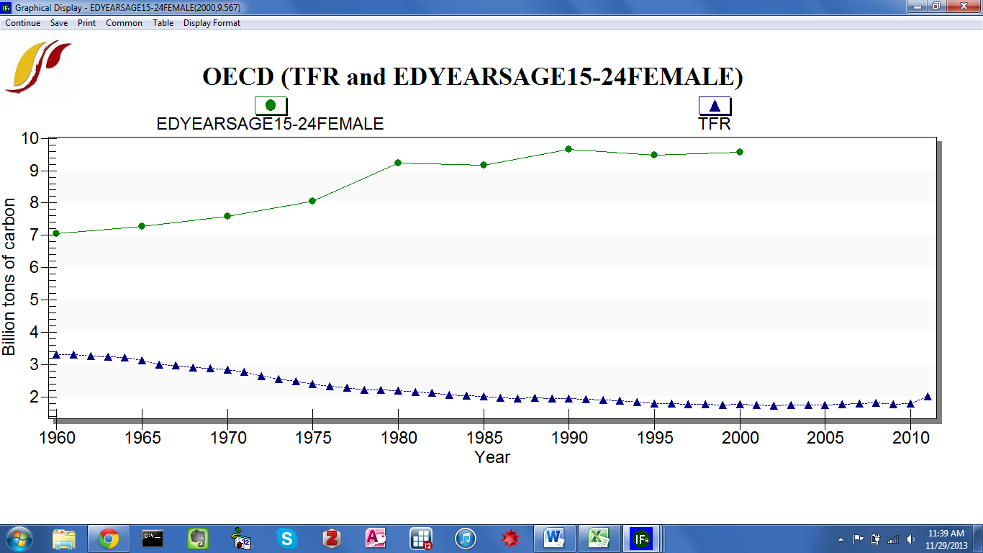
TFR and Female Educational Attainment in OECD and non-OECD countries

Dyadic Conflict Display
The fifth, and final, Data Analysis feature is a specialized display, designed to capture relationships between pairs of countries, referred to as dyads. From the home screen, click Dyadic Conflict Display to reach the form displayed below. A country dyad—constructed via boxes CountryA and CountryB—can include any of the 186 countries in IFs, from Afghanistan to Zimbabwe. The variable scroll box contains data series for which IFs has country dyad data.
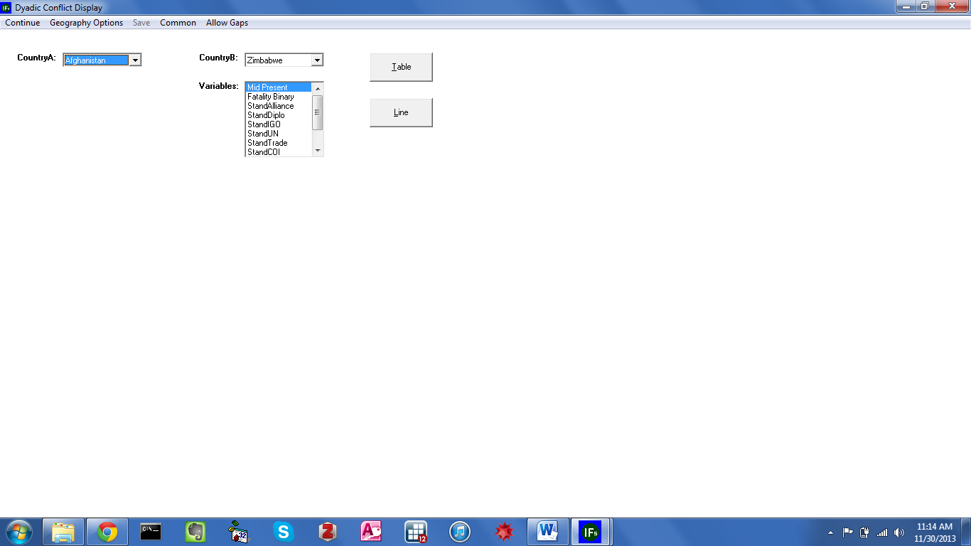
Dyadic Conflict Display Form
The first two series do concern conflict: the presence of a militarized interstate dispute (Mid Present), and whether a militarized interstate dispute involved a combat fatality (Fatality Binary). However, the following four series capture diplomatic relations between countries: alliances (StandAlliance), a tiered measure of the degree of bilateral diplomatic connection (StandDiplo-), shared membership in international organizations (StandIGO), shared accession to treaties held by the United Nations Secretariat (StandUN). As opposed to the pooled approach taken throughout the model, the fifth series captures actual bilateral trade subtracted from expected levels of bilateral trade calculated using a gravity approach (StandTrade). The final data series available in a dyadic display represent characteristics of bilateral engagement. StandCOI is the sum of StandDiplo, StandIGO, StandUN, and StandTrade and represents a bilateral culture of interaction. StandLiberalisHighest measures the degree to which the dyad conforms to liberal norms by measuring overall levels of membership in IGOs, commitment to treaties held by the United Nations, levels of trade, and democratization. StandRealismLowest measures the distribution of power across the dyad. Threat is a simple sum of the Stand COI, StandLiberalisHighest, and StandRealismLowest. Below, a graph depicts historical trend in bilateral trade minus expected levels of bilateral trade based on a gravity model between the United States and one of its principal trading partners, China. After 1970 trade between the two countries was higher than a standard gravity model would predict, rising to over two standard deviations above the historic mean of all trade dyads by the early 2000s.

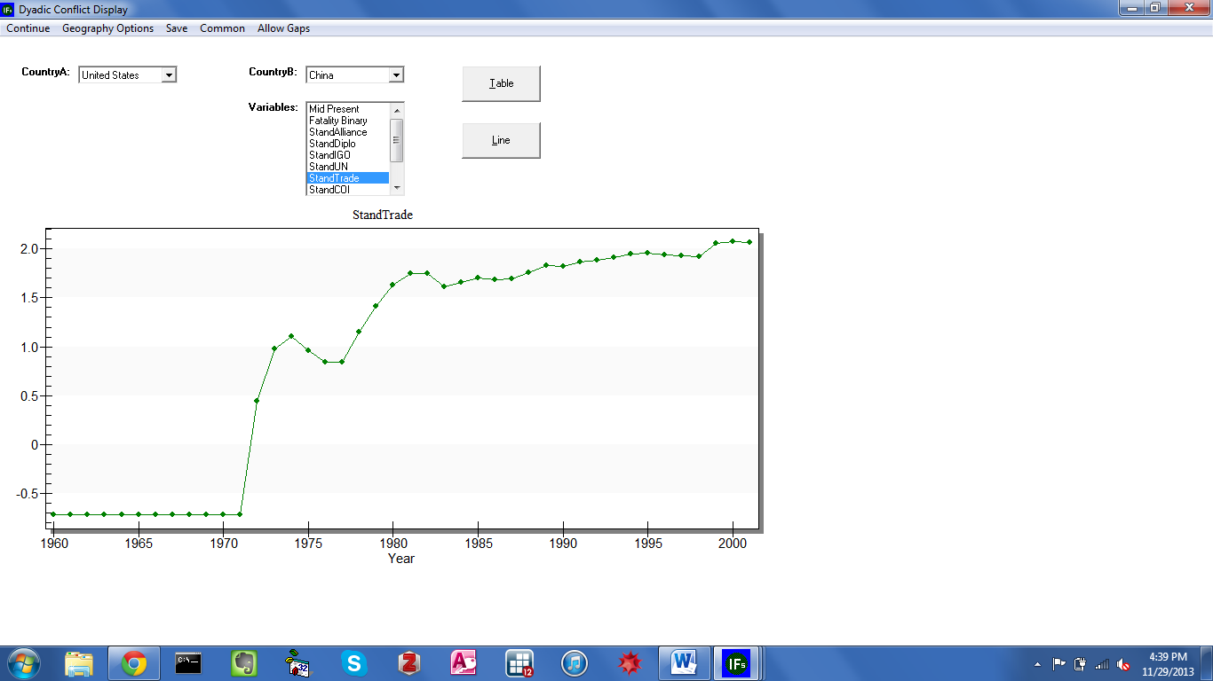
Dyadic Conflict Display Form, Trade Between the U.S. and China

Display Analysis
Where do we seem to be going?
Objectives
In this section of the training manual, users will learn how to:

  - display forecast variables for any country/region or group
  - navigate several specialized displays
  - use the IFs Help System as a supplementary resource
  - identify connections between variables within the model
  - export forecasts and historical data for manipulation in other software packages

From the IFs home screen, select Display. The subsequent drop-down menu includes links to a wide range of tools, used to visualize IFs historical data and forecasts. The five Display menu sub-options are:

  - Flexible Display
  - Geographically-fixed Display
  - Basic Display For Countries
  - Specialized Display For Issues
  - Self-Managed Display (Complete Flexibility)

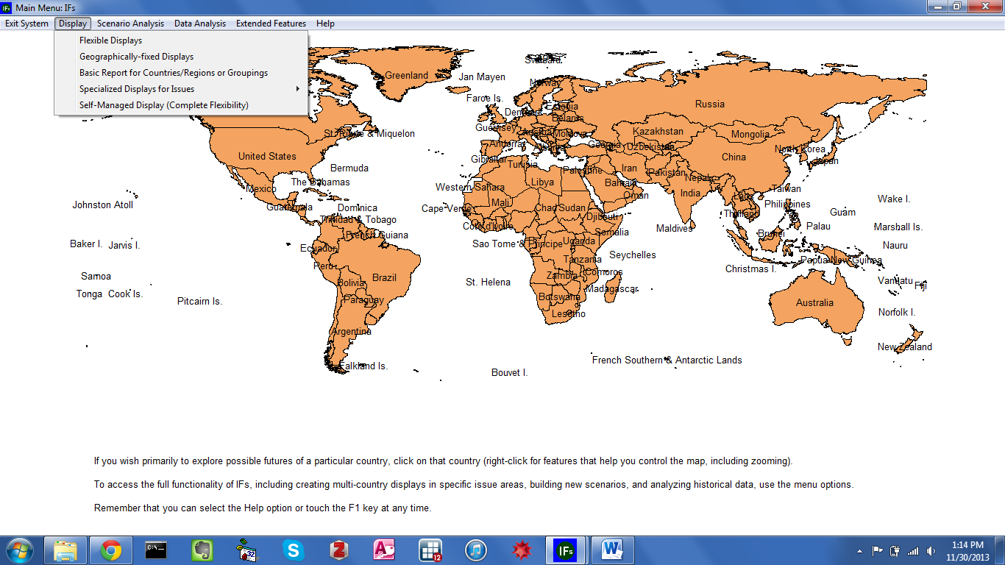
IFs Home Screen: Display Menu

Introduction
The International Futures (IFs) model comes pre-loaded with a Base Case scenario—saved as a run file, named IFsbase.run. It is worth reiterating that the Base Case is not an extrapolation of data series discussed in the historical analysis section of this manual, nor is it merely a ‘business-as-usual’ scenario, as some forecasters prefer to call it. The Base Case is rather a dynamic evolution of current development patterns. The model creates this reference scenario from quantitative representations of structures, agents and interactions within and across various social, economic and ecological systems. Throughout the following section, demonstrations will explore where global poverty trends seem to be heading, according to the Base Case. The first two sub-sections, Flexible Displays and Geographically-Fixed Displays, present poverty forecasts by region, and then at the country level. In the next forty years, developments in one large country, India, will have a major influence on poverty headcounts. Subsequent sections, Basic Display for Countries and Specialized Display for Issues, unpack the Indian context. And the final section, Self-Managed Display, introduces the subject of causal driver analysis. Along the way, users will learn to use tabular features and a broad, versatile, set of graphical display packages.

Flexible Displays
From the IFs home screen, the first sub-option under the Display menu organizes variables into thematic categories. This display feature facilitates quick, but flexible, presentation of historical data and forecasts. From the Display menu, click Flexible Displays to reach the form shown below.
The Flexible Displays form is divided into three scroll boxes. Beginning from the left, the Display Categories box contains data series categorizations, which range from broad (Energy), to more narrow (Education Tertiary). The second box, Displays, contains data series corresponding to the highlighted category. Initially, ALL will be highlighted, so Displays will contain every data series included in the Flexible Display, ordered alphabetically, from A Selection of Human Condition Variables to Youth Bulge, Percent of Adult Pop Between 15 and 29. For any data display, the third box specifies a geographic dimension. By default the 186 countries captured in IFs are available for selection. However, toolbar options allow users to select alternate geographic representations. Four grouping sub-options are located under the Geography Options menu: Countries/Regions, Groups, Decomposed Groups and Geographic Lists. Once an option other than Countries/Regions is selected, the Geography box will change its contents accordingly. Two smaller boxes, located at the bottom of the form, control additional dimensions. Horizon specifies the year to which forecasts extend. And the box labelled Scenarios contains Run Files.
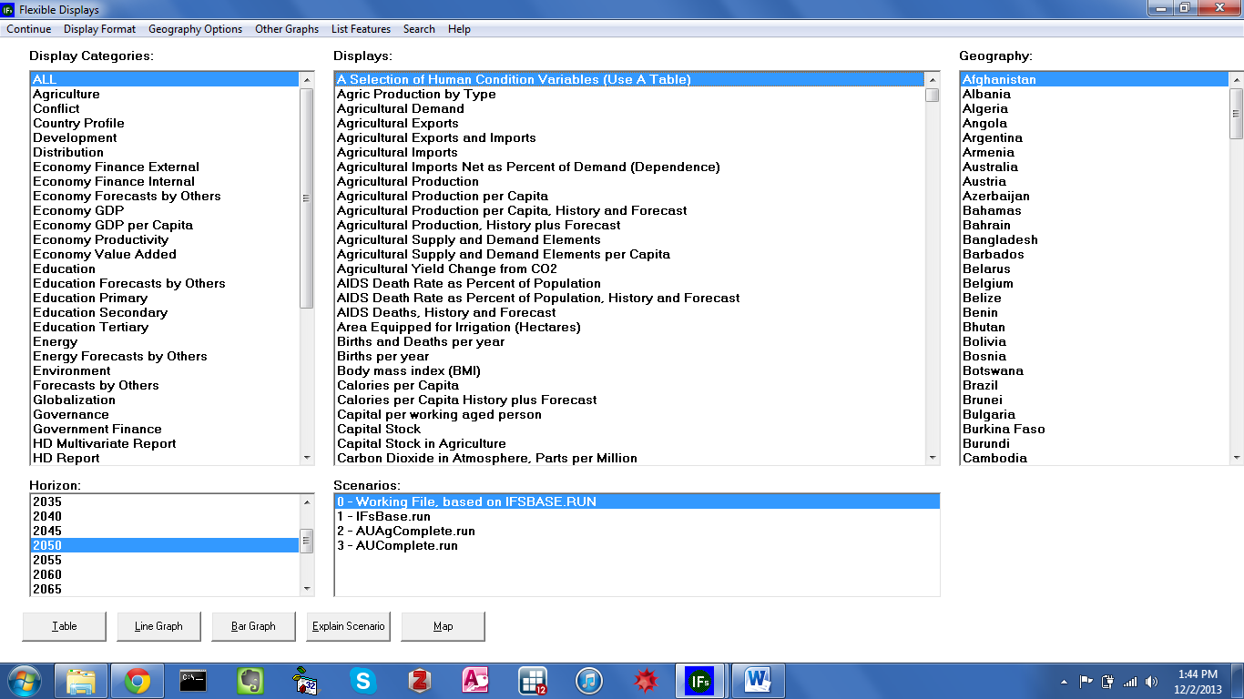
Flexible Displays in IFs

To demonstrate the display process, explore where global poverty trends seem to be heading, over the next forty years. On the Flexible Displays form, select Poverty from the left-most category box. Now, the Display Package box will only contain available series related to poverty. For this example, click on Poverty Percent Less Than $1.25, Log Normal Formulation. The Dimension Box on the right initially contains a list of 186 countries, ordered alphabetically. In order to examine poverty across broad regions of the world, change the grouping option. Click on the Grouping Options menu, and then select Using G-Lists. From the ensuing dialog box, which contains all of the geographic lists defined in IFs, choose World Bank Developing Regions (WB Regions Developing). The Horizon box designates temporal dimensions that range from, 2010, the base year, to 2100, ninety years out. Set forecasts to extend to mid-century, to the year 2050—this will be the default selection. Alternatively, users can change the display horizon using the Horizon sub-menu option under Display Format –displayed below. The Display Format menu also includes tools that customize: titles, display intervals, and the type of currency, which will be set to American dollars as a default.

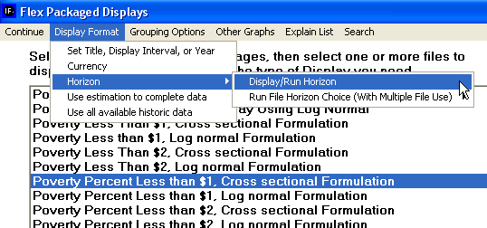
Changing Display Horizon in IFs

Centrally located towards the bottom the form, the Scenarios list box is populated with the IFs Base Case, IFs Working File and other pre-packaged scenario result files (.run) that come loaded on all versions of IFs–see the figure displayed below. The box assigns a numeric sequence to the run files. Until the user creates an alternative scenario, the working run (run 0) and the base run (run 1) are the same. Choose either option to examine the future of poverty under the IFs Base Case.

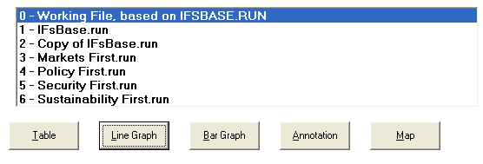
Run Files and Command Buttons in Flex Display

Once the desired series, geographic representation, time horizon and run file are selected, create a line graph. Along the bottom of the Flexible Display are four buttons. Each command button generates a different display from the selection criteria. Options include: Table, Line Graph, Bar Graph and Map. (A fifth option, Explain Scenario, describes the highlighted run file.) Click Line Graph to create the graph displayed below.

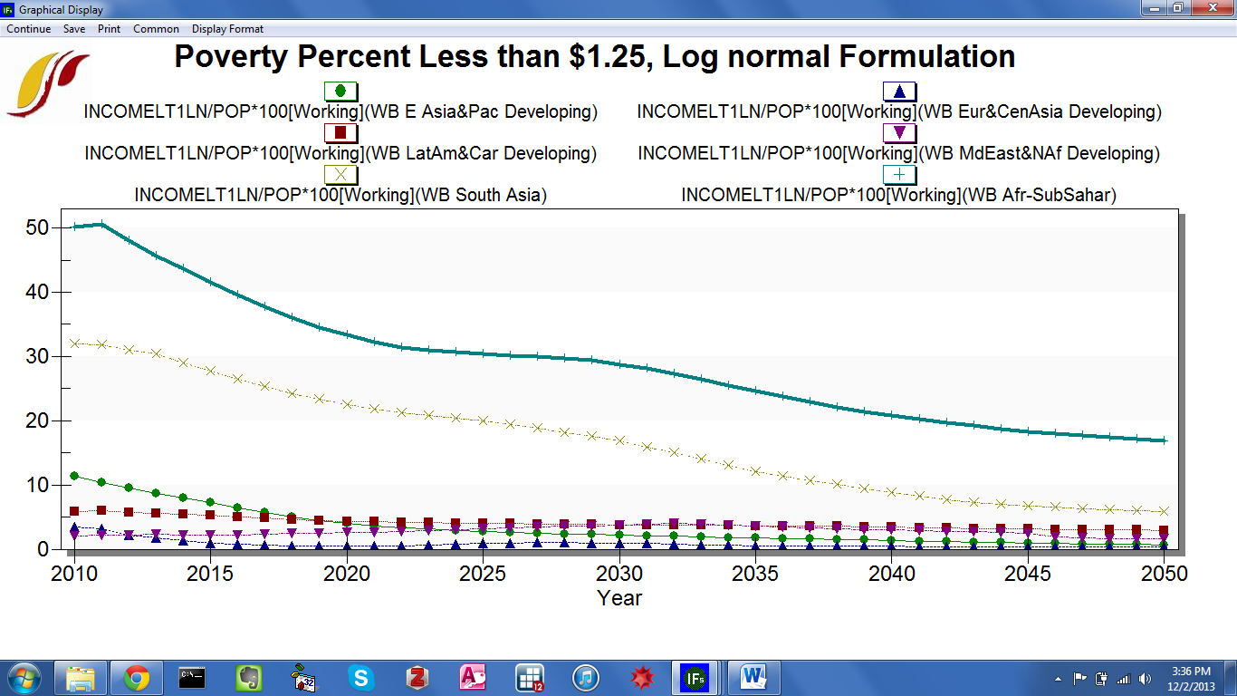
Base Case Poverty Forecasts for Developing Regions

The line graph offers a simple but powerful message: global poverty eradication efforts should target two regions, Sub-Saharan Africa, and South Asia. All other World Bank Developing Regions—East Asia & The Pacific, Latin America & The Caribbean, Europe & Central Asia and the Middle East & Northern Africa—exhibit extreme poverty rates of less than 10 percent. And this figure is set to decline over the next 40 years. Standing in stark contrast, nearly half of all people living in Sub-Saharan Africa live in extreme poverty, and according to the Base Case forecast, this figure will decline only slowly, reaching 20 percent by mid-century. Trends in South Asia are similarly dire, at over 30 percent today, and set to decline gradually throughout the time horizon.
As a further illustration of Flexible Display features, conduct a comparative analysis of the two highly impoverished regions. Line graph analysis revealed that poverty is a persistent problem for sub-Saharan Africa and South Asia. From the Flexible Displays form, select the Poverty category once again. The previous section discussed poverty in percentage terms. Now, from the Displays scroll box, choose an absolute formulation, Poverty Less Than $1.25, Log Normal Formulation. In order to refine geographic representation, select groups rather than geographic lists. Open the Geographic Options menu along the toolbar, and select Using Groups. From the ensuing Geography list box, select two World Bank regions, WB Afr-SubSahar and WB South Asia. (After selecting the first group, hold down the Ctrl key to select the second group.) With data series, geographic dimension and temporal dimension set, click the Table button, located at the bottom of the form to generate the figure displayed below. Recall that sub-Saharan Africa exhibited the most severe case in percentage terms. The tabular headcount display, however, tells a different story. Over 100 million more people live in extreme poverty in South Asia than in Sub-Saharan Africa. Along the tabular form toolbar, features allow users to perform additional comparison. For instance, click Comparison Options, Difference Comparison (b-a) to quantify the difference in extreme poverty between the two regions.

Table Data in IFs

Along the toolbar, additional features allow users to graph, filter and rank data. And under the Save option, users can export data and graphics for use in other software. Data can be saved as an Excel file (.xls) or a comma separated values (.csv) format. And, alternatively, the option Save Normal View, Save to Clipboard copies tabular data into computer memory, allowing users to drop the data onto a Excel spreadsheet using Excel’s Paste option—see the graphic displayed below.

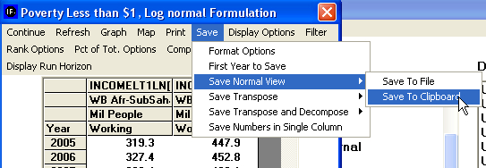
.
Saving Table Data in IFs

As a demonstration of IFs geographic options, continue exploring poverty trends. Table analysis identified South Asia as the region poised to encompass the highest number of extremely poor in the coming years. But, what countries make up the impoverished region? Are certain countries weighing especially heavily on the forecasts? IFs features a grouping option titled Decomposed Groups that allows users to select a group and display data for individual member countries or regions, narrowing the level of analysis. Using Decomposed Groups is a sub-option under the Grouping Options menu, located in several IFs display screens, including Flexible Displays—see the graphic displayed below. Once clicked, the Geography box will contain all of the pre-defined IFs groups.

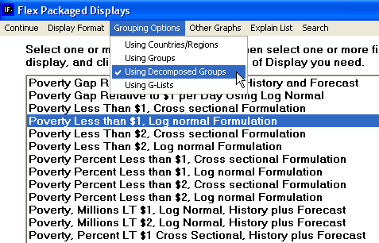
Using Decomposed Groups Menu in IFs

Scroll through the geography list and select WB South Asia. Now, from the Displays box, select Poverty, Millions LT $1.25, Lognormal Formulation, History Plus Forecast to generate the line graph displayed below. Clearly delineate the boundary between historical data and forecasts by inserting a vertical line at the base year, under Display Format.
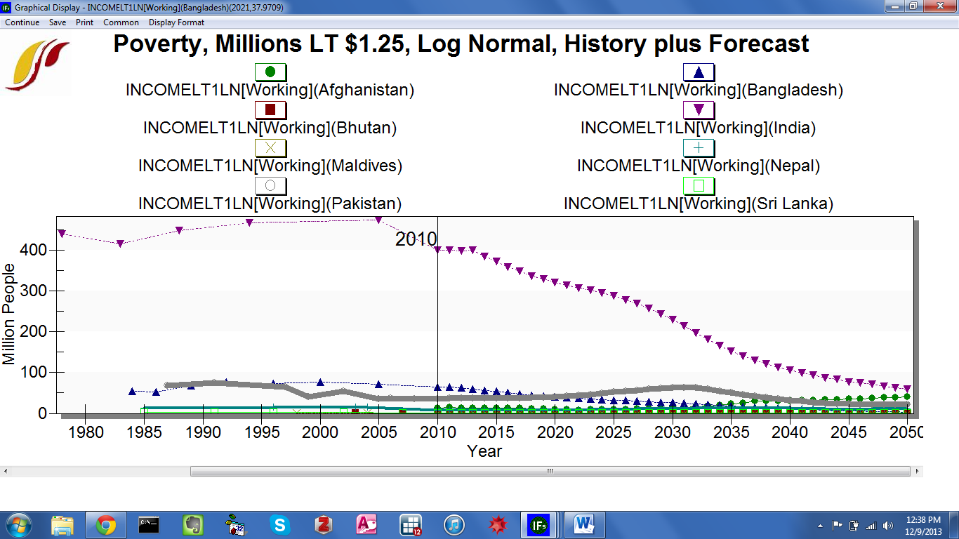

Poverty Headcounts for South Asian Countries: Base Case Forecasts

The line graph identifies an imbalance in country size. With a massive, growing population, India’s contribution to absolute poverty in South Asia dwarfs all others; in 2010 over 400 million Indians subsisted on less than 1.25$ per day. The next closest country is Bangladesh, which is home to over 60 million people living in extreme poverty. The other members of the South Asia group—Afghanistan, Bhutan, Maldives, Nepal, Pakistan and Sri Lanka—contain to less than 40 million extremely impoverished people each.

Graphical Forms
This section will discuss graphical tools accessible from the Flexible Displays screen. (Note that these tools appear throughout the model, including in Analyze Across Countries (Cross-Sectional), Analyze Across Time (Longitudinal), and Self-Managed Display.) From the IFs home screen, open the Display sub-menu, and select Flexible Displays. Command buttons that generate line graphs and bar charts appear along the bottom of the ensuing form. And on the toolbar, the option Other Graphs contains links to pie charts, radial diagrams and scatter plots.

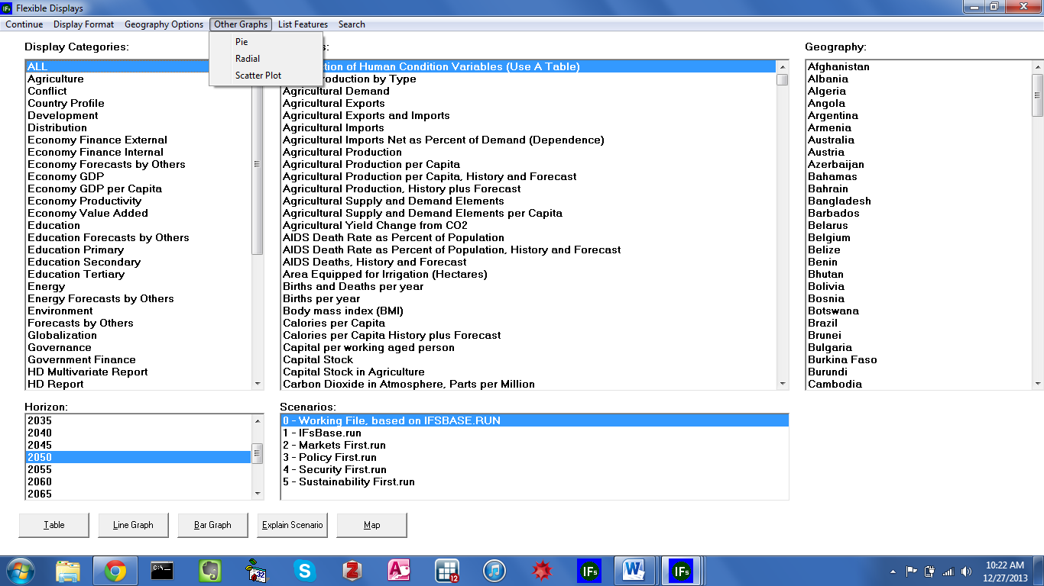
IFs Flexible Display: Graphs

Line and Bar Charts

On the bottom of the Flexible Displays form, the first graphical display feature creates line graphs. As an illustration plot a line graph of a power index. In the Display Categories box, highlight Power. The contents of the Display box will change to include representations of power, military spending and technology. Select the data series titled Hard or Capabilities Power. To see exactly what this series measures, click List Features from the toolbar, and select Explain List. The ensuing form indicates that the series is an index, recorded as percent of global power. For additional information click Data Information. The extended definition lists index components: military spending, GDP at market exchange rates, GDP at purchasing power parity, and population. Click Continue to return to the Flexible Displays form. Now, for the geographic dimension select three countries, the United States, China and India. Do not change the default time horizon, 2050, or the scenario dimension, IFs Working File. Click the Line Graph button to product the graphic displayed below.

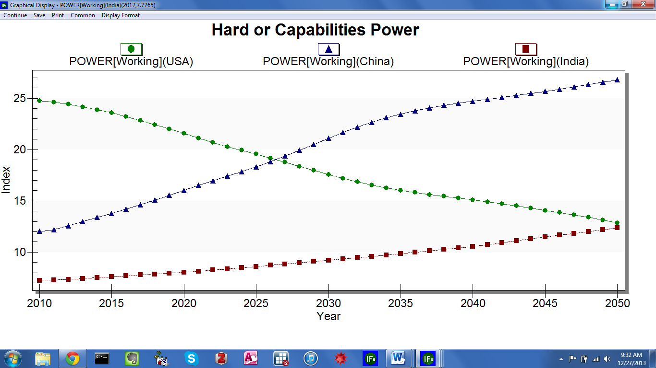
IFs Flexible Display: Line Graph
Options on the line graph form allow users to customize the graphic. From the left, the first toolbar option, Continue, navigates back to the previous screen. The second option, Save, exports the image either to the clipboard, or as a separate file—file formats include .emf, .wmf, .bmp, .jpg, and .png. Print, the third option, sends the image to the printer. The fourth option is a toggle between Common/Scale. When scaled is active (and thus visible on the toolbar) the y axis reflects data values, and when common is active, values are modified to range from 0 to 1. And the fifth option, Display Format tailors all visible display elements, from titles and run horizon, to legend characteristics.
Additional features are linked to the plot area. Left clicking on the graph allows users to zoom in, and hovering over a data point displays the associated value. Right clicking in the plot area brings up a set of customization options: Viewing Style menu sub-options control color schemes, shadow effects and border definition; Border Style sub-options format the box surrounding the plot area; Font Size sub-options set all text to either small, medium or large; Sub-options under Legend Style control the position of the legend on the form; Numeric Precision set the displayed data to zero, one, two or three decimal points; Plotting Method sub-options allow users to add additional elements to the graph. By default Points + spline will be active. However, additional settings add lines of best fit, or even replace lines with bars or area graphs, changing the display type altogether; the next sub-menu heading Data Shadows, toggles between standard shadowing, 3-D shadowing or no shadowing at all; Grid Options control the presence of vertical and horizontal lines in the plot area, as well as line width; the Graph and/or Table sub-menu option allows users to add a data table beneath the plot, or replace the graph with a data table; Undo Zoom restores initial zoom settings; Maximize shifts to full-screen mode. And the sub-menu option Customization Dialogue brings up a pop-up box containing all of the features listed here.
The line graph displayed above tells a story of power transition. In 2010, the United States scores highest of the three countries on the material power index. After 2025, however, China takes the lead. As a demonstration, use the zoom function to pinpoint the exact year in which the transition takes place. First zoom in to the intersection of the lines representing the United States and China. Click the plot area, create a box with the cursor and drag to cover the area of interest. Hover over the data points to see the value of each country’s index during the transition year
As a further demonstration, change the display of hard power in China, India and the United States to a bar chart. From the line graph form, click Continue, located on the toolbar. Now click the Bar Graph command button—located on the bottom of the Flexible Displays form—to create the graph displayed below. The bars retell a story of increasing Chinese power, and the United States’ decline. Customization options located along the toolbar, and in the plot area, are identical to those discussed above, for line graphs.

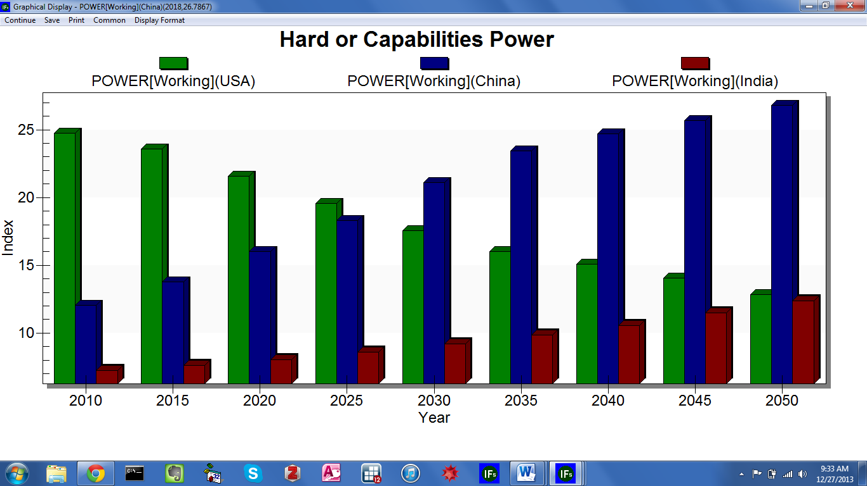
IFs Flexible Display: Bar Charts

Radial Diagrams
On the Flexible Displays form, the toolbar option Other Graphs links to radial diagrams, pie charts and scatter plots. This brief exercise will use the radial chart feature to create governance profiles. From the IFs home screen click Display, and select Flexible Displays. Scroll through Display Categories, and highlight Governance. The Displays list will change accordingly, to include variables related to democracy, freedom, gender empowerment, corruption, and government performance. For this example, select the display titled, Governance Triangle Security, Inclusion Security, Total Indices. For comparison, select a group of countries likely to exhibit dissimilar governance scores, say, Bahrain, Iraq, Kenya and the United States. In order to select multiple countries, after selecting the first country hold down the Ctrl key, then select the others. Set the year 2010 as the time horizon. Now, click Other Graphs along the toolbar, and select Radial. Bring clarity to the ensuing graphic by modifying format options. Click Multiple Graphs, and then Variables per Graph. By default, the following input box will contain a six. Chose three instead, and click OK to generate the graph displayed below.
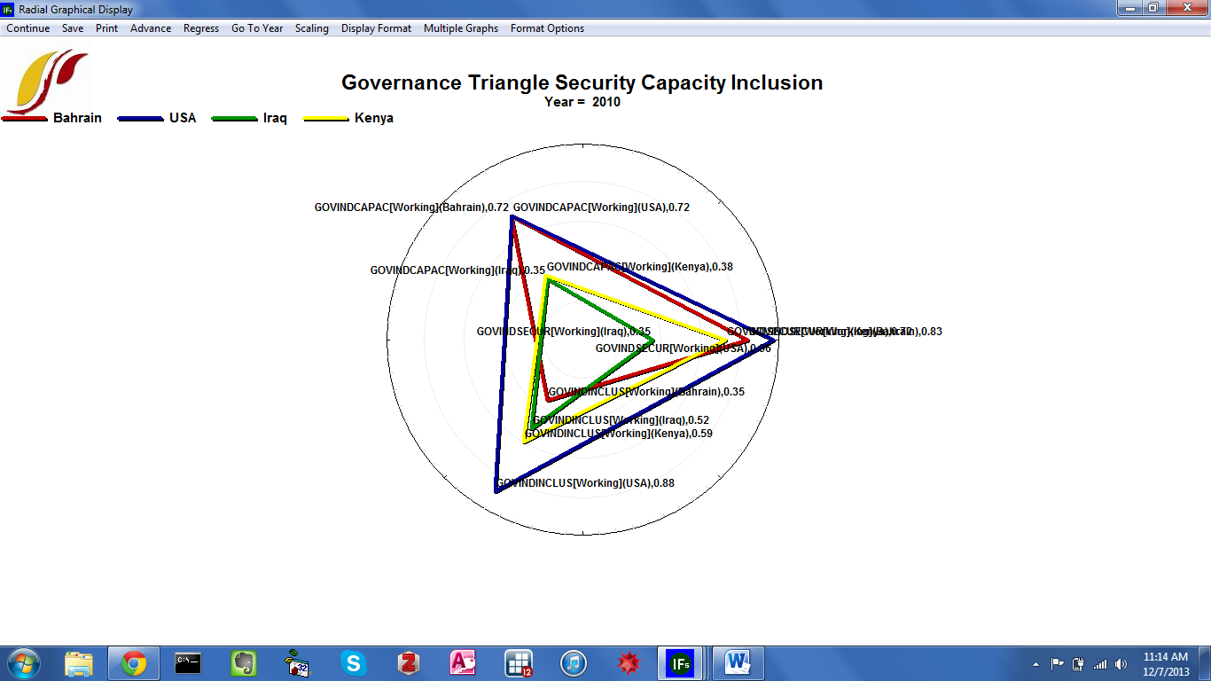
IFs Flexible Display: Radial Diagram

Each of the four countries is represented by a triangle, with vertices corresponding with security, capacity and inclusion. The farther from the center the vertex, the higher the associated governance score. It is clear from the radial diagram that, as would be expected, Bahrain, USA, Iraq and Kenya have different governance profiles. The highly developed USA exhibits high scores across the governance indices. Bahrain fares similarly well on capacity and security, but much lower on inclusion. Both Iraq and Kenya surpass Bahrain on the inclusion measure but struggle to attain capacity and security. Iraq fares particularly poorly on the security index. The single graph approach facilitates direct cross-country comparison. As the number of countries rises, however, the display becomes cluttered. Again select Multiple Graphs, and click display in different graphs to generate the graphic displayed below.

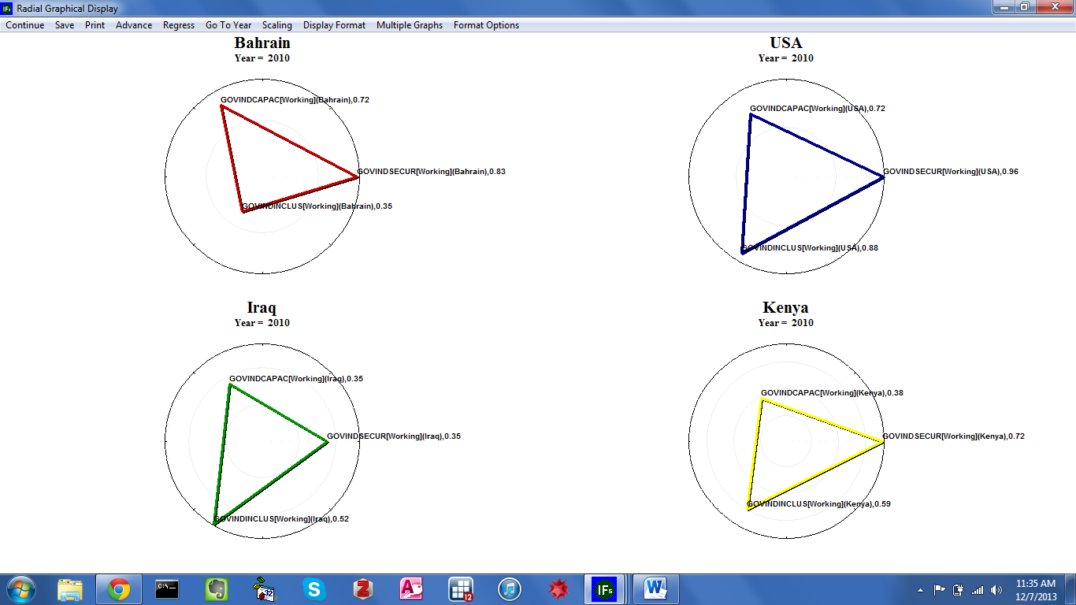
IFs Flexible Display: Radial Diagram, Multiple Graphs

Scatterplots
On the Flexible Displays Form, the second option under Other Graphs displays data as a scatterplot. As a demonstration, create a scatterplot of total fertility rates and GDP per capita. From the left-most box, select two categories, Economy GDP per Capita and Population. (After selecting the first category, hold down Ctrl while selecting the second.) Now the Display box will contain data series belonging to both categories. Select GDP Per Capita at PPP and Fertility Rates, and then, for the geographic dimension, select all countries. With Geography options set to Using Countries/Regions hold down the Shift key to highlight all 186 countries, or as a short cut, double click the Geography box’s title to highlight all countries. As an alternative, set Geography options to Decomposed Groups and select World. Without changing the default run file, Working File, click Other Graphs, and select Scatter Plot to produce the graph displayed below.

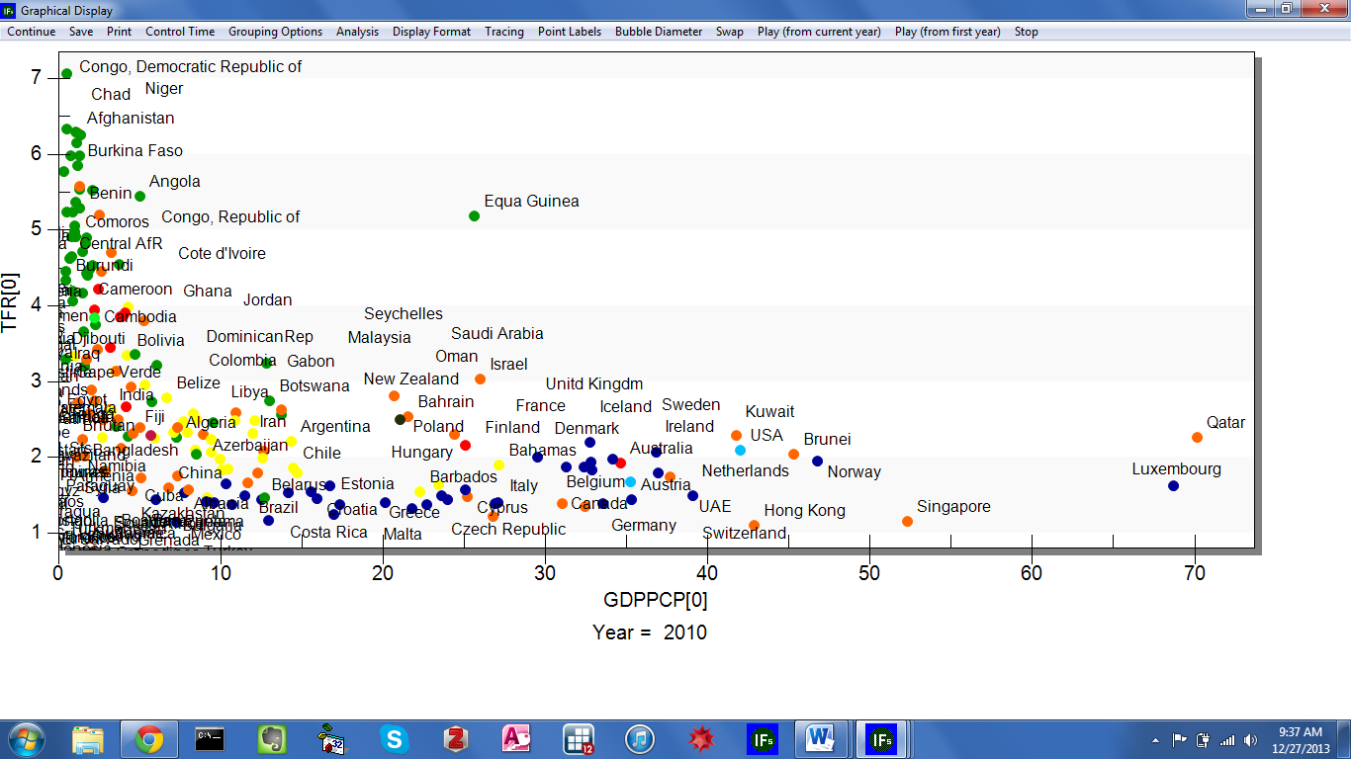
IFs Flexible Display: Scatterplot
Toolbar options allow users to customize graphical elements and play longitudinal movies: from the left, the first toolbar option, Continue, returns to the previous screen; the Save and Print toolbar options function identically to the corresponding options on line graphs and radial diagrams; Control Time allows users to advance through IFs forecast years. Advance and Regress move forward and backwards through time, at 5 year increments. And Go To Certain Year, displays data for any forecast year; Grouping options control levels of geographic aggregation; Analysis fits statistical relationships to the data, either linear, logarithmic, exponential, power, polynomial or logistic relationships; the next toolbar option, Display Format, includes customization option affecting titles, run horizon, legends, and the axes; Tracing, when activated, traces the path of each country during a longitudinal movie; the Points and Labels toolbar option allows users to hide data points or associated labels from the scatterplot; Bubble Diameter adds another data element to the display; Swap switches the x and y axes; and the final three toolbar options—Play (From Current Year), Play (From First Year), and Stop—control longitudinal movies. For further discussion of movie and bubble diameter features, and an accompanying demonstration, see the Data Analysis section.

Geographically-fixed Displays
The second option on the Display menu offers a pre-constructed set of graphics. Whereas Flexible Displays allow users to customize geographic representation, the geographically fixed displays are, as the name indicates, fixed. However, each item on the list of fixed displays tells a story of potential human development. The feature can serve as an initial, exploratory phase of forecast analysis. From the IFs home screen, click Display and then Geographically-fixed Displays to reach the form displayed below:

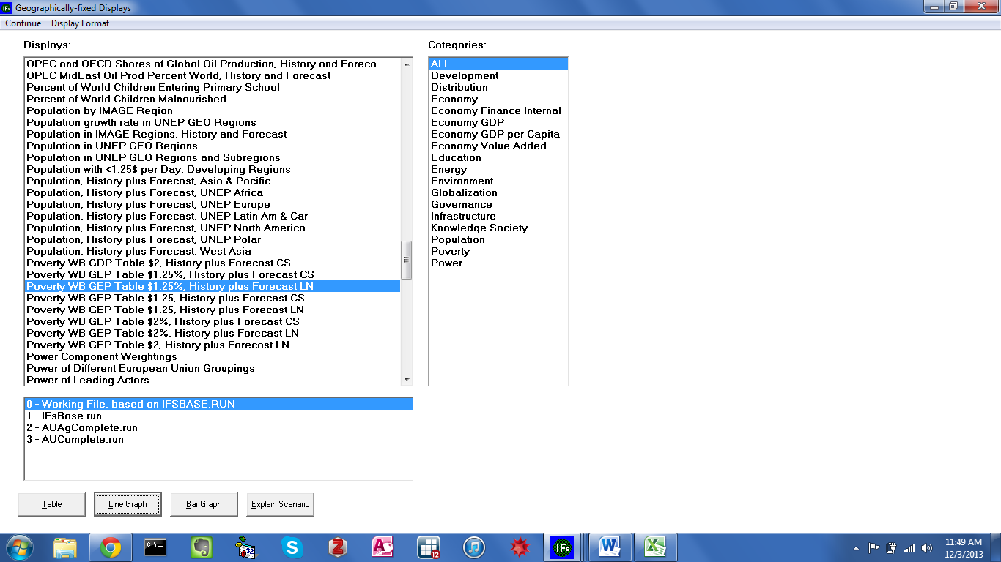
Geographically-Fixed Displays

Similar to Flexible Displays, the Geographically-fixed Displays form consists of several scroll boxes. Located on the right, the Categories box contains display groupings, by theme. By default the All category will be selected, so the Displays box to the left will contain all available pre-constructed displays. The box below Display designates the run file, from the Working File, IFsBase, and alternate scenarios. For any set of specifications, several command buttons along the bottom of the form generate tables, line graphs and bar graphs. Again, as on the Flexible Displays form, Display Format sub-options customize: titles, display intervals, the currency and time horizon.
As a demonstration, use geographically-fixed displays to explore poverty trends in South Asia. First select Poverty from the Categories box. The ensuing set of displays will include several formulations of poverty, plotted for a geographic list titled, WB GEP—the acronym stands for World Bank, Global Economic Prospects. For this example, select Poverty WB GEP Table $1.25%, History plus Forecast LN. Click Plot to generate the graph displayed below.

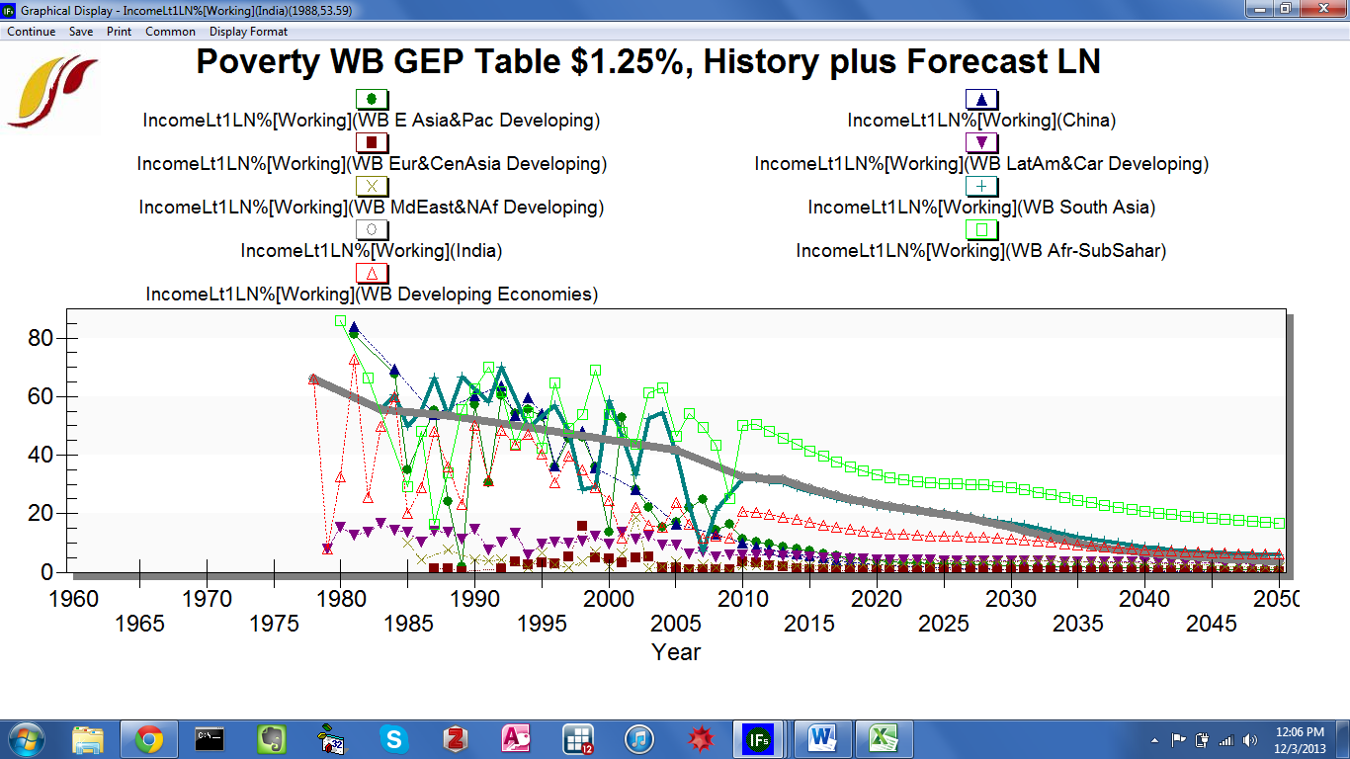
Geographically Fixed Displays, Poverty In World Bank Global Economic Prospects Regions

The line graph highlights the importance of India and China in the global drive to eradicate extreme poverty. Before the turn of the 21st century, more than 40 percent of the people living in the two countries subsisted on less than $1.25 per day. Recently, booming economic growth and industrialization have pushed poverty figures down in China. India, however, has continued to exhibit high levels of poverty. And according the IFs Base Case forecast, poverty rates in the country will decline gradually.

Basic Report For Countries/Regions
From the IFs home screen, the third menu sub-option under Display is Basic Report For Countries/Regions. This feature provides an overview of where a region is today, and where it appears to be heading. The report table contains important variables across all of the IFs modules. Open the Display menu and click Basic Report For Countries/Regions to reach the form displayed below.

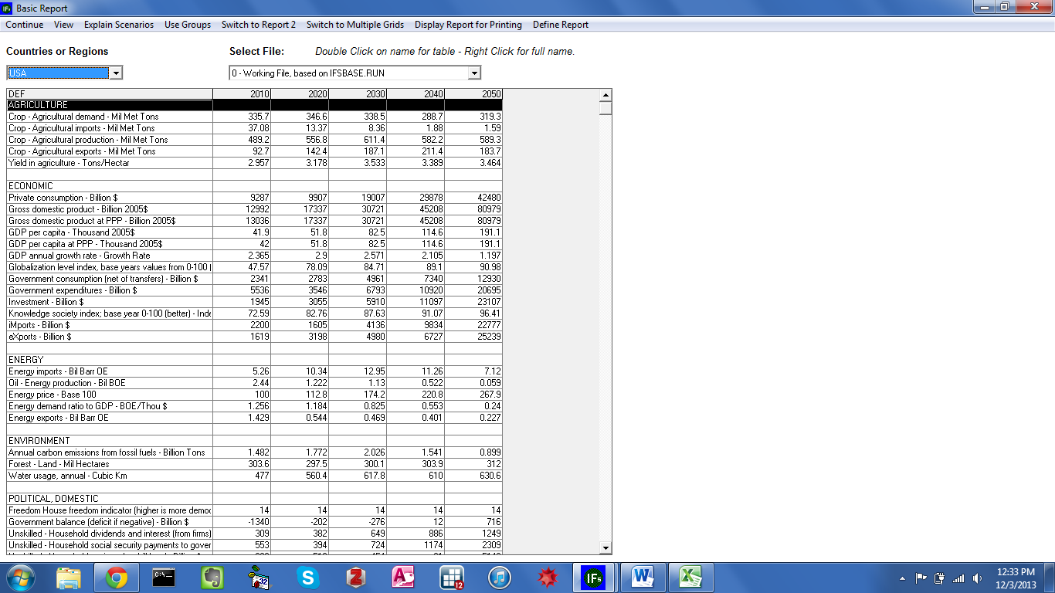
Basic Report for Countries/Regions

The basic report form contains a selection of development indicators across systems. The left-most column, titled DEF, lists variables, by category—Agriculture, Economic, Energy, Environment, Political, Population and Social. The five remaining columns hold a value for 2010, and forecast values for the years 2020, 2030, 2040 and 2050. Note that, for each variable, units are listed along with descriptions in the DEF column. (Because so many series are displayed side by side, it is important to keep units straight.) At the top of the form, input boxes control the active country or region, and run file.
As an illustration, generate a basic report for the South Asian country with the highest poverty headcount, India. By default, the Countries or Regions Box in the upper left-hand corner will contain the country last clicked on the world map—in this case, the United States. Click the down arrow, scroll to India and press the Enter key. Values in the table will change accordingly. On the Basic Report form, scroll down to the Population column. Here a selection of series gives an overview of potential future trends in births, deaths, life expectancy, total population and growth rates—see the figure displayed below. Beginning in 2010 at 1.225 billion people, the Indian population reaches over 1.6 billion by 2050 in the Base Case. The Population Growth Rate row indicates a steady decline in the percent growth in population. Interestingly however, the growth rate in urban population outstrips overall growth rates by roughly 1 percentage point throughout the time horizon.

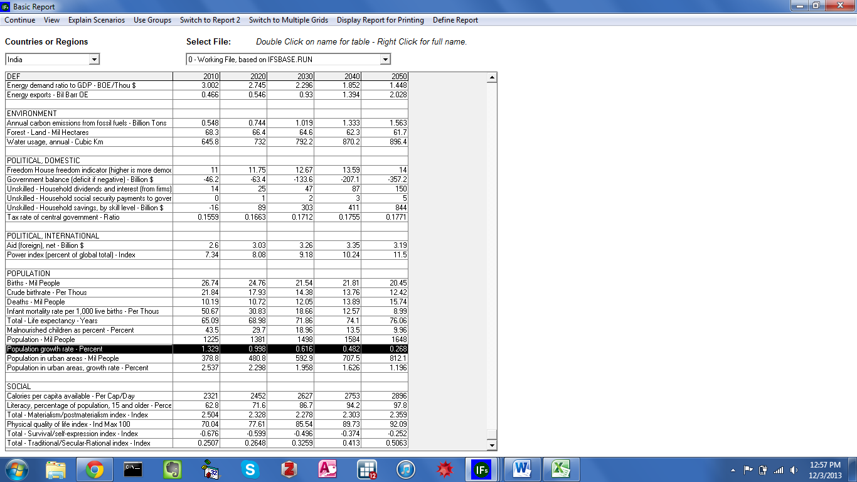
Basic Report for Countries/Regions: India

Specialized Displays
The fourth menu sub-option under Display is a list of specialized displays for issues analysis. This set of data visualization tools compliments the graphics and tables that are available through Flexible Display and Geographically-fixed Display, discussed above. From the IFs home screen, open the Display menu and select Display Specialized Displays For Issues. The subsequent list includes 22 displays, across several issue areas—see the graphic displayed below. Alternatively, users can access a truncated version of the specialized display list by clicking anywhere on the home world map image. This section will walk through several of these features, continuing the investigation of human development indicators in India. Several specialized displays are available that are not covered here, including: Birth Cohort Information, Costs of Education, Mortality and Disability, Country Profile, Infrastructure Profile, Social Accounting Matrix, World Bank Financial Flows, World Values Survey, and Advanced Sustainability Analysis. For a thorough explanation of these features, see the specialized display section of the IFs Help System, available at http://www.du.edu/ifs/help/use/display/specialized/index.html.
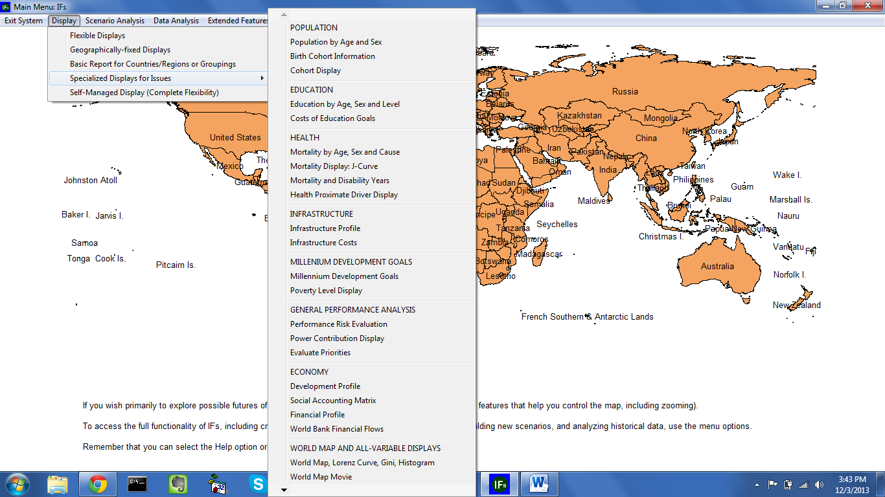
Specialized Displays For Issues

Specialized Displays: Population
The first thematic category on the dropdown menu is Population, which contains three specialized displays. First, Population by Age and Sex, a set of population distributions often used by demographers; second, Birth Cohort Information, a generational breakdown of regional populations; and third, a micro-level analysis of fertility patterns, Cohort Display. This manual will focus on the first feature. From the Specialized Displays For Issues sub-menu, click Population By Age and Sex to reach the form displayed below.

Specialized Population Displays: Age-Sex Distribution
The Specialized Display Population By Age and Sex is a set of several distributions. By default, the form will display population distributed by age, in the year 2010, for the country last selected on the world map—here, the United States. A set of horizontal bars—blue for males, green for females—signifies the size of 22 age cohorts, presented in ascending order along the left-hand side. Cohorts range from ages 0-4 to older than 100. And IFs forecasts are linked to the age distribution. Buttons along the toolbar control the flow of time: Advance moves 5 years forward in time, up to the year 2100, and Regress moves 5 years backwards in time. Under the first toolbar option, Distribution Type, users can choose to organize the specialized display into a population pyramid, or through the fertility distribution and mortality distribution features, explore drivers of population change. For any of the four display types, additional features allow users to print the graphic, save to a file or the clipboard, and customize display elements.
As a demonstration of the specialized population display functionality, explore various distributions of India’s population. From the initial Age Distribution form, click Change Display along the toolbar, and select Change Country/Region. A scroll box containing all 186 IFs countries will appear on the right of the form. Select India, and the population graphic will change accordingly. The length of the bars will remain roughly constant, but note the new horizontal axis: whereas in the United States the highest value is 14 million, the highest value for India is 50 million. Aside from an increase in total population, the Indian graphic tells an interesting story about gender. All age cohorts below 60-64 exhibit a pronounced imbalance between males and females. In order to quantify the overrepresentation of males, click the toolbar option Show Numbers. A table will appear on the right side of the form. Younger cohorts, beginning with 0-4 and on through 45-49, include 5 to 6 million more Indian males than females.

To further explore nuances of the Indian population chose an alternative distribution type. From the Age Sex form, with India highlighted, select click Distribution Type and then Population Pyramid to generate the graph displayed below.
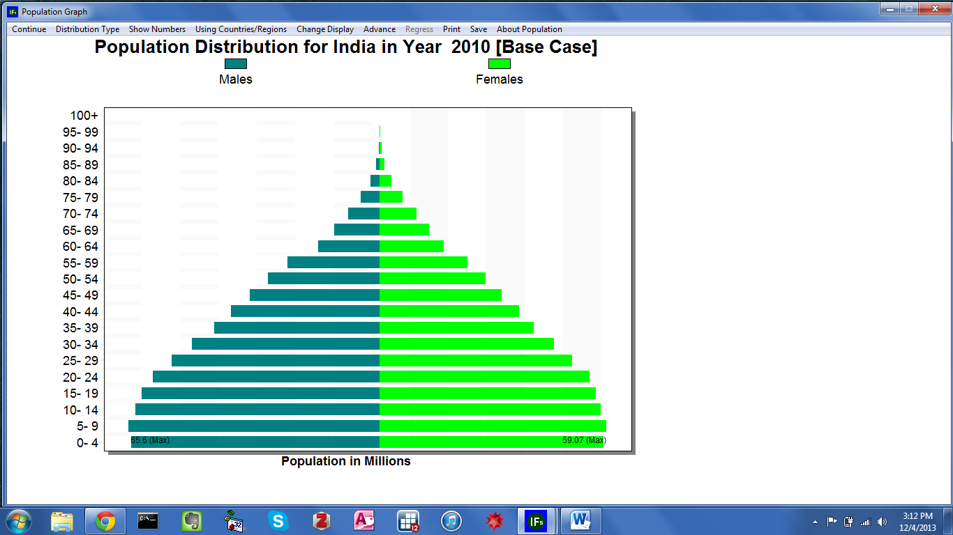
Specialized Population Displays: Population Pyramid
The population pyramid display facilitates comparison between genders and age cohorts. In the Indian case, as discussed above, males outnumber females. And, the younger cohorts—0-4 through 20-24—are significantly larger than the other, older cohorts. This phenomenon is often referred to as a youth bulge. A large population entering their working years can be a boom to economic growth or a source of social tension, depending on labor market performance. How long is India’s youth bulge likely to persist? From the toolbar, click the Advance button 8 times, to reach the year 2050—see the graph displayed below. By mid-century the population bulge has shifted upwards; the populous youth cohort is now entering middle age. The new population pyramid shape indicates that, throughout their lives, the younger generations have had fewer children than their predecessors.
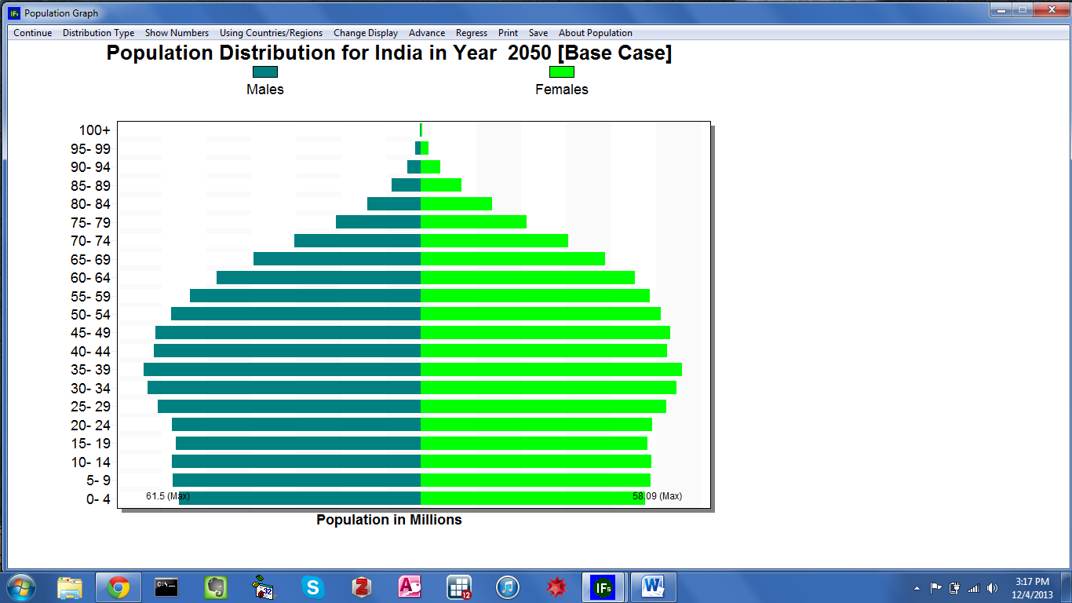
Specialized Population Displays: Population Pyramid

The two remaining distribution types—Fertility Distribution and Mortality Distribution—capture drivers of population: births and deaths. Keeping India as the active country, click Distribution type from the dropdown menu, and select Fertility Distribution. Represented by horizontal bars, the ensuing form captures the annual births per 1000 women by age cohort. As would be expected, the majority of babies are born to mothers in there 20’s, and very women over the age of 45 give birth. Analysis of the population pyramid suggested a decline in Indian fertility rates over time. To validate this impression, click Show Numbers for 2010 and view birth figures for cohorts 15-19 through 30-34. Then, from the toolbar click Change Display, and select Set Year. In the ensuing dialogue box, enter 2050. Now, display fertility numbers in a table, and compare results against the 2010 figures—see the graph displayed below.

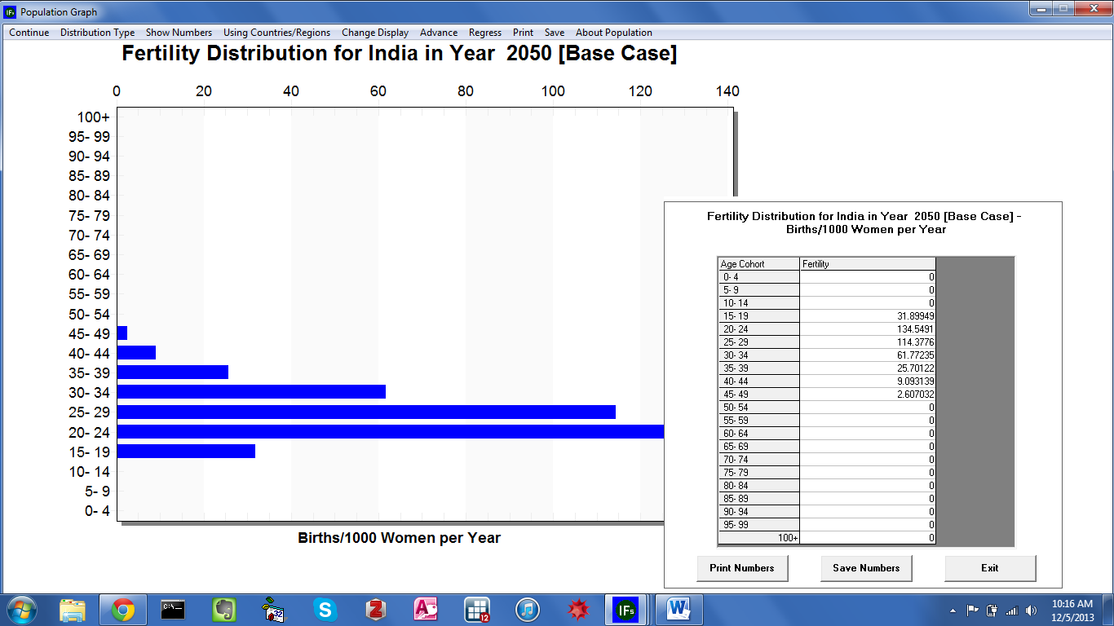
Specialized Population Displays: Fertility Distribution

Specialized Displays: Education Cohorts

On the Specialized Displays For Issues drop-down menu, the second thematic category, Education, includes a pair of features: Education By Age Sex and Level, and Cost of Education. This specialized display adds another layer—educational attainment—to the age cohort features of the population pyramid. From the Specialized Displays sub-menu, click Education By Age, Sex and Level to reach the form displayed below.

Specialized Population Education By Age-Sex Cohort

The Education by Age, Sex and Level form is a modified version of the population pyramid. Again, horizontal bars represent millions of men and women in 22 age cohorts, appearing in ascending order along the left side. On each bar, color-coding indicates the highest level of completed education: grey for children too young to attend school; red for less than primary education; green for primary education; yellow for secondary education; and, finally, blue for completed tertiary education. (Note that IFs captures educational system information for each country—e.g., the grades that constituent primary education are not the same in China and South Africa.) With the exception of Distribution Type, the toolbar options are identical to those on the population pyramid display. Users can generate a table, customize display elements, change countries or groups, advance and regress time, print the graphic, or save the graphic to a file. However, nine unique displays are located under Distribution Type. By default, the first, All Levels of Education All Age Cohorts, will occupy the form. The next four displays provide graphical representations of individuals who have completed less than primary education, primary or more, secondary or more, and tertiary education. Users can utilize these forms to produce a demographic profile of, say, tertiary graduates in a country or geographic region of interest. The sixth, seventh and eighth menu sub-options each focus on a subset of the education pyramid, levels of education attainment held by people in their working years, age 15 to age 69. And the final option, Comparative Display, produces several pyramids on a single form.

As an illustration, explore future educational attainment patterns for India. On the Education by Age, Sex and Level form, click Change Display, and select Change Country/Region. A scroll box will appear on the right side of the form. Select India, and the education pyramid will change accordingly. Perhaps the most striking element of the graphic is an educational gap between men and women. From age cohort 15-19 onwards, a greater number of women have attained no education or less than primary, as signified by red coloring. Next, click Distribution type from the toolbar, and select the last option, Compare Countries, to generate the graph displayed below. Despite its name, this display facilitates either cross-country comparison, or comparison across time in a single country. Scroll through and select India in each of the four input boxes. Set the first year dimension to 2010, the second, to 2015, the third to 2020, and the fourth to 2040.

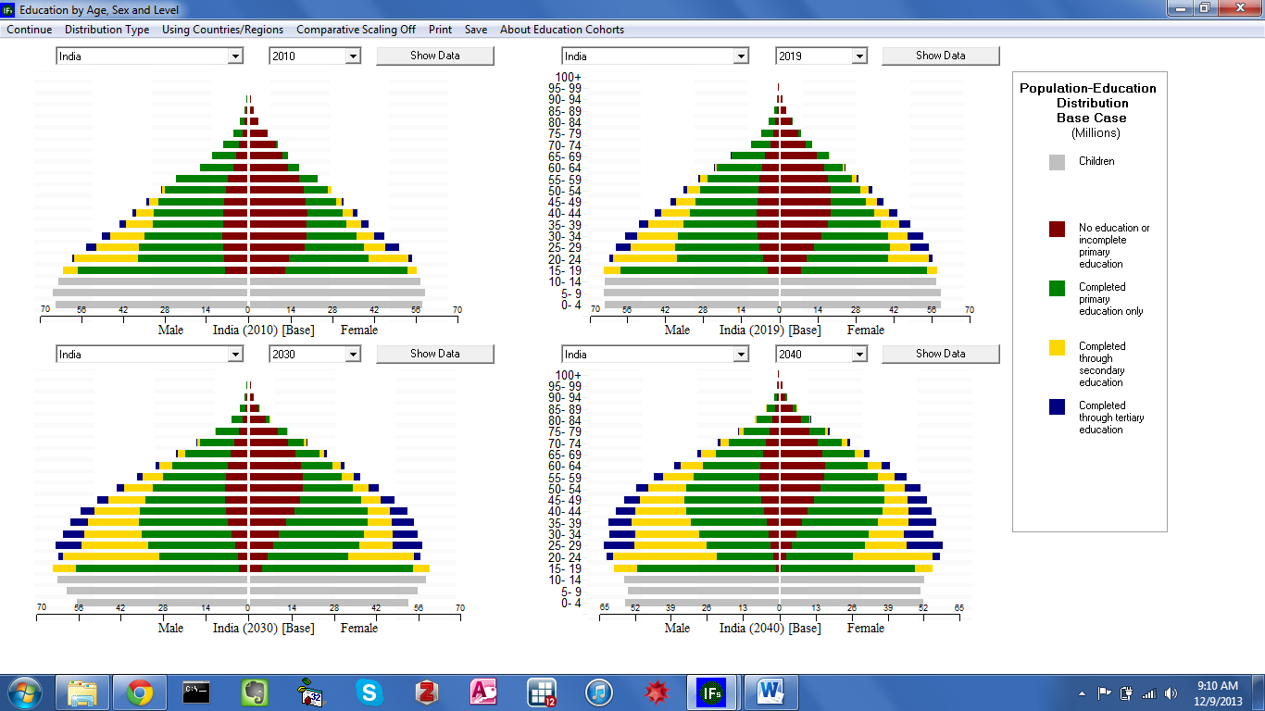

Specialized Display Population Education By Age-Sex Cohorts

The four snapshots of Indian educational attainment, taken at ten year intervals, tell several stories. First—as discussed in the previous section—the India of 2010 features a large youth bulge. As the decades roll by, and fertility rates decline, the bulge moves up the demographic pyramid. Secondly, according to IFs Base Case forecasts, the gender gap in attainment narrows over time. By 2040, college-aged people, those aged 17-24, have nearly attained gender parity, at least in terms of individuals will less than primary attainment.

Specialized Displays: Health

On the Specialized Displays For Issues drop down menu, the third thematic category, Health, includes four features: Mortality By Age Sex and Cause, a distribution of deaths; Mortality Display, an alternate death distribution; J-Curve; Mortality and Disability Years; and Health Proximate Driver Display. From the drop-down menu under Health, select the first option to reach the form displayed below.

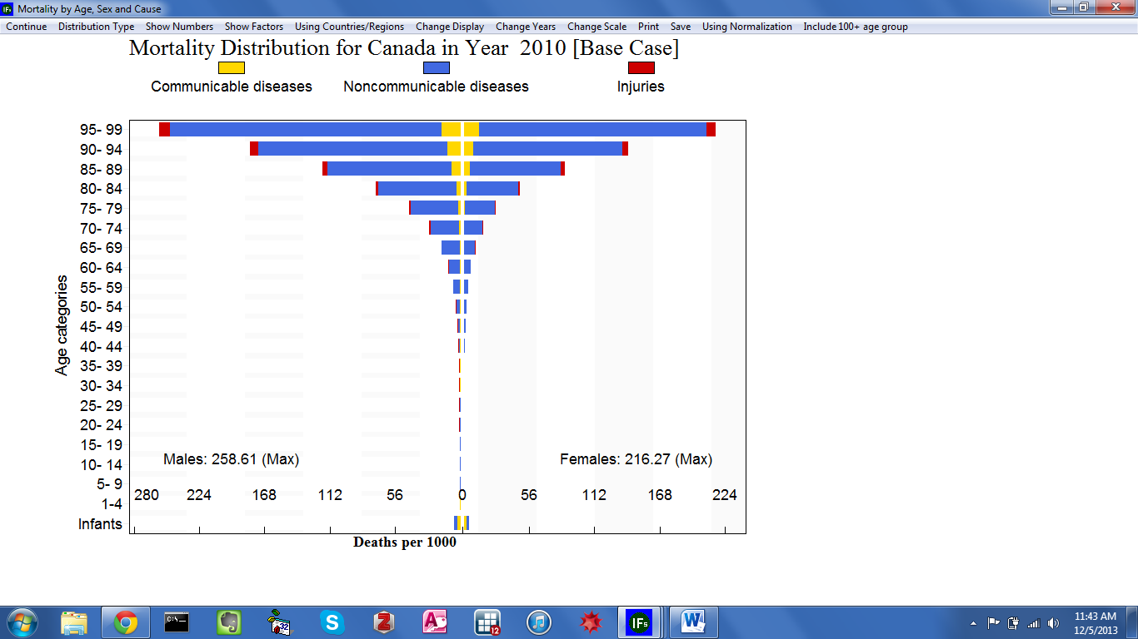
Specialized Display: Mortality Distribution By Age and Sex

The mortality distribution displays death rates by age group, across three broad categories, and both genders. 21 age cohorts appear along the left side of the form, in ascending order, from infants through 95-99. For each cohort, a horizontal bar indicates number of deaths per 1000 people—also referred to as crude death rate. Across horizontal bars, yellow corresponds to death by communicable diseases, blue to death by non-communicable diseases and red to deaths caused by injuries. Options along the toolbar are similar to those featured on the population and education distributions—discussed above. Users can generate a tabular data display, customize display elements, change geographic representation, progress through forecast years, print the graphic, or save the graphic to a separate file. However, several additional tools are unique to the health distribution form. The option Show Factors, allows users to view the composite parts of the three mortality categories. Change Scale allows users to fix the scale, located at the bottom of the form. The Using Normalization switch, when activated, adjusts the sum of the deaths to match death figures produced in the IFs population module. And, a final option, Include 100+ Age Group, as the name indicates, adds a group at the top of the cohort list. Again like the distributional displays for population and education, the specialized health form contains several displays, located under the Distribution Type option. By default the graph will depict the first option, All Types of Mortality. The next three types are subsets of the full mortality distribution, highlighting death rates by communicable disease, non-communicable disease and injuries. Users may be particularly interested in the fifth, sixth and seventh display options; they produce a mortality distribution for each broad category, disaggregated by specific cause of death. The final option, Compare Countries, facilitates either cross-country, or longitudinal comparison across time, within a single country.

As a continuation of the demonstration running through this section, create several mortality graphs for the country of India. From the Mortality by Age, Sex and Cause form click Change Display and select Change Country/Region. From the ensuing scroll box select India, and the distribution will change accordingly. The graph indicates that, across Indian cohorts, people are dying from communicable disease, non-communicable disease and, to a lesser extent, injuries. But looking at a single country in isolation can be misleading. Is India’s mortality distribution typical? Is the scale of crude death rates high or low? Compared to what baseline? In order to put the data in perspective, create a comparative display. From the toolbar, click Distribution Type and select the last option, Compare Countries. From the first input box—located in the upper left-hand corner—select India. For the second and third displays select two highly developed countries, the United States and Canada. And for the final display select China, a fellow BRIC country. Set the four year dimensions to 2010—see the graphic displayed below.

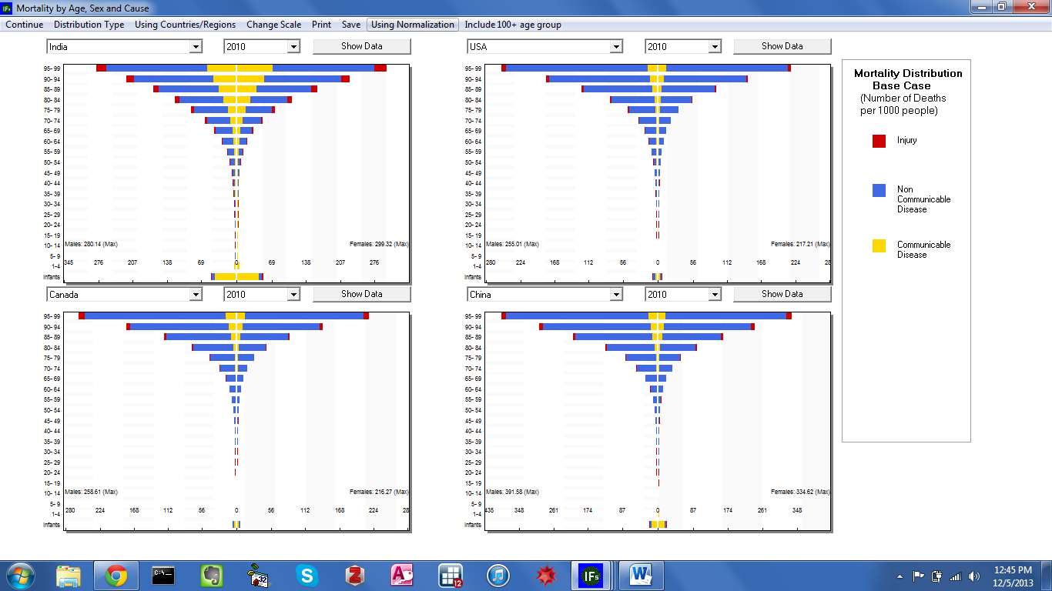
Specialized Display: Mortality Distribution By Age and Sex: India, China, USA, Canada

Several points of interest stand out on the comparative mortality display. The three additional country distributions provide a benchmark for the Indian case. Understandably, it appears that, compared to highly developed countries, India’s crude death rates are high. Compared with China, however, India’s rates are lower, with the exception of the Infant age group. And secondly, the number of deaths in India attributed to communicable disease appears high, even compared to a fellow BRIC. This initial analysis suggests questions for further research. What communicable diseases account for the high mortality rate, across the general population, and especially among infants?

Specialized Displays: Millennium Development Goals

On the Specialized Displays for Issues menu, the fifth thematic category is Millennium Development Goal (MDG) Display. This category helps users explore the uncertainty around the Millennium Development Goals, through two distinct features: Millennium Development Goals and Poverty Level Display. Initially, the first feature, the MDG display screen, displays the first MDG goal: reducing poverty to half of its 1990 value, by the year 2015. Vertical bars represent the percentage of the population living in extreme poverty for each year. (If a bar is missing, data for the corresponding year are not available.) Three trend lines are imposed atop the bar graph. First, a red line represents the country or group’s historical trajectory. Connected to the end of this line, a purple line plots future trends, according to the IFs Base Case scenario. Third, and cutting across history and forecast years, the green trend line represents the path necessary to accomplish the MDG target. Input boxes along the top of the form control the active goal, target, indicator, and geographic dimension. And options along the toolbar facilitate further customization and comparative analysis.
As discussed previously, South Asia is home to the largest number of extremely poor people in the world today, a distinction that will persist into the future. As a demonstration, examine the region’s progress towards the first MDG target. From the toolbar, click Use Groups to toggle the available geographic representations. Open the scroll box, located in the upper-right-hand corner of the form, and select South Asia. The bar graph will change accordingly—see the graph displayed below. Historical data shows that despite a steady decline in poverty rates, the region is not on track to reduce poverty by half by 2015. Furthermore, the goal will remain out of reach until around the year 2020, according to the Base Case trends line. To identify the exact year in which, at the current pace, South Asia will achieve MDG goal 1, create a table. In the area labelled Display, activate the Data radio button. The ensuing table includes rows for historical and future trends as well as the MDG trend. Highlight the MDG Estimates Column, and scroll down to the year 2015; this value would satisfy MDG target 1. Now, search the IFs Working column to locate the target value. Another important take-away from that graph is a lack of data availability more recent than 2005. The region has exhibited progress toward meeting the goal of halving their 1990 poverty level by 2015, but more remains to be done.

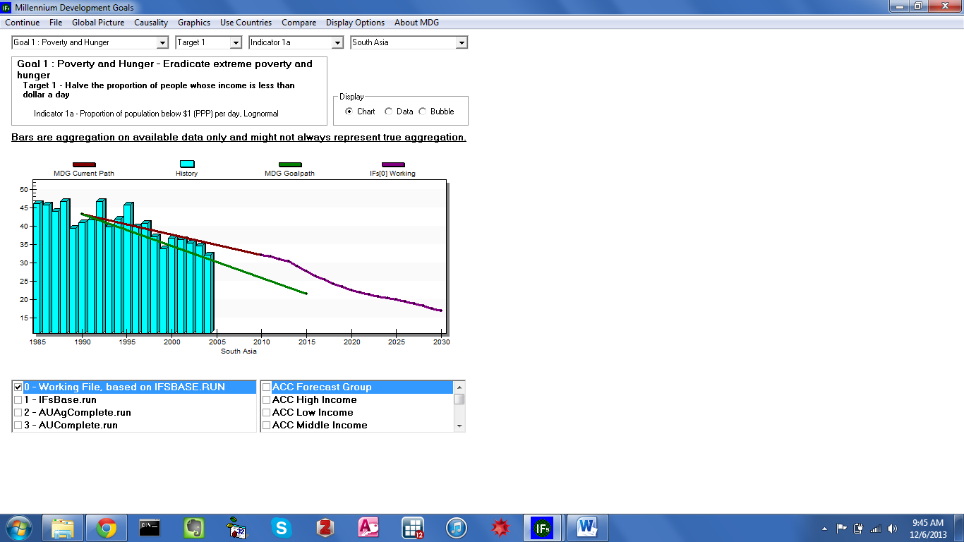
Millennium Development Goal Display: Poverty in South Asia

Specialized Displays: Performance Risk Evaluation
On the Specialized Displays for Issues menu, the fifth thematic category, General Performance Analysis, includes 3 features: Performance Risk Analysis, an investigation of specific points of instability for each country or region; Power Contribution Display, a nuanced look at quantifying material power; and a guided scenario creation resource, titled Evaluate Priorities. This section will focus on the first option only. On the IFs home screen, select Display, the specialized issues sub-menu option, and then Performance Risk Evaluation to reach the form displayed below.

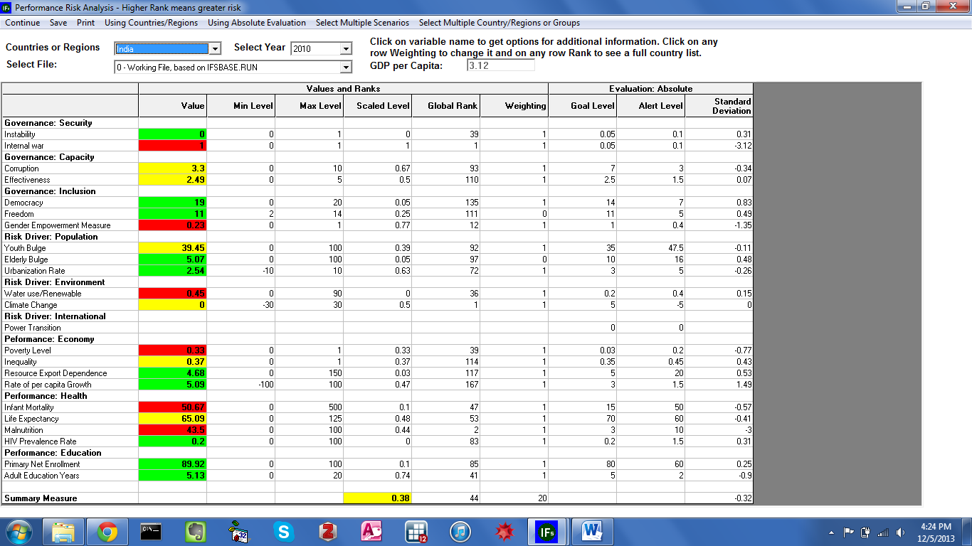
Performance Risk Analysis Goals Specialized Display in IFs
For IFs countries and regions, the form evaluates performance across the following categories: Governance Security, Governance Capacity, Governance Inclusion, Population, Environment, International, Economy, Health and Education. And each category is comprised of subcomponents, displayed in the first column. For example, population performance consists of two age-related indicators, Youth Bulge and Elderly Bulge, as well as Urbanization Rate. Cells in the second column contain the value for the associated indicator, along with color-coding. Neighboring columns provide a benchmark for comparison. Min Level and Max level contain the highest and lowest values exhibited by any country. And Global Rank contains ordinal rankings for the active country or region. Proceeding from the left, the seventh column, Goal Level, contains a target value that, for each indicator, represents good performance. If the observed value meets or surpasses the goal, the color-coding will be green. If the value falls slightly short of the goal, the coding will be yellow. And if the value is far short of the goal, coloring will be red, indicating a risk alert. Three scroll boxes along the top of the form allow users to specify the active country or region, year and run file. Additional features located along the toolbar save or print the graphic, toggle between countries and groups, and facilitate comparison by country and by scenario.
As an illustration, produce a risk analysis form for the largest country in South Asia, India. Open the Countries or Regions scroll box, select India, and the table will change accordingly. The color coding system provides an immediate sense of potential sources of risk. Of the 23 performance indicators, six are highlighted in red, signifying an alert: internal war, gender empowerment level, water use, poverty level, infant mortality and malnutrition. Now, open the Select Year scroll box and chose 2050. Forty years on, only four indicators are flagged as alerts. India still faces risk from internal war, gender empowerment and water use. However, a new source of instability has arisen: climate change. In 2010, Indian challenges cut across subsystems. Over a longer time horizon, however, policy makers may want to focus on gender empowerment and water conservation efforts.

Specialized Displays: Development Profile
On the Specialized Displays for Issues menu, the seventh thematic category, Economy, includes four features: Development Profile, a deconstructed analysis of economic growth; Social Accounting Matrix; Financial Profile, a breakdown of internal and externally held public debt and trade balances; and World Bank Financial Flows. This section will focus on the first option. From the IFs home screen, open the specialized display menu and select, Development Profile.
The Development Profile decomposes economic growth into four categories: Human Capital, Social Capital, Physical Capital and Knowledge. The first column on the form lists the components that make up each category. For each indicator, the second column includes the computed value, for the active geographic region, year and run file—as specified by the scroll boxes located along the top of the form. From the left, cells in the second column contain the expected value of each indicator, given the region’s GDP Per Capita at Purchasing Power Parity (PPP). And, the fifth column indicates the contribution to annual growth (percent)—note that the figures are a percent of over overall GDP.
As an illustration, identify lags and contributing factors to Indian GDP growth. Open the Countries or Regions scroll box and select India to generate the table displayed below.

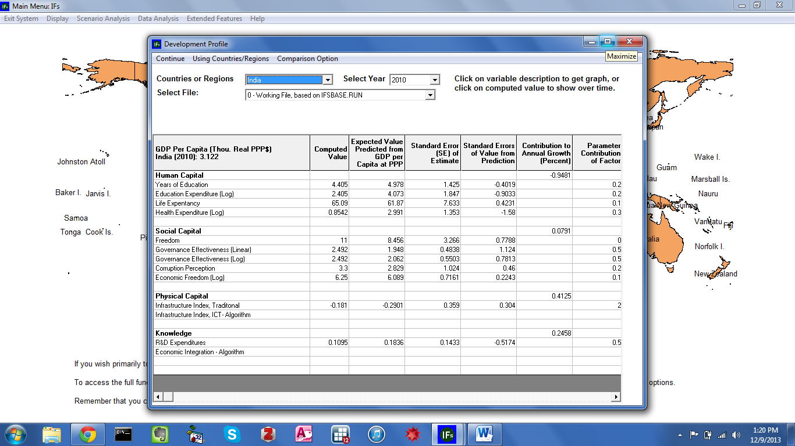
Specialized Display: Development Profile
The Contribution to Annual Growth (Percent) column provides insight into Indian economic performance. The first category, Human Capital, receives a value of -.094, indicating a drag on growth of nearly 1 percent of GDP. Consulting the first three columns, in India, educational attainment, spending on education and spending on health are lower than expected, creating a lag on growth. However, the country’s life expectancy value is higher than would be expected. The three other categories—Social Capital, Physical Capital and Knowledge—contribute positively to growth. Across Social Capital components, India’s computed value exceeds the expected for freedom, government effectiveness, corruption and economic freedom, culminating in an annual growth boost of .079 percent. Similarly, India’s score on Infrastructure Index, Traditional contributes nearly half of a percent to economic growth. And spending on research and development, the subcomponent of Knowledge, contributes nearly a quarter of a percent to growth. For a discussion on growth accounting, and the IFs economic model in general, see the standalone economic module documentation.

Specialized Displays: Informal Economy
In the Specialized Displays for Issues drop-down menu from Display on the Main Menu, the seventh thematic category, Economy, includes multiple features, including: Development Profile, a deconstructed analysis of economic growth; Growth Accounting, a decomposition of economic growth into its major categories; Social Accounting Matrix; Financial Profile, a breakdown of internal and externally held public debt and trade balances; Agriculture Focused Analysis; Cyber Opportunity and Risk; Informal Economy, a representation of informal labor and GDP shares with an option to change those shares and take them directly to a scenario run; and World Bank Financial Flows. This section will focus on the informal economy. From the IFs home screen, open the Display/Specialized Displays for Issues menu option and select Informal Economy (the Informal Economy display includes all shadow economy related functions as well).
The informal economy specialized form has two major functionalities. The first allows the user to display the key variables related to informal economy. Central to these are the informal share of the labor force and the informal share of the economy. Additionally the form shows the key drivers of the informal labor force share, including the government business index, and the key forward linkage variables, including both total factor productivity and various taxes. As usual, the user can select and display these options for any country/region or grouping of countries and for any scenario set desired,
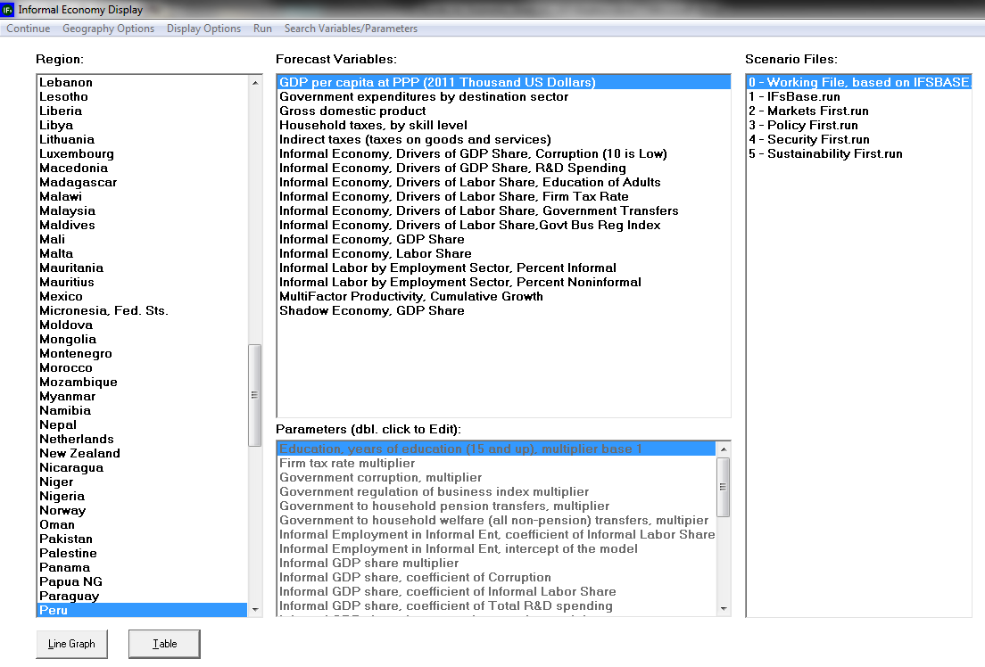
The second functionality, turned on by Display Options/Use Parameters allows the user to double click on the parameter name of any parameter related to informality and thereby to call up another form that allows customized change of the parameter (see scenario analysis for more detail on that customized form, but see also the example form for the firm tax rate multiplier, below). This ability to go directly to scenario analysis for a particular aspect of the model is unique to the informal economy sub-model of the economic model and a couple other specialized displays. Once parameter changes are made, the user can save and exit back to the Informal Economy Display form and, if desired, change other parameters. When finished with parameter changes, the user can proceed to run the scenario with the menu option from the Informal Economy form (if the user Continues out of the Informal Economy Display to the Main Menu and selects Scenario Analysis/Quick Scenario Analysis with Tree, it is also possible to use the Scenario Files/Name and Save option to save interventions).

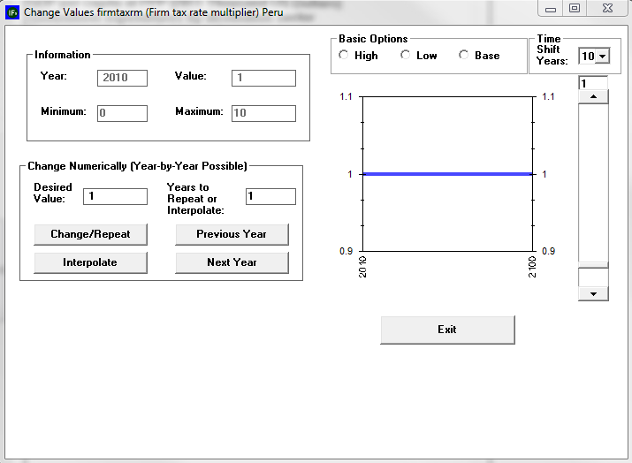
As an example exercise, try selecting the informal labor share multiplier with a double-click, changing its value to Low, and then running the scenario for 20 years. Then explore the impact of your scenario intervention on the following variables: Informal Employment Share of Total, Non-Agricultural; Informal Economy Share of Total; GDP per capita at PPP.

Specialized Displays: Agriculture Focused Analysis

The Agriculture Focused Analysis Form within IFs is designed to allow users to easily view historical trends in agricultural data, view base case forecasts across a variety of variables, and to produce future forecast scenarios for different potential paths of agricultural development. The form can be accessed through the main menu from the following path: Display>Specialized Display for Issues>Agriculture Focused Analysis (under the ECONOMY heading).
Form Layout
Upon entering the Form, the user will see a Main Screen with four fields, a set of Menu Options above, and a set of Buttons below.
Main Screen
The main screen contains four fields, as described below:
- Field 1: Far left of the form. This contains the country or region list that users have selected from the Geography Options menu option.
- Field 2: Top middle of the form. This contains either Historical Data series or Forecast Variables, depending on which sub-options a user has selected from the Display Options menu option at the top.
- Field 3: In the bottom middle of the form. This field allows users to access parameters in order to conduct scenario analysis. Unless users select the Use Parameters sub-option from Display Options at the top of the form, these are not accessible.
- Field 4: Far right of the form. When users are exploring Historical Data, this field determines which source(s) to use to fill the list of Historical Data series shown in Field 2. Currently, there are two sources and the user can select one or both of these. When users are exploring Scenarios, this field determines for which scenarios the Forecasted Variables should be shown. Users may choose one or more scenarios at a time.
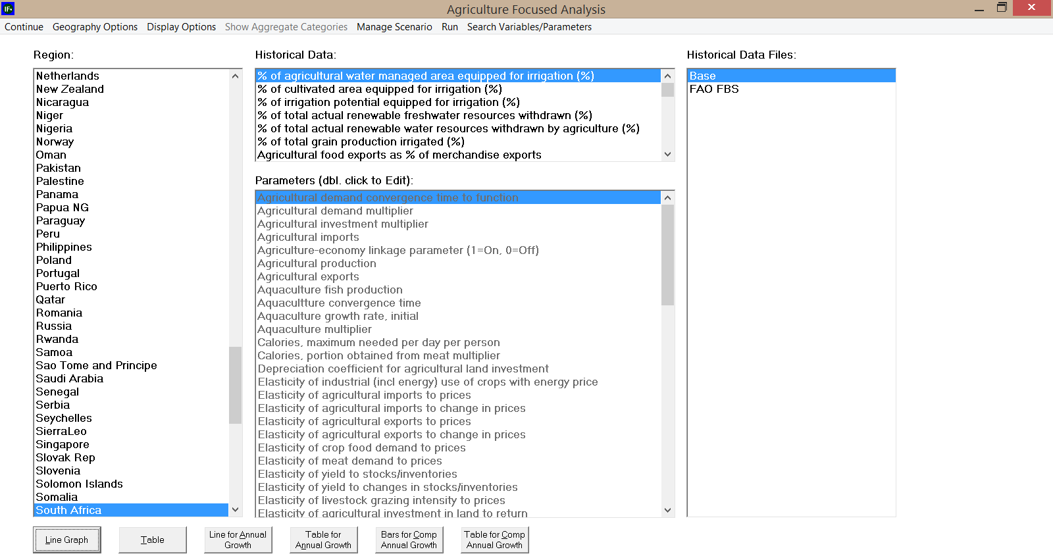
1
2
3
4
Main Menu Options
Menu Options are listed at the top of the form and include the following:
Continue: Returns users to the main screen of IFs.
Geography Options: Allows users to change the geographic options on the form. Users can select from countries, regions, disaggregated regions, and geography lists. Changing these options alters what options are visible in Field 1.
Display Options: Allows users to change the focus of the form display and alter the time frame displayed. The first menu option allows users to access parameters (Field 3 in the bottom middle of the form) from either the historical display mode or the forecast display mode selected in Menu option 2. The second menu option allows users to transition between viewing forecast variables and viewing historical data series in Field 2 (top middle of the form).
The third menu option will change the break year for historical analysis and the calculation of annual and compound growth rates. It has no effect when users are looking at forecast variables. The fourth menu option changes the year in which analysis starts when calculating annual and compound growth rates. It has no effect when users are looking at forecast variables.
Show Aggregate Categories: This menu option is only active when displaying historical data series from the Food and Agricultural Organization's (FAO's) Food Balance Sheets (FBS). Clicking this option filters the data set to display only aggregated FAO product categories.
Manage Scenario: This menu option saves scenario files and resets the working file after running a scenario.
Run: This menu option will run scenarios built in the form.
Search Variables/Parameters: This menu option searches for particular data series, variables, or parameters by name or description. It only searches on the lists that are active in Fields 2 or 3.
Buttons
The buttons at the bottom of the form allow you to access different data display and analysis options for the country/region and series selected above. These include producing line graphs and tables of the data, line graphs and tables for annual growth rates, and bar graphs and tables for compound annual growth rates. The compound annual growth rates can only be shown for Historical Data and show values for two historical periods up to the date of the most recently available data. The start and break years for the calculations of the compound annual growth rates can be changed using the Set Start Year and Change Break Year options in the Display Options list.
Using the Form
For Historical Analysis:
In order to use the Agriculture Focused Analysis form to explore past trends in the data, open the form from the Main Menu's Display>Specialized Displays for Issue sub-option. Then select Use Historical Data from the Display Options list, and choose the data file you wish to access from the field on the far right of the Main Screen (Field 4). The Base data file contains the basic agricultural variables of the IFs system, taken mostly from FAO data. The FAO FBS data file is a very large and specialized file, consisting primarily of FAO data from its Food Balance Sheets. You can then select which specific historical series and countries to view in Field 1 (far left) and Field 2 (top middle). Finally, use the buttons at the bottom of the form to display the data in the form you wish.
As an example exercise, try bringing up a line graph for annual Cocoa Bean production for Africa as a whole from the FAO FBS (Food Balance Sheet).

For Scenario Analysis:
Viewing Forecast Variables
To switch to viewing forecast variables for any of the built scenarios, select the Use Forecast Variables sub-option in the Display Options list. This will alter the information displayed in the top middle field (Field 2) to display forecast variables. The far right field (Field 4) will also change to show several prebuilt scenarios which can be visualized. In Scenario Analysis mode, the form will not calculate compound growth rates.
As an example exercise, try bringing up a table for annual Yield in South Africa as a whole for the IFsBase scenario.
Creating New Scenarios
To build scenarios using this form, activate the parameters in Field 3 (bottom middle field) from the Display Options list in the Main Menu. Select the country or region you wish to make a change to in Field 1 (far left field) and double click on the parameter you wish to change. A form like the one below will appear. Make whatever changes are desired and click the exit button to return to the main screen. To run the scenario, hit the Run button at the top of the form. IFs will then process your parameter changes and ask you for the year to which the model should run the scenario. Select the year and hit Start Run. When the model has completed the scenario run, hit the Run Successful – Click to Continue button to return to the main form. You can view the results of your scenario by selecting 0 – Working File, based on IFSBASE.RUN in Field 4.
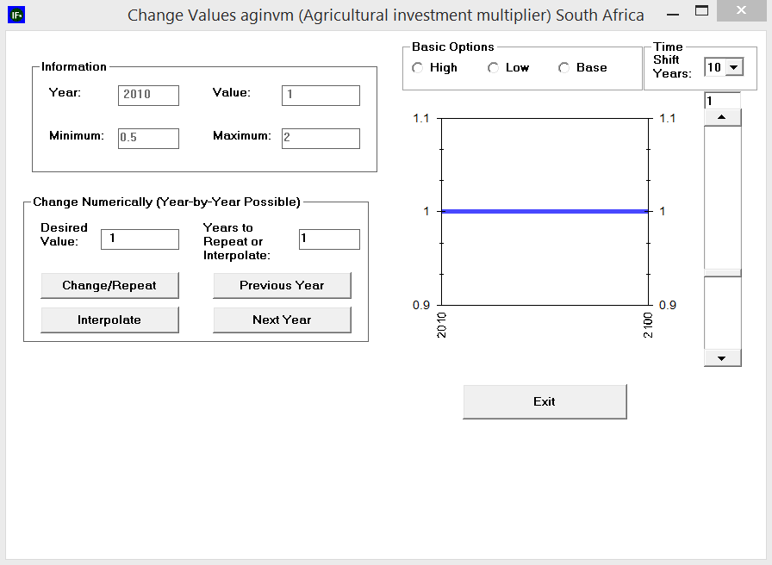

As a test, try to create a scenario which increases agricultural investment for all ECOWAS countries to high and run the scenario to 2030. Then compare the values of the Forecast Variable (K)capital in agriculture (not including land) for this scenario and the IFsBase scenario.

Self-Managed Display (Complete Flexibility)
From the IFs home screen, the fifth and final option under Display is Self-Managed Display (Complete Flexibility). This feature represents the height of IFs functionality, containing all variables, parameters, displays and run files; it provides maximum flexibility in accessing and visualizing historical data or forecasts. However, increased functionality comes at the expense of increased complexity, so users are encouraged to consult the Self-Managed Display section in IFs Help—located in the IFs Help System at the path: > Display> Self-Managed Display, available at http://www.du.edu/ifs/help/use/display/selfmanaged/index.html. Open the Display menu, and chose the Self-Managed Display (Complete Flexibility) option to reach the form displayed below.

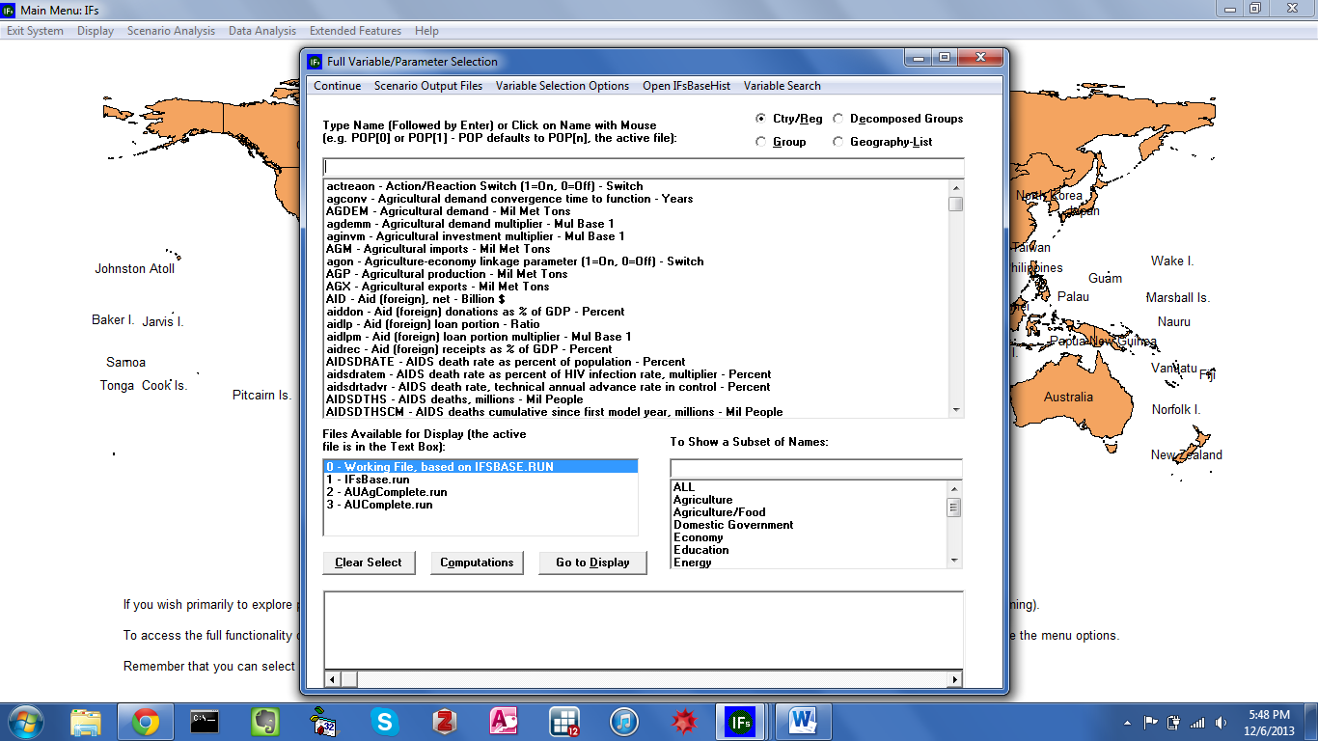
Self-Managed Display: Select Names
The core of Self-Managed Display is a form titled Full Set of Variables/Parameters Selection. Comprised of several input boxes, the form resembles elements of Flexible Displays and Cross-Sectional Display, discussed previously. In addition to all forecast variables, the central box contains all of the parameters in IFs. Above the list, an input box features a simple function that searches on prefix characters—e.g., the string “AIDS” would automatically cycle to the variable AIDSDRATE in the alphabetical list of all variables and parameters. The box To Show a Subset of Names filters variables and parameters by thematic category. (By default, All will be active.) The third box specifies which run file is linked to forecasts. And radio buttons, located in the upper right-hand corner, designate geographic representation.
Additional features are located along the toolbar. First, Scenario Output Files includes a brief tutorial description and allows users to add run files to the active list. The second menu button links to a lengthy set of variable selection filters: under Variable Selection Options, the first menu sub-option, Explain Names, triggers a tutorial box. The next five options filter the variable and parameter list by element type and by temporal coverage—e.g., historical data versus forecasts. The next twelve options, Create Variable List From Status Selection Box through Append to Variable List from Selection Box, customize organizational elements found throughout the model. And the final four options tailor data display features. Returning to the toolbar, OpenIFsBaseHist validates IFs forecasts against observations. And the final toolbar option, Variable Search, provides users with a robust search function.

Located at the bottom of the Full Set of Variables/Parameters Selection form, a display box contains selected data series and geographic dimensions. In order to edit selected items either click in the display box area, and select Delete, or click the Clear Select Button on the form. Once the desired dimensions are set, the Go To Display button navigates to the form displayed below.

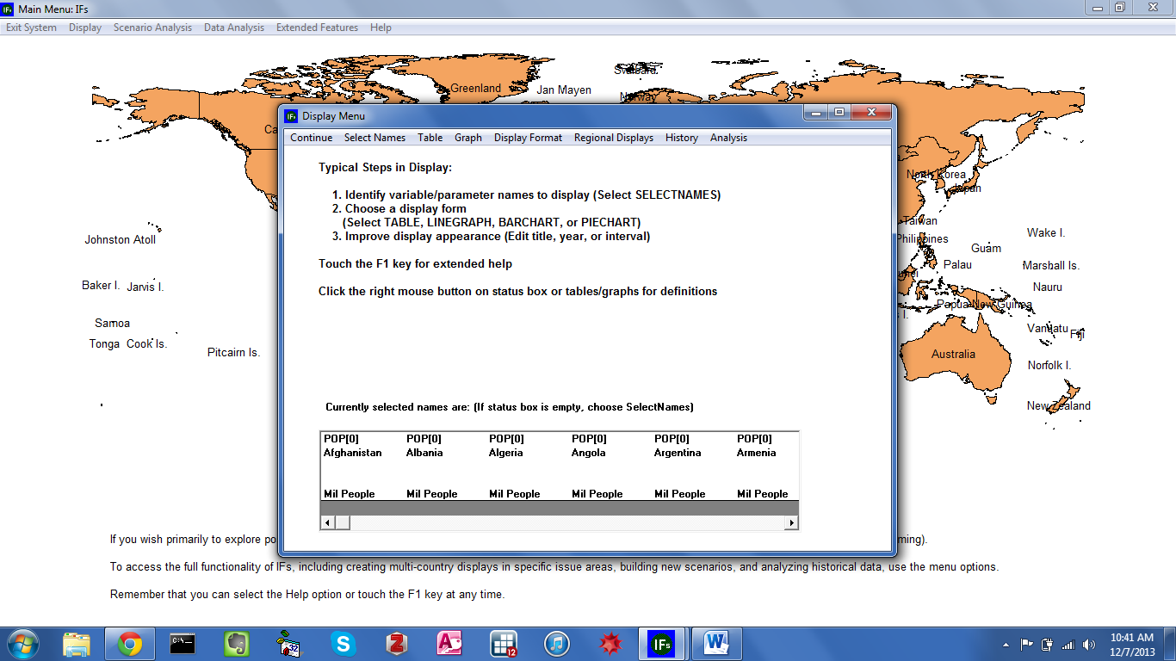
Self-Managed Display: Display Menu—Population For All Countries

The Display Menu form is the second half of IFs Self-Managed Display (Complete Flexibility) feature. All active dimensions will appear in the Currently Selected Names box. A set of data visualization tools is located along the toolbar. As in Flexible Displays users can plot data in a table, line graph, bar chart, radial diagram or scatterplot (unique to the self-managed display, users can also create histograms). And for any graphical form, toolbar options allow users can tailor the title, display interval, currency, time horizon and geographic aggregation. To navigate back to the Full Set of Parameters/Variables form, click the left-most option along the toolbar, Select Names.

Understanding the Model

In the IFs Self-Managed Display, when users click on a variable name, a pop-up box appears, containing: series definition, drivers, metadata, equations and model code. The same pop-up menu is accessible through the tabular form generated in Flexible Displays—see the graphic displayed below. The first pop-up menu option, Define, provides the selected variables definition, the active run file, and the run file’s path. The second option on the pop-up menu is Drivers. Numerous variables can be involved in the complex interactions that characterize dynamic systems. Although it is not always possible to formalize the role of every element, IFs attempts to capture the most critical drivers and interactions. As a supplement to a detailed help system and an open code base, the Drivers screen gives a visual representation of the forward and backward linkages among IFs variables. The third pop-up menu option, View Equations, links to a discussion of model equations in the IFs Help System. For example, viewing equations for the variable SSWELTAX—social security and welfare taxes—brings up a help page that explains government revenue equations. The final pop-up menu option gives users a direct look into the model. View Code links to Visual Basic code associated with the selected variable. (Note that the pop-menus accessed from Flexible Displays tabular form and Self-Managed Display differ slightly. The menu accessed from Self-Managed Displays includes the Delete option, and the menu accessed from a table includes Edit Point.) This section will provide a demonstration of the important forms related to causal drivers. For additional information regarding data definitions, equations or model code, see the IFs Help System path, Using IFs>Repeated Features>Define, Drivers, Explain, Code, and Delete, available at http://www.du.edu/ifs/help/use/repeated/define.html.

Drivers Pop-up Menu: Self-Managed Display Drivers Pop-up Menu: Table

As a demonstration of the model’s capabilities, explore the drivers of poverty, continuing the case study of India. From the Display menu, open Self-Managed Display (Complete Flexibility.) Select the series INCOMELT1LN from the variable selection box, and designate India as the geographic dimension. Click the ensuing entry in the selection box to bring up a pop-up menu, and select Drivers—see the graphic displayed below. In the model, several factors directly drive poverty forecasts: population (POP), private Consumption (C ), domestic Gini coefficient (GINIDOM), a purchasing power parity conversion factor (PPPCONV) and a national accounts to national surveys ratio (NSNARAT). Furthermore, two parameters—incpovlevm and nsnaratm—connect to the poverty series.

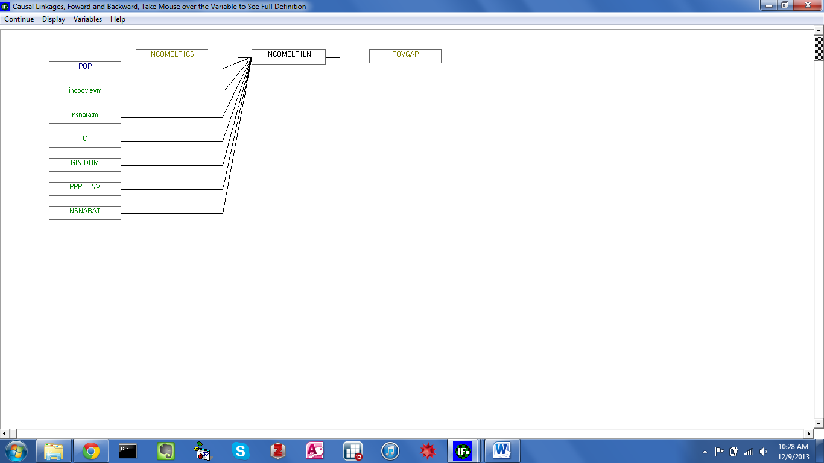

Proximate Drivers of Poverty in IFs

Now, return to the initial form and explore Base Case forecasts for several drivers of poverty. Select the variable C, either by scrolling through the variable box and clicking on the corresponding variable, or by typing C in the text box. Once the series is selected, a second box will open, specifying a country/region or group, depending on the active regionalization option. Again, scroll and find or type in the region name, India. Select two other variables, POP and GINIDOM for India. As variables are chosen they populate a status box located along the bottom of the form. Once the three variables are selected, click the Go to Display button to reach the form displayed below

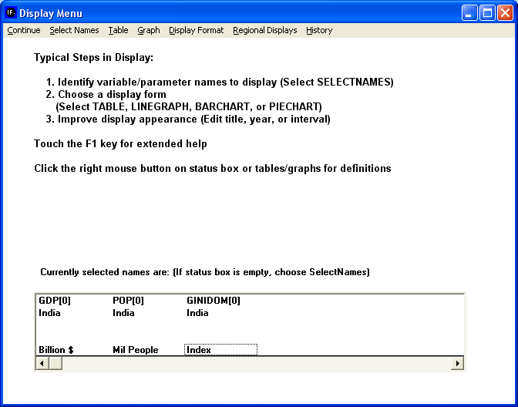
Self-Managed Display: Display Menu

Click Table from the toolbar. IFs can manipulate tabular data in a variety of ways. On the Table Display form, there is a Display Options menu that contains sub-menu options for percentage change, cumulative change, discounting, interval average and moving average, and so forth. For this example, click Percent. The table will now show annual percentage changes in all three variables. Create a visualization of these percentage changes by clicking on the Graph option along the toolbar, then Line Graph and Color Line Graph—see the figure displayed below.

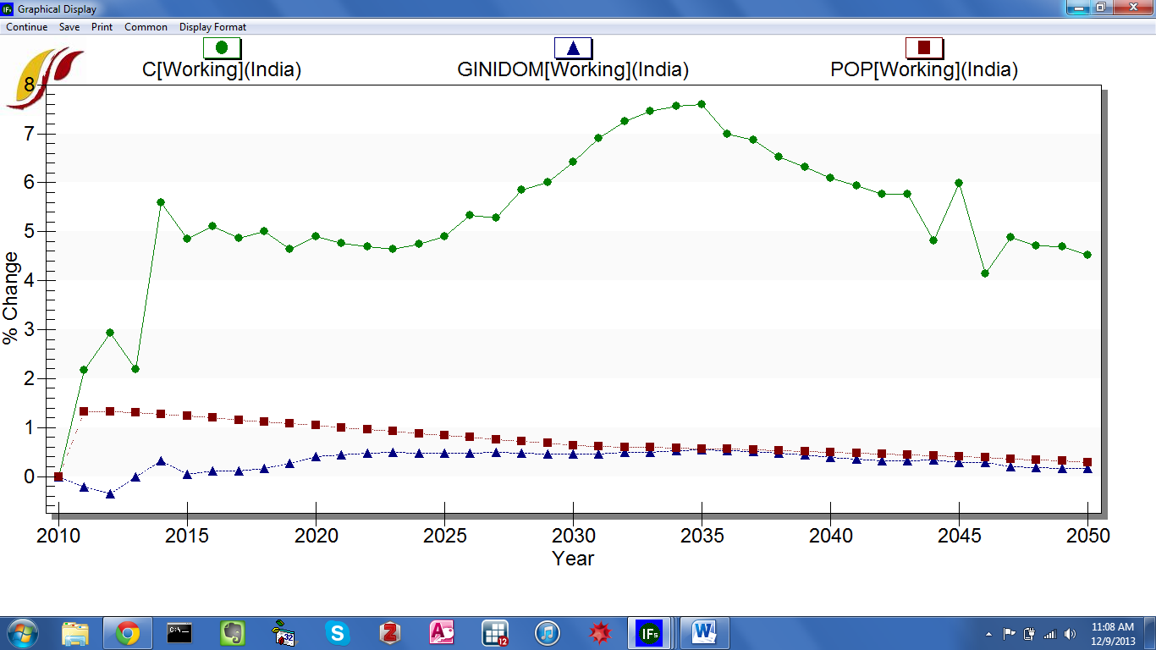
IFs Base Case Forecasts: Poverty Drivers for India

According to the Base Case, consumption in India is set to grow around five percent annually across the time horizon. The total population continues to grow, although at a slower pace. And domestic Gini index does not change much. This initial analysis raises, among others, the following question: if India’s wealth distribution remains static throughout the time horizon, is it significantly equal or unequal? Additional table features facilitate further exploration of the Gini coefficient in India. Click Continue to return to the tabular display. On the form, toolbar options rank countries with respect to the value of the active data series. The Rank Options menu can be found on any of the IFs table displays—as shown in the next figure.

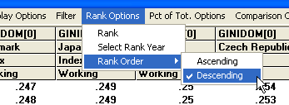
Ranking Options in IFs

Now, rank all countries in the world by their domestic Gini index score. Click Continue to return to the initial Self-Managed Display form, and clear the display area. Choose GINIDOM, and select All from the Country/Group dimension box. Then click Go To Display, and choose to display a table. Once in the Table Display, select Rank Options and then choose Ranking Order, Descending. Finally, rank the countries, again using Rank Options menu, and this time choosing Rank. By ranking the countries, we can see that India has the 114th highest value, corresponding with the 114th most unequal distribution.
As a further demonstration of the Drivers form, investigate the distil drivers of poverty; that is to say, investigate the elements that in turn drive the three proximate drivers of poverty: First click on the GINIDOM variable that we selected before and then click on Drivers to reach the screen displayed below.
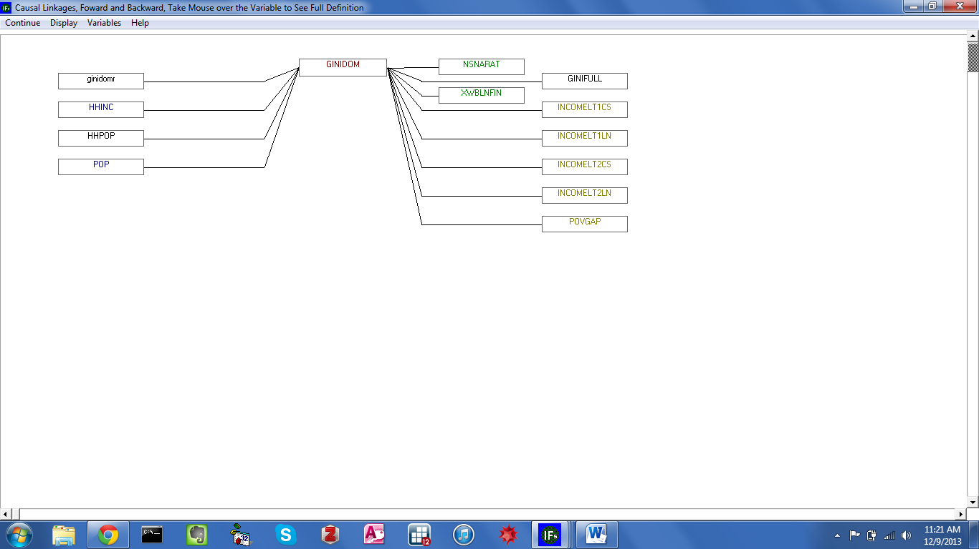

Drivers of GINIDOM

We see that the IFs calculation of the Gini index is directly driven by the income earned by different household groups (HHINC), household population (HHPOP) and overall population (POP). By clicking back and forth through the diagram, we can fully explore the causal relationships captured in the model. For example, household income is a product of, among other things, GDP, which is itself linked to the multifactor productivity growth rate (MFPRATE). Multifactor productivity is in turn driven by the contribution to multi-factor productivity from human capital (MFPHC). And the years of education of those above 15 (EDYRSAG15), is one of the contributors to human capital. Due to its link to GDP, educational attainment is thus a distil driver of private consumption, the second direct driver of poverty rates. Turning to the third proximate driver of poverty, population, driving factors include births and deaths. Education levels influence both births (women’s education is especially important when it comes to births or fertility) and mortality (through the IFs health module). Thus, at a distil level, education affects all three of the proximate drivers of poverty.

Scenario Analysis
Where do we want to be, and how do we get there?

Objectives
In this section of the training manual, users will learn how to
  - create, save and display alternative scenarios
  - locate parameters and initial conditions
  - navigate the IFs file structure

From the IFs home screen, select Scenario Analysis. The subsequent drop-down menu includes tools used to explore, and create, alternative forecasts. The five Scenario Analysis sub-menu options are:

  - Quick Scenario Analysis With Tree
  - Change Selected Functions
  - Guided Scenario Analysis
  - Run
  - File Management

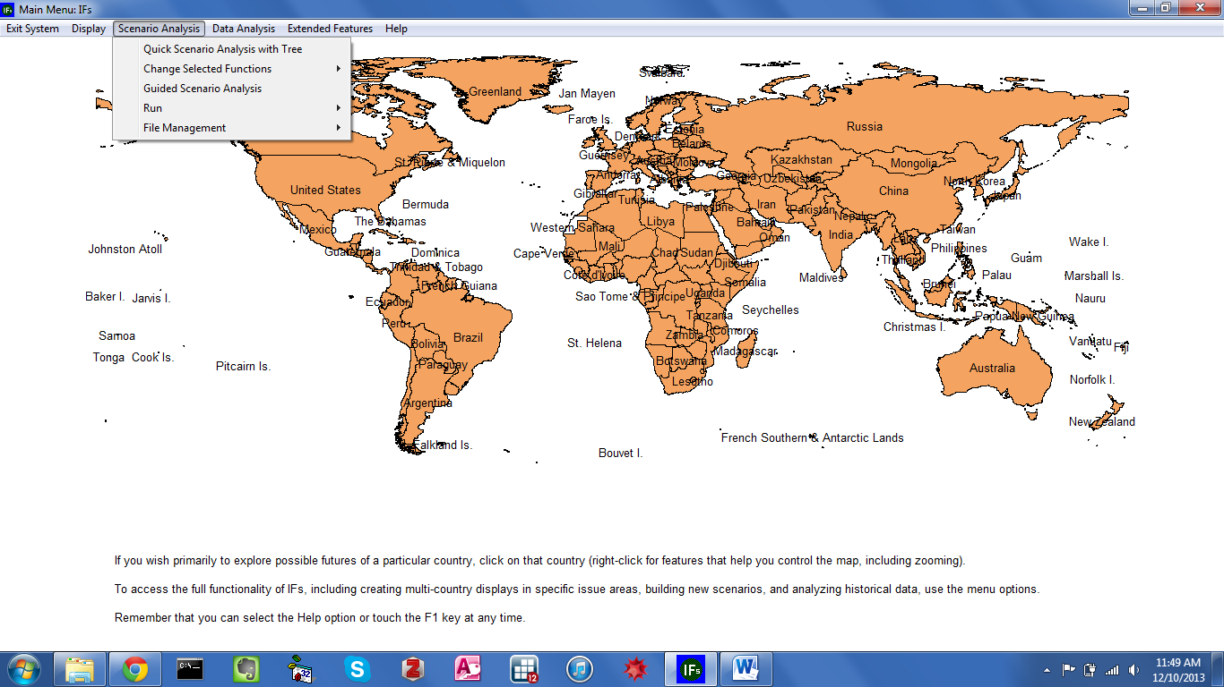
IFs Home Screen: Scenario Analysis Menu

Understanding Scenario Building and Use in IFs
The previous section discussed historical trends and forecasts related to the first Millennium Development Goal (MDG), reducing global poverty by half by 2015. Given that the time horizon for the MDGs is drawing to a close, this section will look ahead to a more ambitious poverty reduction goal. In order to create aggressive but reasonable development targets, we must understand the limits of policy leverage. Or, phrased another way, we must understand how fast, and how far, we can shift the poverty patterns shown in the Base Case. Throughout this section, demonstrations will frame the range of uncertainty surrounding poverty by creating scenario interventions that target three drivers—economic growth, population growth, and income distribution.
The following discussion will reference two file-types involved in IFs scenario creation: scenario files and run files. Scenario files, the first type, are saved with an extension of .sce. Very small in size,.sce files contain information that the IFs model uses to create alternative scenarios; i.e., .sce files contain a list of parameter values that diverge from the Base Case. It is important to note that scenario files do not contain any forecasts. Forecasts are generated only when the scenario is run. Scenario results, forecasts, are saved in the second type of file: run files, saved with the .run extension. Because they contain forecasts of all IFs variables and parameters, .run files are much larger than scenario files.
Separate model features process scenario files and run files. Scenario files are created, accessed and saved from the Quick Scenario Analysis With Tree form. Loading a .sce file adds the associated interventions to the scenario tree. Running the model then transforms interventions displayed on the tree into an alternative scenario. All .sce files are stored in the folder IFs/Scenario. Run files, on the other hand, are generated once a .sce file is run, either from the Run feature under Scenario Analysis, or from the Quick Scenario Analysis With Tree form. Once a .sce file is translated into a .run file, the results are stored as working.run. And the File Management feature under Scenario Analysis saves the working run file for future use. All forecasts are linked to a .run file. Recall that when the model is first opened, the working run file is identical to the Base Case, which is itself linked to the file IFsBase.run. File Management features also retrieve or delete .run files. All .run files are stored in the folder IFs/RUNFILES.
For additional information on the scenario creation process, and the associated graphical user interface, see the IFs Scenario Analysis Guide, or the IFs Help System, available at file:///C:/Users/Public/IFs/helpHtml/ifs/help/use/scenario/quick/previously.html.

Quick Scenario Analysis With Tree
Under Scenario Analysis on the IFs home screen, the first sub-menu option allows users to create scenarios. Alternate scenario analysis is a method of exploring potential patterns of human development, across any system captured in the model. Using the Base Case as a reference, users can modify assumptions or model the effects of policy. Open the Scenario Analysis sub-menu, and then click Quick Scenario Analysis with Tree to reach the form displayed below.

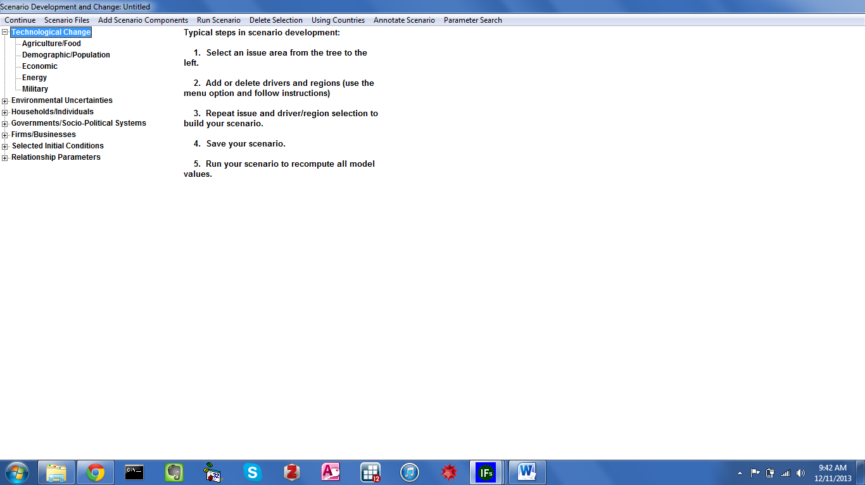
Quick Scenario Analysis With Tree

The Quick Scenario Analysis form is comprised of a selection tree, display area and toolbar options. Initially, when no parameters or variables are selected, the display area contains a brief scenario construction walk-through. First, users wishing to create an alternative scenario must identify an intervention—a term used throughout this manual to mean a change to the Base Case. Interventions can explore implications of, say, a change in global fertility rates; or the implications of modified assumptions, like a higher/lower global stock of oil. Scenario handles in IFs can be used to formalize alternative future scenarios, based on modelers’ understanding of uncertainties and realistic human leverage. All scenario handles are located in a navigation structure called the IFs scenario tree. Parameters or initial conditions are organized into tree branches, and categorized across areas of uncertainty. Categories include: Technological Change, Environmental Uncertainties, Households/Individuals, Governments/Socio-Political Systems, Firms/Businesses, Selected Initial Conditions and Relationship Parameters. Each primary branch is made up of sub-categories. For example, Technological Change expands to reveal secondary branches, corresponding with Agriculture/Food, Demographic/Population, Economic, Energy and Military. Once a branch is active, a box titles Pick Parameter appears on the form, populated with all available intervention parameters. And once a specific intervention point is selected, a pop-up box offers several options: Select, Drivers, Explain, View Equations and Define—see the graphic displayed below.

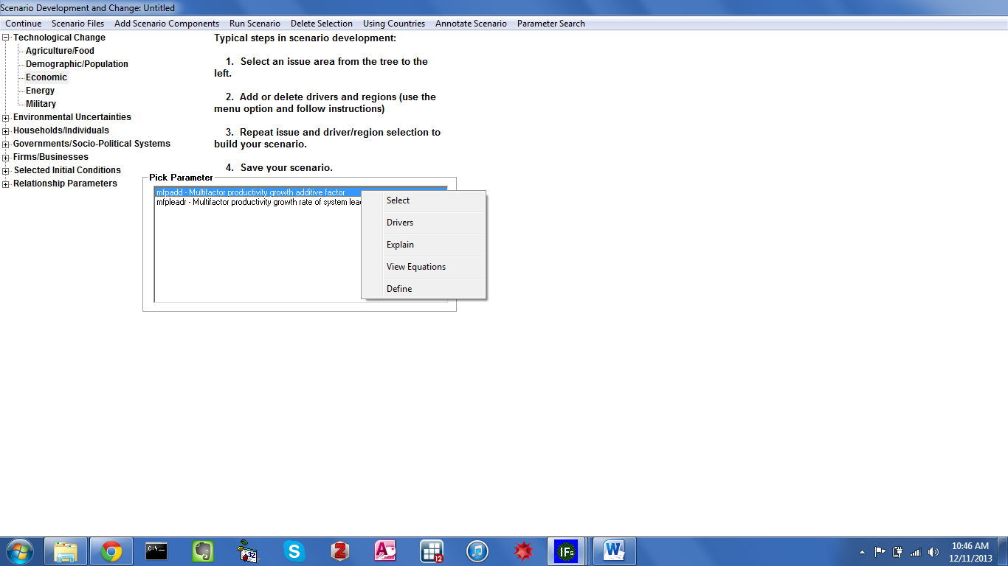
Quick Scenario Analysis With Tree

While they may seem unintelligible at first, parameter names are made up of several short character strings, each of which has meaning. For example, take the parameter, enpoilmax, which consists of: en, a category prefix for energy; p, for production; oil; and max, corresponding with the maximum parameter type. Or take aidsdratem: the first nine characters signify aids death rate, and the final letter m stands for multiplier, a type of IFs parameter. Multipliers, as the name suggests, multiply model functions or equations. In the Base Case, all multipliers take on the value of 1, leaving computations unchanged. For example, ylm is connected to agricultural yield; a value of 1.5 would increase yields by fifty percent in selected countries. This powerful method is sometimes referred to as brute force scenario intervention. For a full list of IFs parameter types, and descriptions, see the Scenario Analysis Guide or the IFs Help System.

Basic Scenario Creation

Returning to the scenario construction walk-through, after identifying an intervention, users should add or delete drivers and geographic dimensions. From the Pick Parameters box, click Select to generate a pop-up menu containing geographic regions. By default, the Pick Dimension box will contain all 186 IFs countries, ordered alphabetically, and a toggle along the toolbar will read Using Countries. Switch the toggle to Using Groups, and the dimension box will change accordingly. (Note that some parameters do not require a geographic region, because they affect all regions uniformly.) Some parameters prompt users for additional dimensions. For example, many parameters related to energy require a type dimension, either oil, gas, coal, hydro, nuclear or renewables.
With a parameter and geographic dimension selected, the display area will contain Base Case information and customization options. The figure below depicts components of the IFs scenario screen: the Scenario Tree on the left; the default values of the selected scenario handle and a graphical representation on the right; and a menu containing various scenario development options on the top of the form.

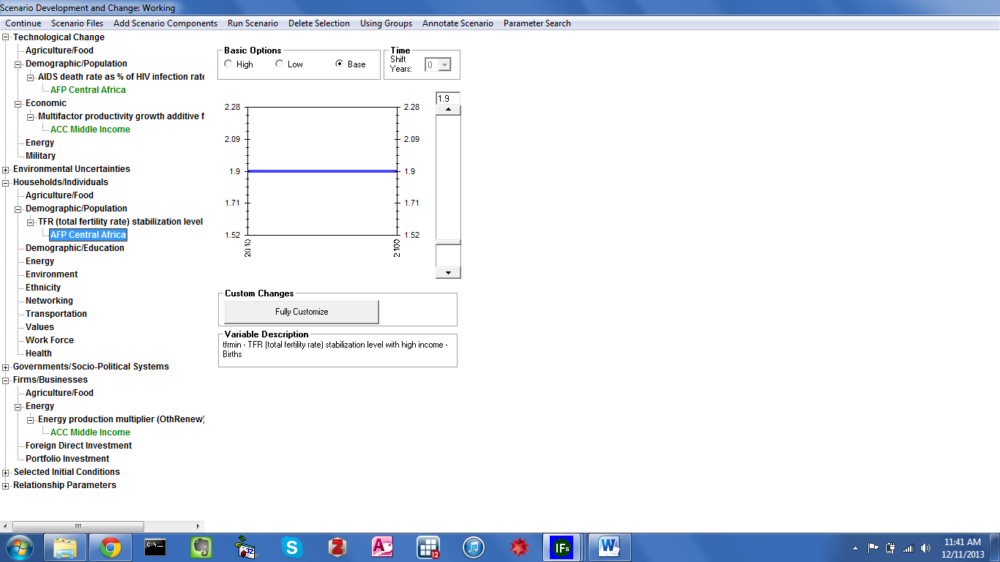
IFs Scenario Tree

The text box labelled Variable Description contains the selected parameter, and a brief description. The blue line, located in the center of the form, indicates Base Case values, from 2010 through 2100—as indicated by the active radio button under Basic Options. Two additional radio buttons allow users to quickly create a new scenario intervention. High and Low, when active, shift parameter values to a higher or lower variant, within the realm of possibility—see the graphics displayed below.

Basic Scenario Intervention: High Variant Basic Scenario Intervention: Low Variant

In addition to clicking through the tree branches to locate the desired scenario handle, users can select parameters via a separate search feature. From the toolbar, select Parameter Search to navigate to a search form, comprised of a list box and an input box. The function searches through parameter names, brief descriptions and a longer, more thorough definition. For instance, the entry “oil” returns several parameters, including: enpoilmax, which has the word oil in its name; carfuel1, described as “carbon generated by burning oil;” and QE, which is described as “Capital Costs-to-Output Ratio.” However, with QE highlighted, click Define to reveal the search term. The complete definition contains the sentence: “the variable determines how many dollars of capital are required in the creation of a barrel of oil equivalent in each energy category.” The search form also features buttons linked to model equations and driver analysis—discussed in the previous section. Once the selected parameter is located, and highlighted, the Load button navigates back to the customization screen.
Clicking through the scenario tree and using the parameter search are two ways to load interventions. But, many packages of interventions come pre-built. Moving to the toolbar, the second option from the left, Scenario Files, allows users to load files, and save their own creations. As mentioned above, IFs scenarios involve two file types. Scenario definitions are saved in files with an extension of .sce. These .sce files are very and text-based, saving all the modified assumptions and interventions of the scenario. However, they do not contain any forecasts. Forecasts from a particular scenario are generated only when the scenario is run. These forecasts are saved in files with the .run extension; run files are much larger than scenario files because they contain forecasts of all IFs variables and parameters. IFs comes preloaded with few .run files and a large number of .sce files, organized into a folder structure with meaningful titles. The pre-packaged .sce repository is located at the path: C:> Users> Public> IFs> Scenario. To explore existing scenario files, click Scenario Files and select Open—see the figure displayed below

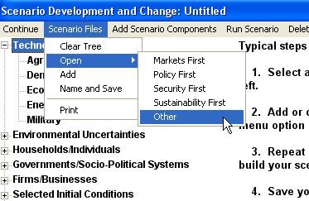
IFs Scenario Files Menu

The Open sub-menu contains a list of pre-defined scenarios. IFs version 6.75—used here— starts with four scenarios created for the UNEP GEO—United Nations Environment Programs’ Global Economic Outlook. The four files simulate a future in which markets, policy, the environment or national security are prioritized over all else. Load any of the UNEP scenarios into the tree by simply clicking on the file name. Clicking on Other—the fifth sub-menu in the figure above—will open a folder structure containing all the pre-packaged and user saved scenarios. For example, navigate to the folder World Integrated Scenario Sets -> PPHP Poverty -> Framing Scenarios and open Low Population.sce. Notice how the tree on the left has expanded a new branch representing a low fertility rate multiplier for the developing world. Click on the branch World to display a graphical representation of how, exactly, the scenario reduces the TFR multiplier. Over 30 years, the intervention reduces TFR in developing countries (non-OECD) from 1 to .6. In general, loading a scenario to the tree provides an understanding of which scenario handles are selected, and how they are manipulated.
Before attempting to open a new .sce file, users can either clear the entire tree—see the menu in the figure above— or add to existing interventions. For example, we might want to explore how greater economic growth would interact with lower fertility rates. The scenario folder Poverty Framing Scenarios also contains a High Economy.sce file. Add this scenario to our working file by opening the Scenario Files menu and clicking Add. To tell an even more optimistic story, we could then add the file Low Inequality.sce to our tree, again from the same location.
Alternatively, users can add scenario components via the second option located along the toolbar. The button Add Scenario Components opens pre-packaged IFs scenarios in a file tree, which is a graphical representation of the file structure under C:/Users/Public/IFs/Scenarios—see the graphic displayed below.
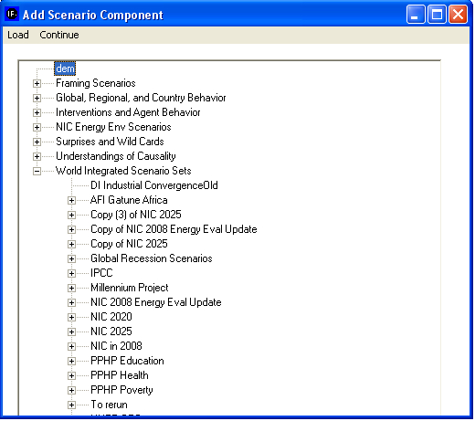
Add Scenario Component

Users can create interventions or load interventions from pre-existing .sce files. But scenario files (.sce) or working scenarios need to be run to generate a .run file— containing scenario results for all IFs variables. On the Quick Scenario Analysis With Tree form, moving from the right, the fourth toolbar option is Run Scenario. are two steps involved in running a scenario. First, with a set of interventions selected, the user must click on the Run Scenario button—see the figure displayed below.

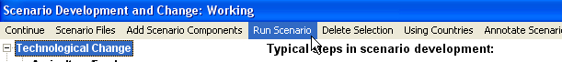
Scenario Screen: Run Scenario Menu

The ensuing pop-up box will ask the user if he or she is ready to proceed. IFs will then process all the scenario parameters and take the user to the Running Scenario screen—see the figure displayed below. Users enter the horizon for their scenario and click on Start Run. By default, the time horizon is set to twenty years, but any year from 2011 through 2100 is acceptable.
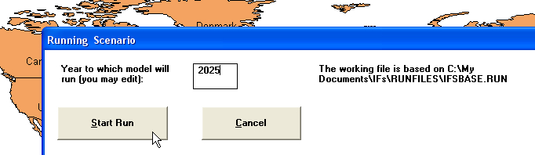
Running a Scenario

While the model is generating an alternate scenario, a set of macro-level forecasts occupy the screen. Display boxes hold forecasts of the world population, global gross domestic product, forest coverage, and levels of atmospheric carbon dioxide. As the model runs, forecast will change accordingly—see the graphic displayed below. And once the scenario is run successfully a confirmation message will appear. Click OK to return to the IFs home screen. Previously, the IFs working run file and Base Case run file were identical. After running a set of interventions, however, the working file contains the results of changes and diverges from the Base Case.

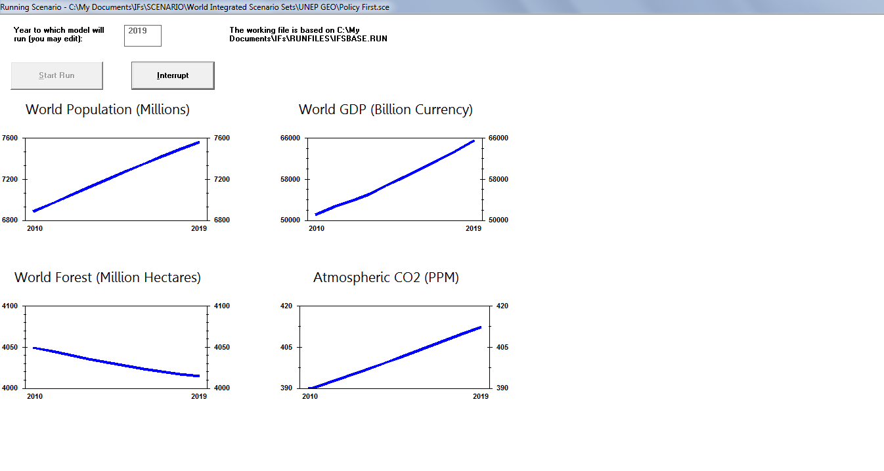
Running a Scenario

As an illustration of the quick scenario analysis feature, compare Base Case forecasts against a set of pre-packed interventions. Beginning from the IFs home screen, click Scenario Analysis, and select Quick Scenario Analysis With Tree. If any interventions are currently active in the tree, open the Scenario File sub-menu and click Clear Tree. Next, click Add Scenario Components to open the scenario file structure. The last root listed alphabetically, World Integrated Scenario Sets, contains numerous subfolders, which hold scenarios created for the African Futures Project (AFP), International Panel on Climate Change (IPCC), United States Nation Intelligence Council (NIC) and the Potential Patterns of Human Progress (PPHP) series. For this example, open PPHP Poverty, the set of scenarios created for the first PPHP volume. Expand the node labelled, Best and Worst Framing Cases, and highlight Best Case Poverty Framing Scenario, a simulation meant to offer a benchmark of very optimistic developments in global poverty. On the form’s toolbar, click Load, and the package of interventions will appear on the scenario tree. While pre-packaged names indicate the concept being modelled, the scenario tree indicates exactly which parameters will be manipulated. For example, explore the branch titled TFR(total fertility rate) multiplier, which will be open under Households/Individuals and Demographic/Population. Click the geographic dimension under TFR, non-OECD, to reach the form displayed below.

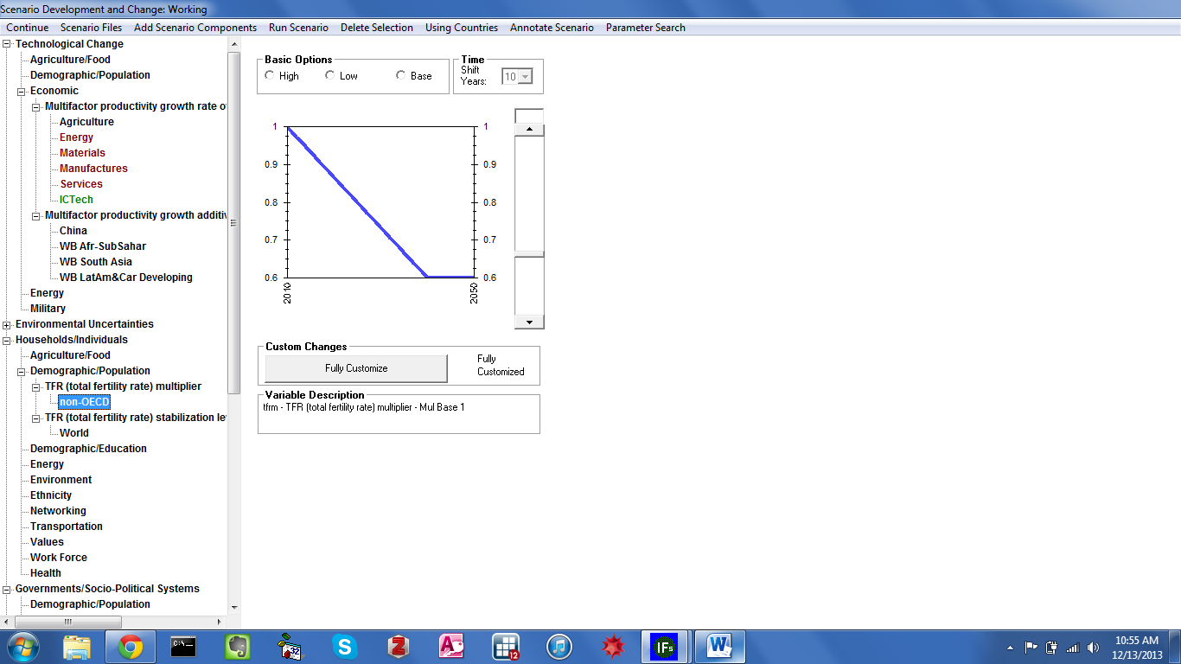
Running a Scenario

From the graphic, it is clear that the intervention reduces fertility rates throughout non-OECD countries. Tfrm—a total fertility rate multiplier—is the intervention parameter, as specified by the Variable Description box. Recall that, in the Base Case, all multipliers are set to 1. According to the blue line, in the new scenario tfrm declines gradually, reaching a value of .6 in roughly 2040. Furthermore, none of the Basic Options radio buttons—High, Low and Base—are active, indicating a custom intervention. In order to understand precise intervention details, click Fully Customize. For each year, the exact value of tfrm appears in the corresponding box under Information. And the sloping line means the change is a result of Interpolation rather than Change/Repeat. Thus, one of the interventions that comprise the Best Case Poverty Framing scenario is a 40 percent reduction in total fertility rates, interpolated over 30 years.
As evidenced by the scenario tree, remaining interventions target economic growth, via multifactor productivity growth rates, and income distribution, via the Gini coefficient. As discussed in the previous section—Display Analysis—the proximate drivers of poverty are population, private consumption and inequality. The Best Case Framing Scenario thus modifies all of the direct drivers simultaneously. Now, from the toolbar click Run Scenario, and Yes on the ensuing pop-up box. Instruct the model to run through the year 2050, and click Start Run. The process will last around 5 to 6 minutes. (For a shorter wait time, run the scenario out to 2030.) Upon completion, click Run Successful to return to the IFs home screen.
Now, the working run file will contain a best case poverty scenario. From the home screen click Display, and select Flexible Displays. Highlight Poverty as the Display category. From the filtered Displays list, in the central box, select Poverty, Millions LT $1.25, Log Normal Formulation. Then, open the Geography Options menu along the toolbar, and click Using Groups. From the Geography box select World. At the bottom of the form, the Scenarios box will contain 0-Working File, and 1-IFsBase. Hold down the Shift key, and highlight both scenarios. Click Line Graph to generate the graph displayed below—poverty headcount differences (income less than $1.25 per day, lognormal formulation) for the world between the IFs Base Case and the Best Case scenario.

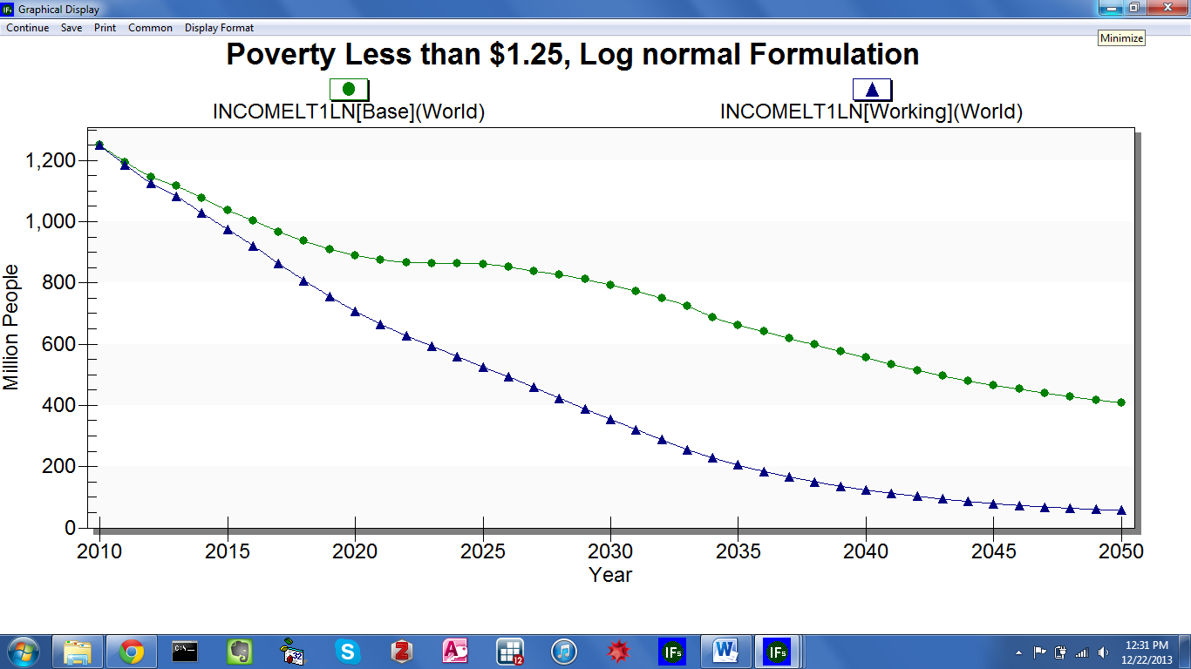
Poverty Headcounts: Base Case versus Best Case
The optimistic scenario, currently saved in Working run file, will disappear when IFs shuts down. To save the scenario for future use, continue back to the IFs home screen—click Continue along the toolbar. Open Scenario Analysis, and then File Management. From the ensuing sub-menu, click Save Working File As. A file navigation box will appear, pointing to C:/MyDocuments/IFs/RUNFILES .All saved run files are stored in this location, including the four UNEP scenarios: Markets First, Policy First, Security First and Environment First. Name the working file Optimistic Poverty Future, and click Save. Next time the model opens, the run file will be available for quick comparison.

Advanced Scenario Creation
In addition to more basic techniques, IFs allows users to create their own scenarios, and fully specify interventions. With a scenario handle selected, click the Fully Customize button to reach the form displayed below.
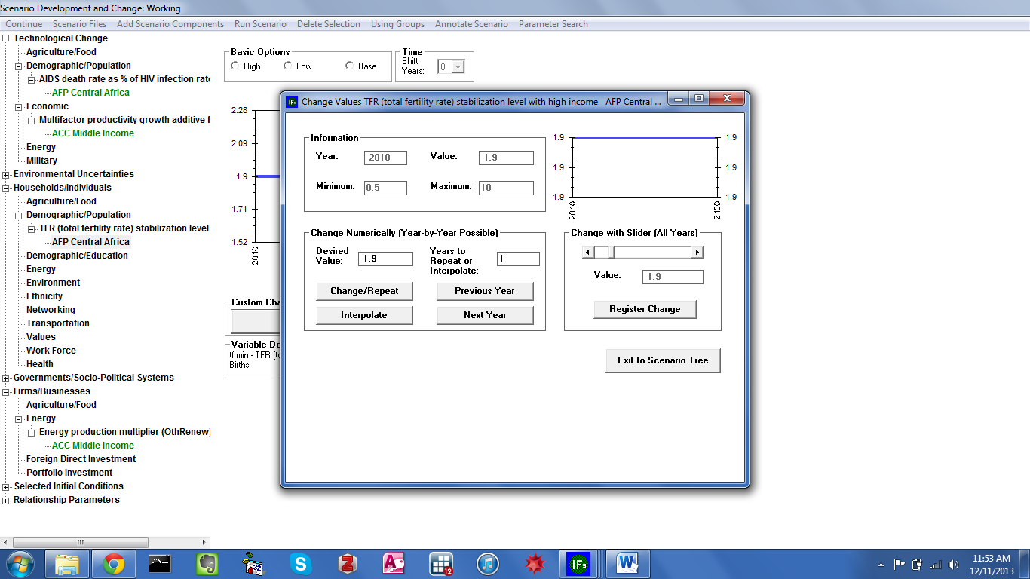
IFs Scenario Analysis: Fully Customize

The ensuing form contains parameter information and several customization features. A box located at the top of the form reports, for the active parameter, current year and current value, as well as the minimum and maximum allowable values. As on the previous form, a line graph represents values across the 2010-2100 time horizon. And customization tools are located in the box titled, Change Numerically (Year-by-Year Possible). The default value, used in the Base Case, will appear in the Desired Value box. Enter a new figure—within the acceptable range, bounded by the maximum and minimum—and the number of years to repeat or interpolate. Initially, the desired figure will occur for a single year. Once a new value and temporal dimension are selected, the user must click either Change/Repeat or Interpolate for changes to take effect. The first option, Change/Repeat simply replaces the existing value with the desired value for the number of years specified. Interpolate, however, moves from the existing value to the desired value, over the course of the specified number of years. See the figure below for an illustration of the difference between the two techniques. As an alternative, users can drag the slider to any allowable value, and click Register Change to enforce a new value, constant across the time horizon.
Fully Customize: Change/Repeat vs. Interpolate

To further demonstrate IFs scenario analysis capabilities, create a custom intervention around poverty. From the IFs home screen, click Scenario Analysis and, once again, select Quick Scenario Analysis With Tree. The scenario interventions making up Best Case Poverty Framing Scenario will still be active. Before constructing a new, custom scenario make sure that the tree is completely clear. Interventions loaded in a scenario tree branch (and all of its sub-branches) can be deleted by two methods. First, highlight an intervention and then click the Delete Selection menu on top of the scenario screen—see the figure displayed below. Or, as a second method, simply click Scenario Files, then Clear Tree, to delete all changes.

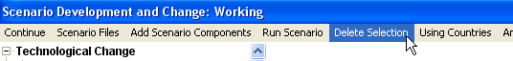

Deleting Scenario Tree Branch

As discussed previously, education is a distil driver of economic growth, income distribution and population growth. For this example, create an alternative scenario exploring education futures in a single country, India. The tree on the left side of the scenario Screen contains all of the parameters and variables available to the user. One way to find the parameter or variable you would like to change is to navigate the thematic categories. The first two options on the tree, Technological Change and Environmental Uncertainties, allow you to shape the future of technological growth and various environmental trends. The third, fourth and fifth options on the tree, Households/Individuals, Governments/Social-Political Systems and Firms/Businesses, allow you to shape the parameters for the three principal classes of global actors. The final two options, Selected Initial Conditions and Relationship Parameters, allow you to change parameters at the onset of your run file or the relationships between various parameters.
For this example, choose branches Government / Socio-political Systems and then Fiscal Expenditure. From the subsequent list box, choose gdsm, government expenditure by destination multiplier. Then choose India from the list of countries, and then choose education from the list of sectors— you can also apply the handle to a whole group by changing the grouping option in the top menu.
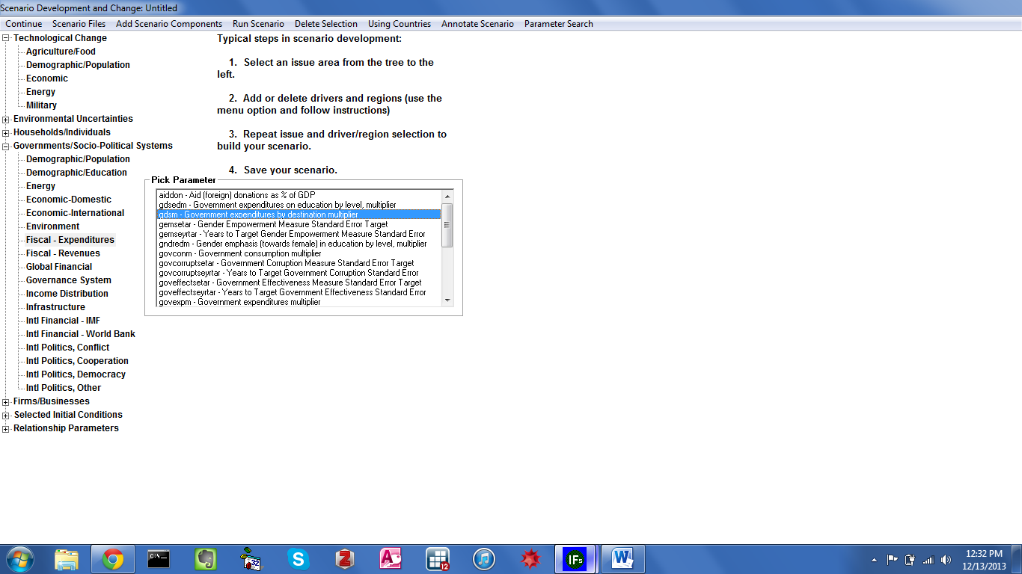
Scenario Tree Categories

Click gdsm, and then the Select option. On the ensuing screen, you will see radio buttons labelled Base, High and Low—see the figure displayed below. Because the selected parameter is a multiplier, the Base Case value will be 1. Recall that the model uses multipliers to increase or decrease Base Case values of many variables, and all multipliers are set to 1 in the Base Case. (As mentioned previously, multipliers can be distinguished from other scenario handles by the suffix m.) The blue line graph, located on the right of the form, is a summary of your intervention. For this example, create a custom parameter change. Click the Fully Customize button. Now, in the Desired Value box, enter 1.2, and interpolate over 10 years. Now, the Year Box will read 2020. To enforce the increased value over the entire time horizon, enter 80 in the Years to Repeat or Interpolate box, and click Change/Repeat. Click Exit to Scenario Tree, and the line graph will indicate a 20 percent increase in India’s educational spending over what it would be in the Base Case. The rise takes place gradually, over a span of ten years, and endures for the rest of the horizon.

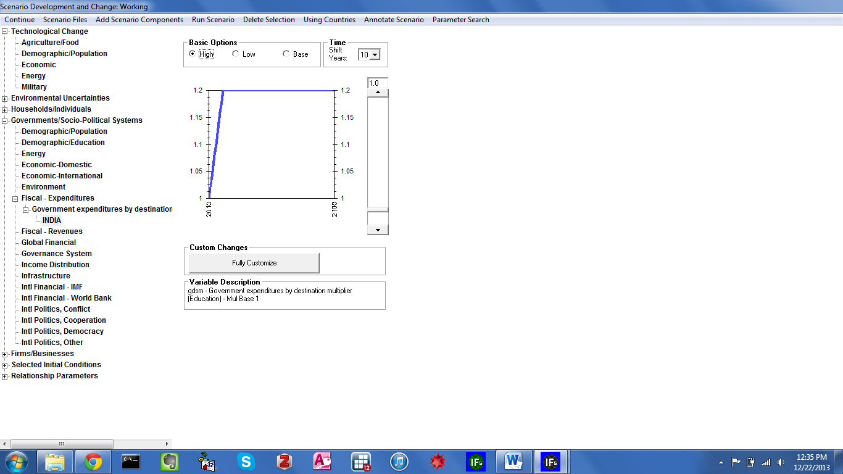
Scenario Intervention: Increased Education Spending
The Quick Scenario Analysis With Tree form provides an alternative method of finding and loading scenario interventions through a user friendly search feature. Users can find the parameters they would like to change by selecting the Parameter Search option on the top right of the scenario form toolbar. Clicking on the search button will bring up a form comprised of an input box and a scroll box—see the figure displayed below.
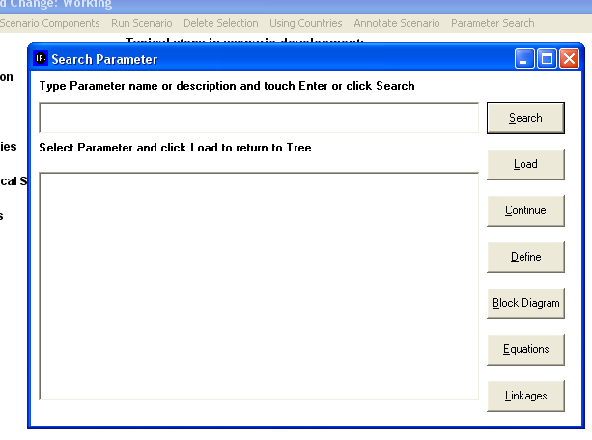
Search Scenario Parameters

With the education expenditure increase intervention displayed in the tree, run the new scenario. When the run is complete, click Display on the IFs home screen, and select Flexible Displays. Now choose Poverty from the Display Categories box, and Poverty Less than $1.25, Log Normal Formulation from the Displays box. And set the geographic dimension to India. With both Working File and IFsBase highlighted, create a table—see the graphic displayed below. We see that an increase to education spending, a driver of educational attainment—which is itself a distil driver of poverty—has a limited effect on Indian poverty rates.

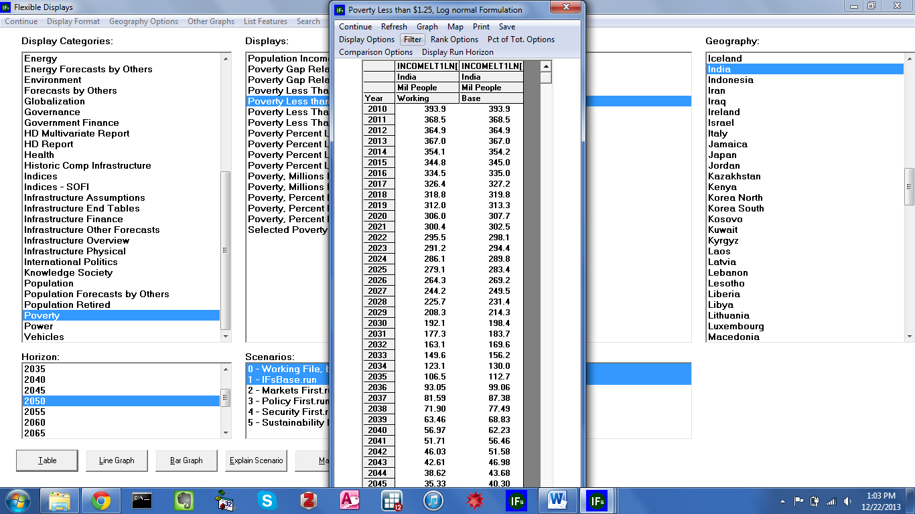
Table Results from Education Spending Increase Scenario

Change Selected Functions
From the IFs home screen , the second option under Scenario Analysis allows users to explore the model’s black box. Under Change Selected Functions, a sub-menu contains links to Bivariate Relationships and Multivariate Relationships. With these features, users can explore, or change, the mathematical relationships used in the model. Click Bivariate Functions to reach the form displayed below.

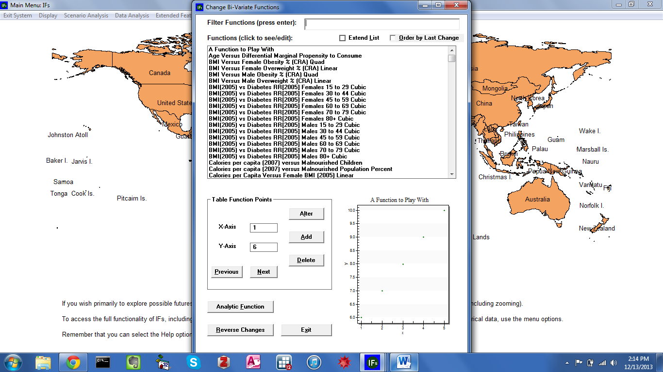
Bivariate Relationship

The ensuing form contains a list of selected bivariate functions used in model computations. Above the list, a box—labelled Filter Functions—serves as a search function that operates on character prefixes; the entry “GDP” would return all relationships beginning with the three letters. Two check boxes directly above the list either extend the function area, or sort entries by the date of modification. And, towards the bottom of the form, function information and an associated graphic are located. For an example, highlight GDP/Capita (PPP 2005) Versus Inequality (2010) Log. The plot in the lower-right-hand corner will now depict the relationship currently used in the model. As the name implies, the chart shows a logarithmic relationship between gross domestic product per capita, at purchasing power parity and the Gini Index. Two features control changes to existing relationships. First, and most user-friendly, is the Table Function feature. A table function takes several x-y coordinates and derives a statistical relationship. As a demonstration, highlight the first entry in the Functions box, A Function to Play With—included in the model as a learning aid. Under Table Function Points, input boxes contain the x and y values for each point. Buttons labelled Previous and Next navigate back and forth along the axes. To change any point, replace a value and click Alter; and to add or delete points entirely, click the corresponding button. The second feature, accessible through the Analytic Function button, builds a statistical relationship from an equation. For a detailed description of relationship modification see the IFs Help System—available at http://www.du.edu/ifs/help/use/scenario/change/bivariate.html. Note that the Change Functions forms do not indicate exactly where, in the model, the functions are called. Users wishing to explore the exact purpose of bivariate or—multivariate—functions are encouraged to consult the IFs standalone module documentation.

Guided Scenario Analysis
From the IFs home screen, the third option under Scenario is a guided scenario creation wizard. This feature is designed primarily for new users, who wish to experience a condensed walk-through of the entire system. Click Scenario Analysis, and select Guided Scenario Analysis to reach the form displayed below.

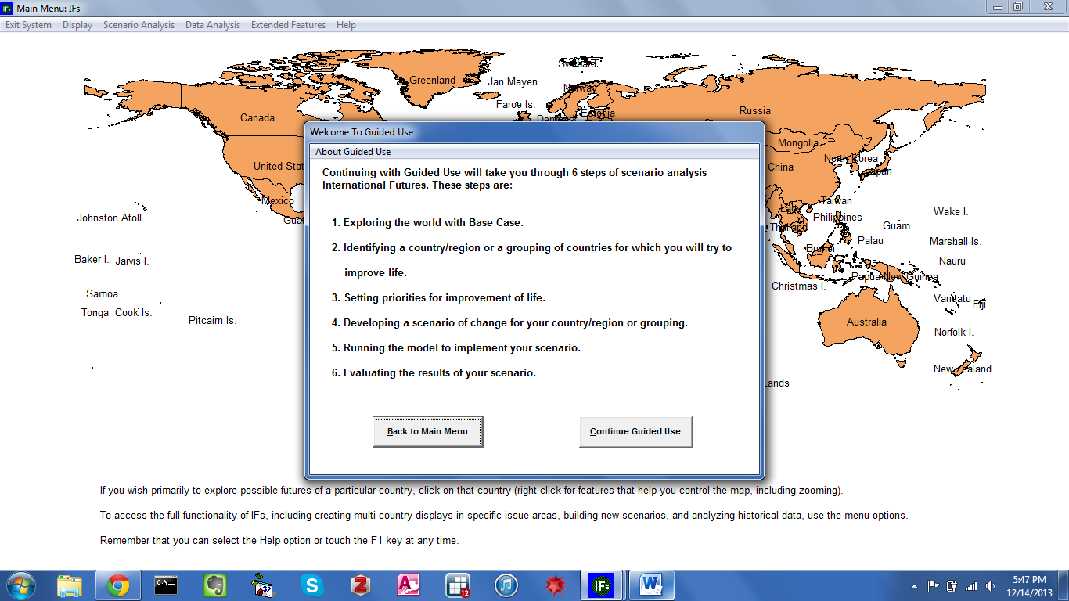
Guided Scenario Analysis

The Guided Scenario Analysis form prompts users for their name, before proceeding through data analysis, flexible displays, and finally, scenario creation. The first step, Exploring the World With Base Case, guides users through three features discussed above: Basic Report, Specialized Displays and Self-Managed Display. Next, the second step, Identification of a Country or Group, provides users with a set of geographic representations. The third step, Set Priorities for Improvement of Life, is a preliminary step in scenario creation. And the final two steps, Running the Model and Evaluating the Results, steps through scenario creation and analysis. IFs Help System includes a detailed discussion of the Guided Scenario Analysis feature. For reference, open Help, along the home screen toolbar, and navigate through Use IFs>Scenario Analysis>Guided Scenario>Guided Scenario Analysis, available at http://www.du.edu/ifs/help/use/scenario/analysis.html.

Run
From the IFs home screen, the third option located under Scenario Analysis allows users to create alternative forecasts—.run files—and evaluate the sensitivity of various parameters. Under Scenario Analysis, click Run to reveal a sub-menu containing: Single Run, Sensitivity Analysis and Batch Run. This section will briefly discuss two .run file creation methods. For a discussion of Sensitivity Analysis consult the IFs Help System, specifically the IFs Help path Use IFs > Scenario Analysis>Running the Model>Sensitivity Run, available at, http://www.du.edu/ifs/help/use/scenario/running/sensitivity.html.
The first option, Single Run is simply a duplicate of the Run Scenario feature, located under Quick Scenario Analysis With Tree. Click Run to process any custom interventions or pre-packaged scenario currently loaded to the Working File. As an alternative, IFs supports batch running numerous alternative scenarios at once. From the home screen select Scenario Analysis, click Run, and then Batch Run to reach the form displayed below.

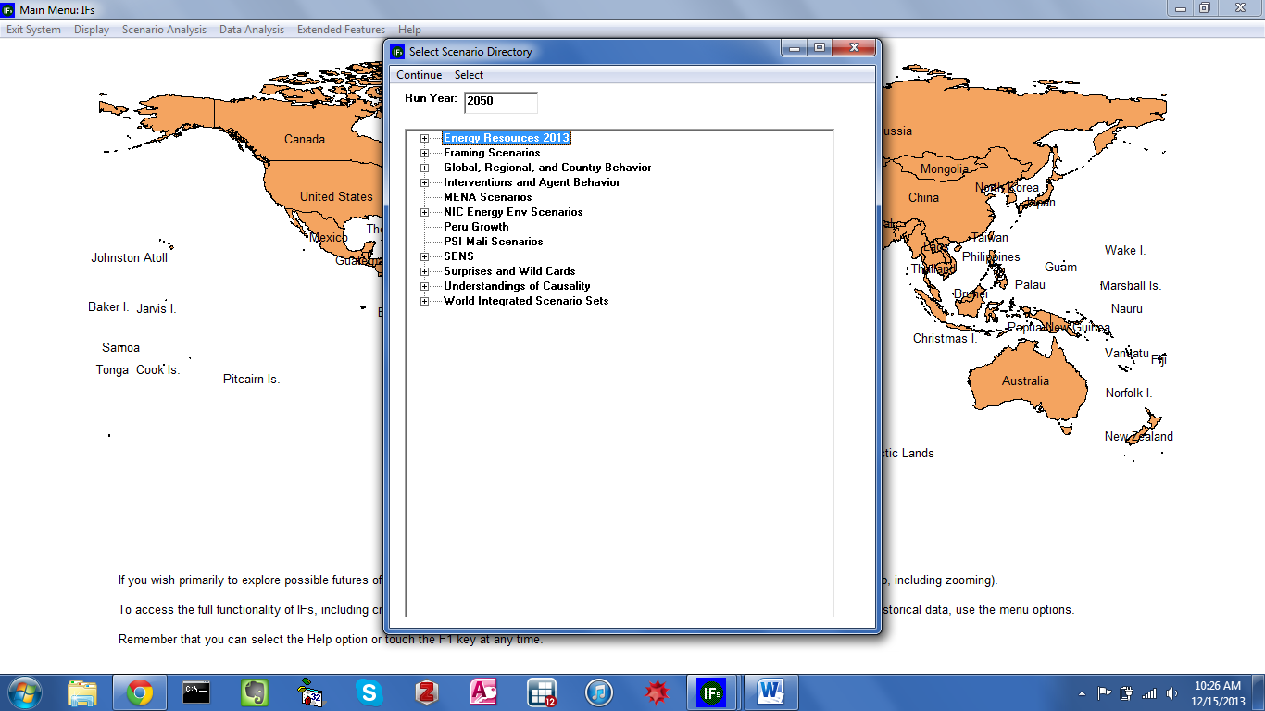
Batch Run

The ensuing navigation tree reflects the file structure located at C:/Users/Public/IFs/Scenarios. Each folder at this location is represented by a top-level navigation node on the Batch Run form. Expand any node to reveal another set of folders. With a time horizon specified in the Run Year box, highlight a folder and click Select from the toolbar to process a set of scenarios simultaneously. For example, the node Framing Scenarios contains several subfolders: Economy, Energy Resources, Ocean Resources, Population and Technology Advance. Economy itself contains two scenarios, High Growth and Low Growth. With Economy highlighted, click Select to run both scenarios—see the graphic displayed below.

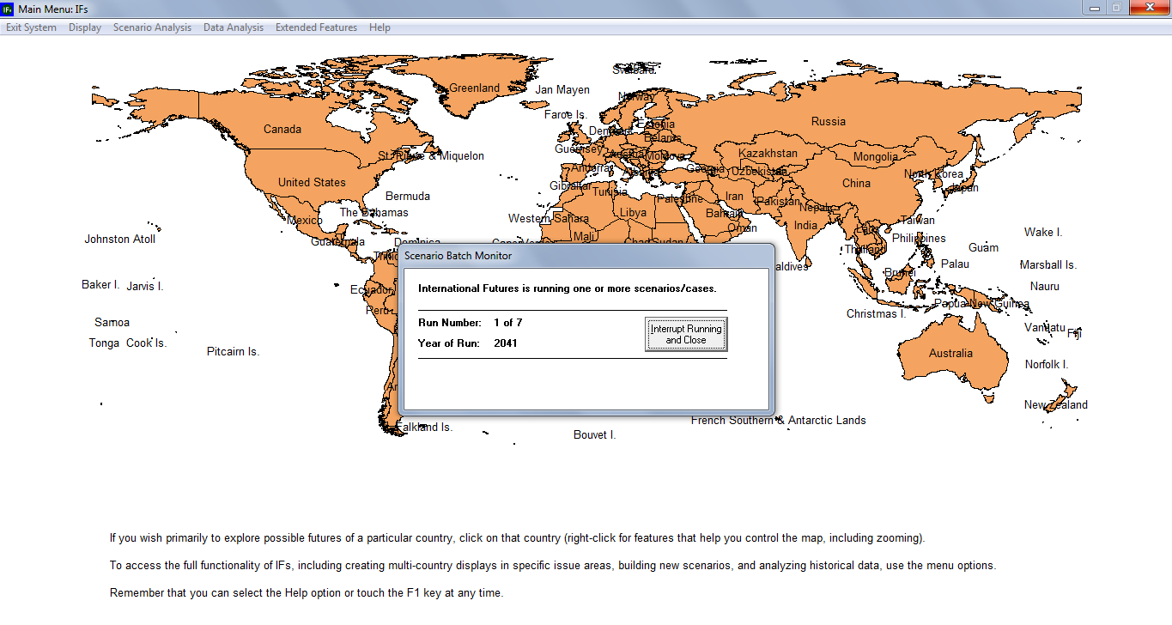

File Management
From the IFs home screen the fourth, and final, option under Scenario Analysis is File Management. Whenever a scenario is run, the results—forecasts of all IFs variables—are written in Working.run, the working file. However, as discussed above, if you do not save your working run file with a different name, scenario results will be lost at the next restart of IFs, when Working.run is overwritten by IFsbase.run, the file containing Base Case forecasts. Scenario run files can be saved only from IFs Main Menu. To save a run file open the Scenario Analysis sub-menu on the IFs home screen, click File Management, and then Save working file as—see the graphic displayed below. Remaining File Management options allow users to open or delete existing run files, as well as select files for display.
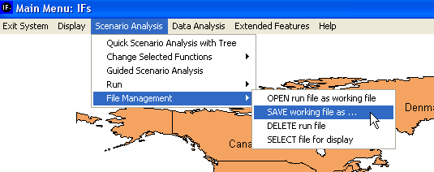
Saving a Scenario Run

Extended Features

Objectives
In this section users will learn how to:
  - alter underlying data series used by the model
  - change country groupings
  - rebuild the Base Case

Introduction
The extended features of IFs are designed for advanced users of the model. This section will serve as a brief introduction to selected features that allow users to: change many underlying data series, change country groupings and add rebuild the model’s Base Case. For an introduction to the complete set of extended features, consult the IFs Help System. From the IFs home screen select Help, and navigate to Use IFs>Extended Features, available at http://www.du.edu/ifs/help/use/extended/index.html. From the IFs home screen, click Extended Features to reach the menu displayed below.

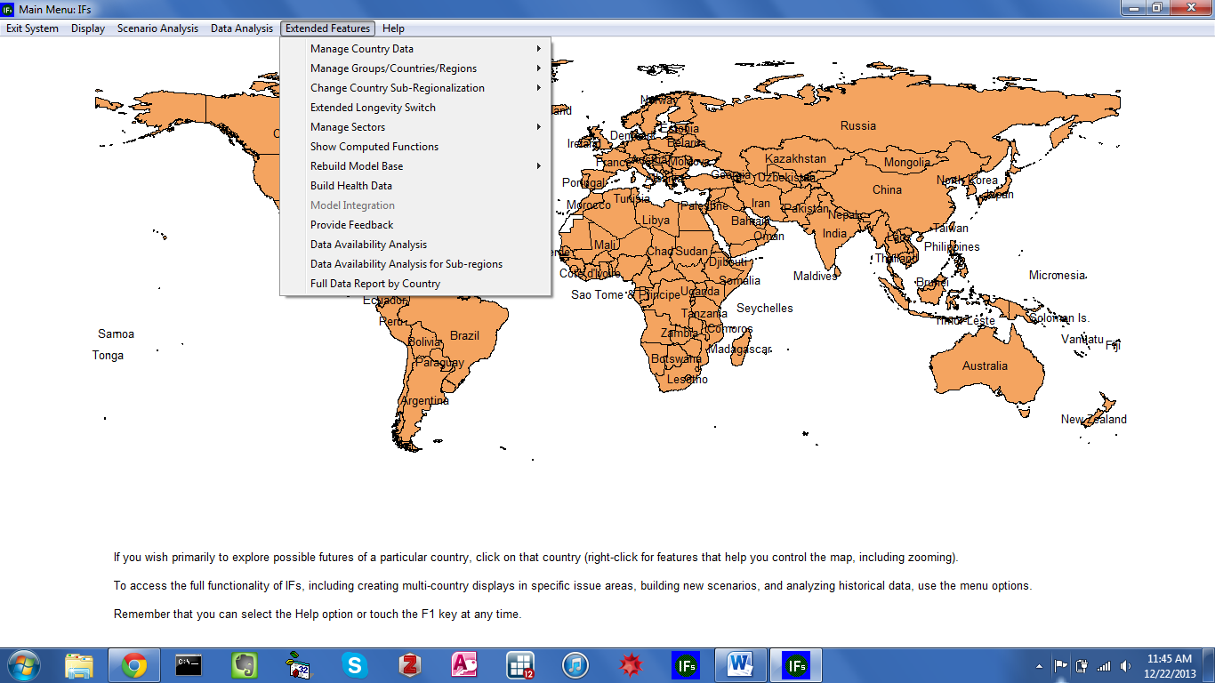
IFs Home Screen: Extended Features

Manage Country Data
The first option available under Extended Features allows users to view source data and import new data series. From the main menu toolbar, open Extended Features and choose Manage Country Data, and then Display Processed Country Data. The ensuing form provides a display of data for each country, data that underlies the use of IFs—see the graphic displayed below. By toggling between the radio buttons located at the top of the screen—Agriculture, Population, Economics, Social/Political and Energy---you can quickly find variables of interest. Click Exit to return to the previous screen.

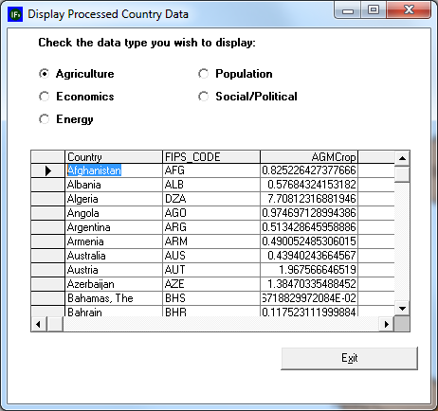
IFs Home Screen: Extended Features

The second option under Manage Country Data is Import Data from XLS File. This feature allows users to import large amounts of data into IFs via Excel. This will add an .xls access file to the IFs historical data set. Click Import Data from XLS File to reach the form displayed below.
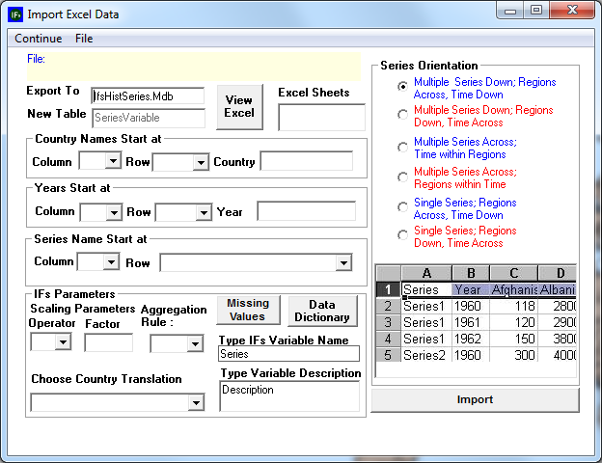
Extended Features: Import XLS

To import data, the first step is to change the Series Orientation setting, located on the right side of the form. Identify how your data set is orientated, and select the corresponding option. Note that the graphic in the lower right-hand corner changes to visually represent the specific data orientation that you choose.
After you have chosen the Series Orientation, click on the File option located on the toolbar. You will be prompted to select an Excel file. Once you have made your selection, the file will be loaded into the Import Excel Data form. Next, select Excel sheets that contain data. Sheets will either have custom names, or simply be distinguished as the default Sheet 1, Sheet 2 and so forth. To see the Excel file you have selected, click View Excel.
And after you have selected your Excel file, you must further specify the locations of country names and years in the data, so that IFs knows how to read the data after it has been imported. Fill in the fields labelled: Country Names Start at; Years Start at; and Series Name Start at. Users are asked to create a name for their data series as well as a brief description. When finished, click Import.

Manage Groups/Countries/Regions
From the IFs home screen, the second option under Extended Features, Manage Groups/Countries/Regions, allows users to explore and manipulate geographic representations. Open the Manage Groups/Countries/Regions sub-menu and click Identify Group or Country/Region Members to reach the form displayed below.
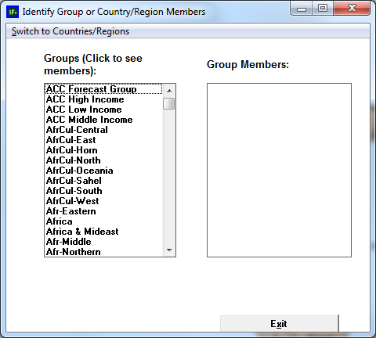
Extended Features: Identify Groups
This option allows users to see countries that are members of various groupings in IFs. Along the toolbar, click Switch to Groups. Now, the scroll box will contain all groups currently defined in the model. Highlight any group, and member countries/regions will appear in the display box to the right. For example, highlight BRICS (5) to reveal the original BRIC countries—Brazil, Russia, India and China—plus South Africa.

The second extended feature located under Manage Groups/Countries/Regions allows users to tailor membership to their needs. From the IFs home screen, open Extended Features and Manage Groups/Countries/Regions, and click Change Grouping/Regionalization to reach the form displayed below.

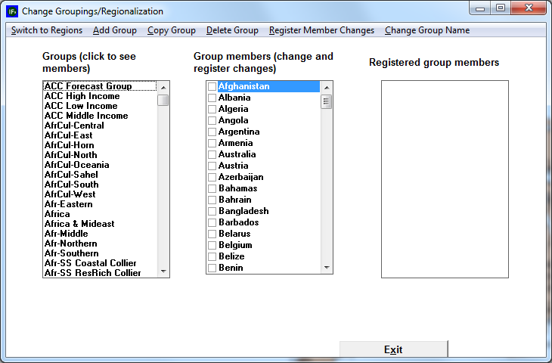
Extended Features: Manage Groups

On the above form, choose the Switch to Groups option. The list box on the left displays the current groups defined in the model. The list box in the middle provides check boxes for all countries/regions in your version of IFs; it allows you to change the membership of the Groups in the left-most box. And the list box on the right shows the full set of country/region members of the active group. S
The toolbar menu-options allow users to modify groups. As a demonstration, try adding a member to an existing group. Click on the Group name in the left-hand list to activate it. You will see the group members on the right. Arbitrarily pick a country/region in the middle list that is not checked, and check the box in front of its name. After you check it, note that the name is still not in the right-hand list. Now click on the Register Member Changes option from the menu. The country/region will then be added to the list box located on the right of the form. With editing complete, you could now exit the form and begin displaying results for the redefined group (or use the group as the basis for parameter change in scenario analysis). But instead, uncheck the box in front of the country/region name and again click on Register Member Changes. You will have undone your change.
Now add a Group. Click on the Add Group option along the toolbar. The system will first confirm that you want to make such a change. For this example, when asked for a name of the Group, simply type “test.” After pressing the Enter key, you will see the new Group at the bottom of the left-hand list.
At this point the Group has been created, but has no member countries/regions. With the name of the Group in the left-most box activated, select its members by activating the appropriate check-boxes in the middle column. When you have finished, select the Register Member Changes option. You will see the members of your Group pop up in the right-hand box. You can now Exit from the form. You should see a message box that indicates no errors were found. Then you will see a message indicating that your new group has been added to the IFs file that maintains such groupings. Now, even when you stop the model and begin again later, the new Group will be defined. From the IFs home screen, go to the Flexible Displays feature, and try to create a table for the new Group. It should work just like any other.

If you have created a Test group, however, you probably do not want it to remain an option. So go back into Change Regionalization/Grouping, select the Test group in the window located on the left of the form, and click the Delete Group option along the toolbar. Again the program will ask for confirmation. Provide it and proceed. There is no limit on the number of Groups that you can designate in this way.

Show Computed Functions
From the IFs home screen, the third menu sub-option under Extended Features is Show Computed Functions. The associated form— displayed below—holds hundreds of functions. (Select one or more of these functions. In order to select more than one function, highlight one function, hold in the Ctrl key and select a second function.) These are many of the functions, the relationships, that underpin the IFs model.

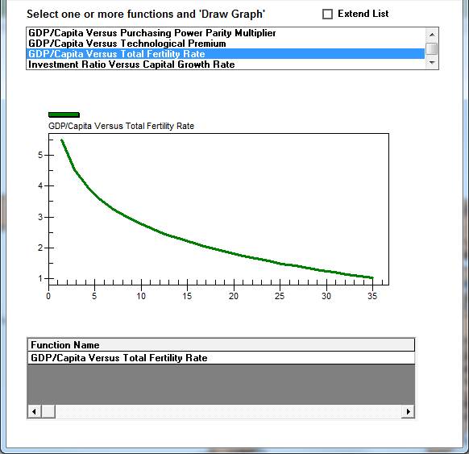
Extended Features: Show Computed Functions

After you have selected a function, choose the Draw Graph option from the top of the menu. This will then display a graphical depiction at the bottom of the screen, along with an r-squared value. Above, see the relationship between GDP per capita and total fertility rate (TFR).

Rebuild the Model Base
If you have made substantive changes to the model, you will have to rebuild the base for them to take effect. From the IFs home screen, select Extended Features, and then Rebuild Base, to reveal two menu sub-options: Rebuild Base and Rebuild Historical Base. Click Rebuild Base to reach the form displayed below.
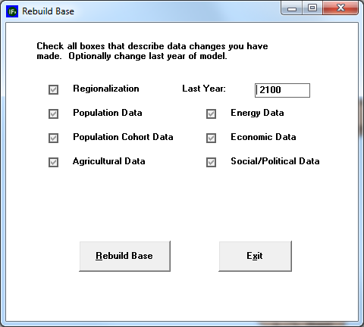
Extended Features: Rebuild Base

Note that IFs will automatically check the issue-area specific boxes, because it needs to create new regional values in each module. Normally you will want to rebuild the Base Case for as long a time period as possible, so leave the Last Year at 2100. When ready, touch the Rebuild Base command button.
Rebuilding the Base Case will take a while, because all country-specific data must be aggregated into regions. A set of algorithms, known as the preprocessor, performs the aggregation, in addition to checking consistency of various data series and to filling holes in coverage. When the process is complete, you will be reminded that you must now run the model. Although all initial conditions and parameters have been placed into the Base Case, all computed values were set at 0 when you rebuilt the base. So Exit to the Main Menu, open the Scenario Analysis menu, choose the Run option, and run the model for the longest time period possible (normally 2100).
Upon completion of the model run, the working run file will contain the computed variables, but IFsBase.run f will not. Because you have rebuilt the Base Case, the model will ask you if you want to save the results of your run (still stored in the working file) as the new Base Case. Respond affirmatively to save the working file as IFsBase.run. These are the only circumstances under which IFs will allow you to save over the Base Case.
You will now have a Base Case that includes whatever changes you made to the model. Any of the displays in IFs will reflect the changes that you have made.

Rebuild the Historical Base
This feature of IFs should only be used if one or more of the following occurs:
- You have lost the Base Case and cannot retrieve it from an instillation disk
- You have changed the country-specific data base in access files
- You have changed the number or membership of model regions
Rebuilding the IFs Base Case will process all of the country specific data in the model and create group files. These files will then be used to construct a new base. Note that rebuilding the Historical Base will delete earlier Run-Result-Files.
After deciding you would like to rebuild the Historical Base, you will be prompted with a menu that allows you to specify what data sets you would like rebuilt and change the last year. The menu should look similarly to the image below:
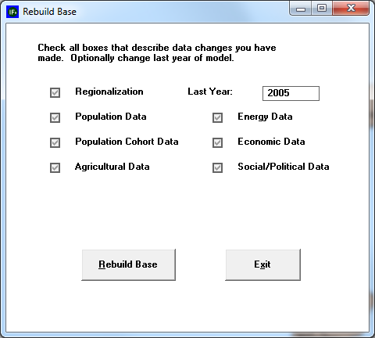
Extended Features: Rebuild Historical Base

Procedure for Overriding Historical Data for a Particular Country (or Countries)
The IFs model keeps its historical data series in a master database file named IFsHistSeries.mdb located in the Data folder in the IFs main installation folder (IFs\Data). The data in this file are taken from standard multi-country sources such as the World Bank’s World Development Indicators and the Food and Agriculture Organization’s FAOSTAT database.
Depending on the project, users may want to use their own data instead of what is in the IFsHistSeries.mdb, e.g. data from a national source instead of the WDI. A special feature in IFs, thus, allows users to override IFsHistSeries.mdb with historical data from other sources without affecting the master database’s original contents.
The following is a step-by-step guide to the override process. You will need Microsoft Access to open the required database files.
- To begin, locate (or create) a project-specific Access database file IFsHistSeriesProject[x].mdb in the IFs ProjectData folder (IFs\Data\ProjectData). The x in the name stands for a particular name-segment chosen for the project. For example, for our work with CEPLAN in Peru, we used the file name IFsHistSeriesProjectPeru.mdb. The project data file is designed to hold the data series that will override those in IFsHistSeries.mdb. Each table in the project data file must have the same name and general structure as the series you want to override in IFsHistSeries.mdb but should only contain rows for the country(ies) whose data you wish to change (the project tables can, however, contain fewer or additional column years—see below). While any series can technically be overrode, it only makes sense to do so with data series used in the model’s pre-processor to rebuild the Base Case as replacement only occurs during the rebuild process (see #3 for instructions on adding other tables to this file). The most common tables put into the project data file will thus be the so-called “essential series” of IFs, namely GDP, GDP per capita, and total population.

- Using MS Access, you can add/edit/remove country-specific data points and country-rows from the data tables in the project database file (IFsHistSeriesProjectPeru.mdb in this example) as needed. You can also bring in new country-rows from the master database (IFsHistSeries.mdb) and then edit those data cells. If you have data for years not covered in IFsHistSeries.mdb you can add the missing years (in the proper order) via the add column function in the design view of the Access table. After saving the design changes to the table, you can add data to the new column. Keep in mind that your new data series will completely replace the existing series of the same name, regardless if the two series cover different periods of time (i.e. if the original IFs series SeriesGDPInformal%Blended has data for years 1990—2010 and your replacement series has data for 2007—2012, only the 2007—2012 data will be kept).

- To add a data series table to the project data file, you will need to copy the corresponding table from the master database, IFsHistSeries.mdb, and paste it into the project database, using the “structure only” option during pasting. You must keep the table’s structure and name the same. You will be asked to provide the database password data4ifs12 (all lower case) on pasting. Once the table itself is copied, copy only those country-rows you want to change (i.e. Peru) into the project database. You can then edit the data points as needed. You can also add additional year columns if needed (following the same procedure described in #2).

- Once you have added all the data tables you want to the project data file, you will need to read that file into the IFs historical database. To do so, select IFs Main MenuExtended FeaturesManage Country DataHistorical Data File ProcessingProject DataLoad Project Data (see figure 2 below). Select the project data file you want to load (IFsHistSeriesProjectPeru.mdb in our example) in the popup dialogue box and click the load button.
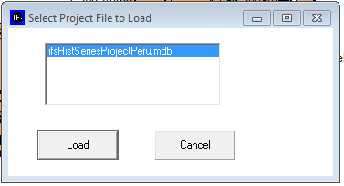
Figure 1: load project file
- IFs will then a file with the augmentations/changes to IFsHistSeries.mdb called IFsHistAugment.mdb and place it in the IFs/Data folder. It will also place a flag in the IFsInit.mdb table ProjectDataCountryLoad
It will also place a flag in the country field of the ProjectDataCountryLoad table within IFsInit.mdb, namely the name of the country for which data have been augmented/changed (normally the table is empty). Once you data changes are loaded, IFs will prompt you to begin the Rebuild Base process (click ok in the first dialogue box, Rebuild Base in the second, and Ok in the third and fourth. The model will then rebuild the Base using the new IFsHistSeries.mdb. IFs will also create in the Data folder a backup version without changes named IFsHistSeriesOriginalNoProjectData.mdb for restoring the original, unaltered master database. Finally, the model will ask you to rerun the Base Case to 2100. Click Start Run. Once the model has finished running, you are set to go.

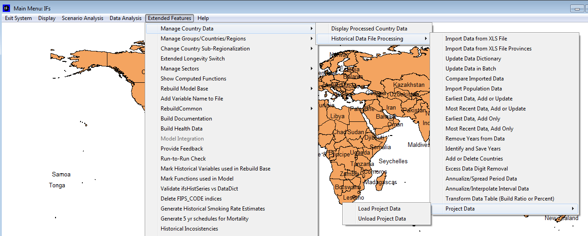 Figure 2: menu-path to load/unload project data file
- To revert to the original, unaltered version of the master historical database, select IFs Main MenuExtended FeaturesManage Country DataHistorical Data File ProcessingProject DataUnload Project Data. This will take you through the Rebuild the Base process again. Once complete, you should completely exit the IFs model and re-launch to ensure that the original model is completely restored.

Note concerning the building of installations for countries/projects with augmented or changed data. Those installations should be sure to include:
New files: (1) IFsHistSeriesProject[country/projectname].mdb under IFs/Data/ProjectData, (2) IFsHistAugment.mdb under IFs/Data and (3) IFsHistSeriesOriginalNoProjectData.mdb under IFs/Data.
Normally distributed but changed files: (1) IFsHistSeries.mdb under IFs/Data and (2) IFsInit.mdb under IFs.

The File System

Objectives
This section of the training manual will introduce users to several important folders, located in the IFs file structure:
  - The Root Folder (IFs)
  - DATA
  - RUNFILES
  - Scenario
  - Code

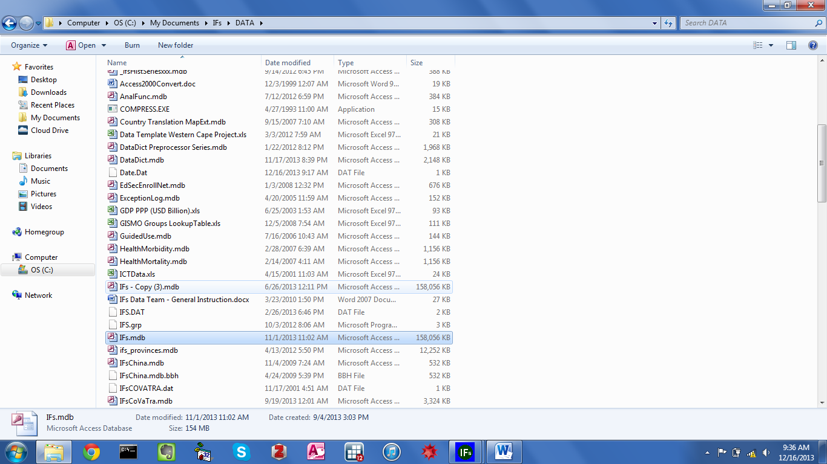
IFs File Structure

Root Folder (IFs)
The root folder is called IFs, and contains most of the system files and folders. The main file of the system is ifs.exe. This is the program itself, compiled into an executable from Visual Basic 6; it contains the code to run every module of the model and is connected to the graphical user interface (GUI).
Another important file is ifsGUIprj.ocx (the GUI), a repository for most of our display interfaces, which use 3rd party controls like GigaSoft Proessentials, BlueMarble GeoObject Map control and FMS Statistical software. We build the .ocx file as a separate file in order to distribute it to users interested in Model Development without forcing them to buy licenses for 3rd party controls, which are used only for display purposes. Another reason for the separation is the ability to update the GUI without recompiling the full model and create a new .exe file. In practice, however, model updates are available infrequently, so they often include changes to the model as well as the GUI. We have also encountered some registration issues when trying to update the GUI by itself, so we don’t currently recommend it. The ifs.exe and ifsGUIprj.ocx files concentrate all of the Visual Basic code developed for IFs over the last 30 years. All other files in the root folder primarily relate to initialization data and forecasting results.

ifsInit.mdb is the first initialization file used in the system. This file holds initialization information for variables, such as values for the first and last forecast years, and file and folder names that are used globally in the system. Of the tables contained in the file only two are currently used: ifsInit, where most configuration variables are stored, and LoadFull, which holds specific configurations for the full version like the model version and maximum number of regions allowed (currently 220). The only difference in this file between a target machine and a development machine is a variable in ifsInit called DevelopmentMode, which is set to false for target machines and to true for development machines. When the setting is set to true, extra options are available in the Extended Features menu. These options are mostly used for configuration of initialization data, like rebuilding documentation support files, estimating historical smoking rates or loading conflict data.

DATA Folder
The DATA folder contains most of our initialization data, and in general its content is not frequently changed in a regular user session.
ifsVar.mdb contains several tables, but the most important one—probably in the entire system—is our catalog of variables (ifsVar). The model currently uses 1164 variables, parameters and initial conditions. This table stores important fields like the name of the variable, a description of the variable, the variable type (variable types include: computed variable, initial condition and parameter) and the number and type of dimensions for each variable. We have a few variables and several parameters that do not have dimensions, for example WPOP, WGDP or some global parameters like hlstddthsw. Most of our variables only have 1 dimension, and that dimension usually is region, for example POP, GDP and TFR. A smaller portion of the catalog has 2 dimensions—variables like LIFEXP and GDS (Government Expenditures by Sector). Finally we have a handful of variables with 3 dimensions, variables like DEATHCAT and HLYLL. Other types of dimensions are gender, economic sector, type of energy and type of land. These different types can be found in another file in this DATA folder: ifs.grp. Other tables in this file include the list of aggregation rules to use for grouping and the set of variable list tables, where we store our prepackaged displays, both fixed and flexible.
Ifs.mdb contains numerous tables, most of them used for initialization. The most frequently used is GlobalParameters, which stores default values for parameters—here you can change the value of a parameter for the Base Case, but then you need to rebuild the Base Case. Another table worth mentioning is the Country Translation Table. Different organizations often use different names for the same country (e.g. Macedonia versus The Former Yugoslavian Republic of Macedonia). We use the Country Translation table to store these variant names and to convert them to a standard set used in the Model. The currency table stores different currency translation values used to display conversions between different currencies. We also store our geographical grouping tables here, starting with RegionalizationFull, which establishes the relationship between Countries and Regions. The relationship is currently one to one, but can be changed. RegionIDNewFull holds the full name of each Region; the names of Regions and Countries are not necessarily the same—for example for the region we use USA and for the Country United States. GroupingFull is the table that establishes the relationship between Regions and Groups, which is many to many (i.e., one region can belong to many groups, and one group can have many regions). GroupIdNewFull holds the full name of each group. Finally, in the geographic section we also have GList, which holds a subset of regions and groups used for display purposes only (GList stores the full name of the geographic list). We usually store historical data in another file, but in cases where we only have data for the Base Year, and the data are organized by age category, we store data in ifs.mdb. Some examples of that are PopAgeCohortCountryMale, PopMortalityCohortCountryFemale and PopFertilityCohortRegionFemale.

ifsHistSeries.mdb is the file where we store historical series commonly used to initialize Base Year values of our variables and to find cross-sectional regressions used forecast values when strong relationships are found. There are over 2000 series in this file now. Four of the most important series are: SeriesPopulation, SeriesPopulationUNFilled, SeriesGDP2000 and SeriesGDP2005PCPPP. The first two tables are from different data sources: SeriesPopulation comes from the World Bank and is used for historical initialization and SeriesPopulationUNFilled comes from the United Naitons and is used to initialize our forecast. The most common format for these tables is to have each year, from 1960 to 2010 (most common time period) ,as a column in the table, and then to add two extra fields to the end, for earliest and most recent years. The fields titled Earliest and MostRecent are computed by a process in the Extended Features menu. There are some exceptions to this format; in some case there are ranges of years in a single year, for example 1980-1999 in table SeriesEnvAvgAnnTemp.
DataDict.mdb is our catalog of historical empirical variables. This file is essentially a list of the tables stored in ifsHistSeries.mdb. The main table is also called DataDict. New historical variables must be registered here or they will not appear when running the program.
TablFunc.mdb is where we store most of the bivariate regressions used in the model. Such regressions need to be one of the following types: linear, logarithmic, exponential, power, quadratic or cubic. We currently cannot mix these types. We can also store up to 10 individual points to describe a function.
AnalFunc.mdb is the file where we store most multivariate regressions used in the model. The regressions need to be one of the types described above. They cannot be mixed within the same independent variable, but you can have different types for different independent variables.
IfsPop.mdb stores age-cohort based data. IFs age categories are 5 years long except for infants, 1-4 and 100+. The file stores different tables with information about education, health, mortality (aggregated and detailed by type), and morbidity.

RUNFILES Folder
The RUNFILES folder is our working folder. Most of the files in the DATA folder are copied to RUNFILES when the model starts, and most modifications that occur during the user’s session are made to the copies in RUNFILES, allowing you to easily cancel your changes by simply restarting the model. You can also save them permanently by saving the modified files back to DATA.
ifsBase.run stores the results of the IFs Base Case forecast from the Base Year (2010) until the desired run horizon, usually 2100—but sometimes a shorter (say, 2050), which keep the runs shorter and the files smaller. The format of the file is binary, (which is basically compressed text format), and it is organized as a long chain of numbers. Logically you can think of it as a matrix, where each row is a year, and each column is a variable with its different dimensions. Variables are ordered alphabetically, and dimensions follow the order in which they were created in the file ifs.grp—described in the previous section (except for the regional dimension, which is alphabetical). Each number is stored as a 4 byte number, and thus you can assume that the length in bytes of each row is the number of variables multiplied by its respective dimensions times 4.
Working.run is a copy of ifsBase.run. The file gets initialized every time you start the model. Thus when you are starting a new session of the model the working file is identical to the Base Case. If you make a change in any of the parameters of initial conditions and rerun the model, your results will change, and they will be stored in this file. If you want to preserve them after you finish your session you must save this file with a different name. In fact, the file gets changed if you simply process your parameter changes from the scenario tree. If you check working.run just before running the model you will see changes in the parameters, but not yet in the computed variables.

The RUNFILES folder also contains a number of other run files. These are our the run files for our packaged scenarios, including Markets First.run, Policy First.run, Security First.run and Sustainability First.run. These four run files are the results of the four scenarios built for the UNEP GEO (Global Environmental Outlook) 4 project. All of these files are the same size as the Base Case because they have the exact same variables and years. If you find a run file that is not of the same size, that means it is from a previous version of IFs with a different number of variables. It is possible to run a scenario for a smaller amount of years than the Base Case and then save it. That will still keep the same size of the file, and the year of the run will be saved at the beginning of the file to indicate that numbers are only valid until that year. The only way to change the size of a run file is by rebuilding the Base Case after changing the variables, dimensions or years to be used.
ifsPopWork.mdb is a copy of ifsPop.mdb described in the DATA section. The file works like working.run in the sense that it is where you store your results when you run the model, and needs to be saved in order to preserve your changes. When you save a working.run file using the menu options under Scenario Analysis, the corresponding version of ifsPopWorking.mdb will be saved with the same name used for the working.run file. The run file’s format will be of the format ifsPopXXX.mdb, where XXX is the name selected for the working file. Another file that is stored with the same name is SAMXXX.mdb, which is used for display of the Social Accounting Matrix.
IFsBaseHist.run is the historical version of ifsBase.run, where the historical forecast is run from 1960 to the Base Year (2010). The historical forecast is commonly used for validation against empirical data. The width of the file is the same as the regular base, but because the number of years is usually different the size of this file is usually smaller.

Scenario Folder
The scenario folder stores all the scenario files, saved in text format with a .sce extension. These .sce files are very small text files, containing all modified assumptions and other interventions that make up the scenario. However, they do not contain any forecasts. Forecasts from a particular scenario are generated only when the scenario is run. These forecasts are saved in files with .run extension, as mentioned above.

Code Folder
The Code folder includes all the Visual Basic files used in the main project to build the Base Case and run the model. In Visual Basic 6 there three types of files: forms with the .frm extension, modules with .bas extension and classes with .cls extension. Forms are mainly used for display and interaction with the user, and have been concentrated in the GUI—though sometimes it is convenient to handle those in the main project itself. Modules are used for the model logic. Classes have not been used frequently in the main project, but they have been used to create displays.
The code for the first initialization, rebuilding of the base, is what we call the Preprocessor, and it is stored in this folder in the set of files that start with the word DATA—for example: DATAPop.bas, DATAEcon.bas, DATAEner.bas.
The code for the run of the model is stored in 9 different physical files where we have tried to organize the different modules and submodules of the model: Economy (Economy.bas), Population (Populat.bas), Agriculture (Agricul.bas), Energy (Energy.bas), Environment (Environment.bas), Automobile (Automobile.bas), Infrastructure (Infrastr.bas), SocioPolitics (SocioPol.bas), and recently added Knowledge (Knowledge.bas).
It is also important to mention that Function2.bas stores the procedure ModelRun, which is the file that calls all of the previous modules. It also stores the procedure that loads the scenarios from the tree into the working file; this procedure is called ProcessTimeSeries.

In the model, variables names appear in capital letters, whereas parameters appear in lower case.
Scenario files(.sce) and run files(.run) are alternatively referred to as scenario parameter files and scenario run files.
Scenarios in a computer model are typically built from multiple interventions that collectively build a coherent story about the future. Often, but somewhat imprecisely, the word scenario is used more loosely to refer to any single intervention—such as the change of a fertility rate for a country, or an alternative assumption about oil resources.
One of the ways you can limit the run file size (and the run time) is by running the scenario for a shorter horizon. However, some scenarios inherently require longer horizon (e.g., a global warming scenario) to be able to make any changes.
It is important to bring in entire country-rows form that database. If you were to create a country-row that was shorter than that in IFsHistSeries.mdb, your changes would not alter values for years that that you have not included.
ifsInit.mdb is a Microsoft Access 2000 compatible file
ifsHistSeries.mdb is currently password protected.
Another series to pay attention to is SeriesPolityDemoc, which starts in the year 1800.

