
FREDERICK S. PARDEE CENTER
FOR INTERNATIONAL FUTURES
EXPLORE UNDERSTAND SHAPE

WORKING PAPER 2013.09.20

IFs AGRICULTURAL MODEL DOCUMENTATION

Authors: Barry B. Hughes and José R. Solórzano
September 2013

Note: This is a draft version.





IFs Agricultural Model Documentation

Table of Contents

1. Introduction 2
1.1 Overview 2
1.2 Dominant Relations 2
2. Flow Charts 4
2.1 Agricultural Overview 4
2.2 Agricultural Demand 5
2.3 Agricultural Production: Crops 7
2.4 Agricultural Production: Meat and Fish 8
2.5 Investment and Capital 9
3. Equations 10
3.1 Supply 10
3.2 Demand 13
3.3 Trade 15
3.4 Stocks 17
3.5 Calorie Availability 18
3.6 Prices 18
3.7 Investment 20
3.8 Economic Linkages 23
3.9 Capital Dynamics 24
3.10 Land Dynamics 26
3.11 Livestock Dynamics 27
3.12 Indicators 28
4. References 29

Introduction

Overview
The structure of the agriculture sub-model is very much like that of the economic sub-model. It combines a growth process with a partial economic equilibrium process, providing for distinct demand and supply sides. The equilibrium process uses prices to seek a balance. As in the economic model, however, no effort is made in the standard adjustment mechanism to obtain a precise equilibrium in any time step. Instead stocks serve as a temporary buffer and the model chases equilibrium over time.
Price elasticities of demand tend to be relatively small compared to the price elasticities of supply, thereby giving the demand side greater influence in determining equilibrium levels.
There are two agricultural commodities in IFs: crops and meat/ fish. Crops have food, animal feed and industrial uses. Meat/fish have only food use. Land falls into five categories: crops, grazing, forest, unused, and industrial/urban use.
The economic model provides income levels and food consumption to the agricultural model. After the computation of demand, supply, trade, prices, and investment in the agricultural model, those values go back to the agricultural sector of the economic model and override the sectoral computations of that model.

Dominant Relations
Agricultural demand (AGDEM) is an aggregation of food (FDEM), feed (FEDDEM), and industrial (INDEM) demand. Agricultural production (AGP) is a product of land (LD) and yield (YL) for crops and of size of livestock herd (LVHERF) for meat.
The following key dynamics are directly linked to the dominant relations:
Food demand depends on the GDP per capita and agricultural prices, computed endogenously. The user can control demand dynamics via an agricultural demand multiplier (agdemm) and the elasticity of crop demand with prices (elascd). Feed demand depends on the size of the livestock herd relative to grazing land capacity and will be strongly influenced by assumptions of the calories that a population derives from meat (calmeatm)

The model user can control agricultural production directly with the yield multiplier, ylm. Rates of loss between gross production and market (LOSS) are determined endogenously, but can be controlled also by the user (lossm). Agricultural capital (AGP) underlying endogenous calculations of yield and developed crop land (LD) depend on endogenously determined, cost-responsive investment rates that the user can influence in the aggregate (via aginvm). Land depends also on exogenously specified multiplier on forests (forestm).

The larger food and agriculture model provides representation and control over agricultural trade and pricing. The model also has an open system for user-specified feedback between carbon dioxide build-up and crop yields. Further, there is representation of both ocean fish and aquaculture fish.

1.3 Structure and Agent System
System/Subsystem | Agriculture
Organizing Structure | Partial market
Stocks | Capital, labor, accumulated technology
Flows | Production, consumption, trade, investment
Key Aggregate Relationships  (illustrative, not comprehensive) | Production function with endogenous technological change  Price determination
Key Agent-Class Behavior Relationships  (illustrative, not comprehensive) | Government taxes, subsidies  Household grain and meat consumption

Flow Charts

This section presents several block diagrams that are central to the agricultural model.

2.1 Agricultural Overview

The agriculture model combines a growth process in production with a partial equilibrium process that replaces the agricultural sector in the full-equilibrium economic model unless the user disconnects it. The model represents agricultural goods in crop and meat categories (adding a simple fish production/consumption model as well).
The key equilibrating variable is again inventories. It works via investment to control capital stock and via prices to control both trade and domestic consumption.
Specifically, as inventories rise, investment falls, restraining capital stock and agricultural production, and thus holding down inventory growth. And as inventories rise, prices fall, thereby decreasing imports, increasing exports, and reducing domestic consumption, all of which hold down or decrease inventories.
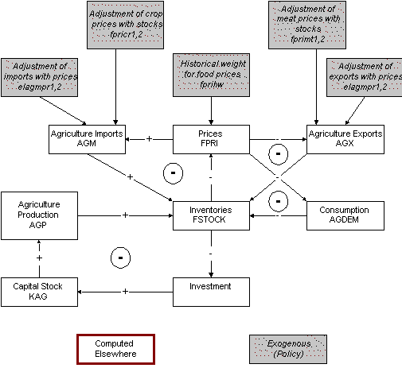

The above variables also make it possible to compute world agricultural prices (WAP) and world food stocks/inventories (WFSTK).

2.2 Agricultural Demand
Agricultural demand is divided into crop and meat/fish. Crop demand has three components: food demand, feed demand (for livestock), and industrial demand. Meat demand is only for food.
The primary determinants of food demand are the size of the population and the consumption level per capita. Calorie consumption per capita both rises with GDP per capita and changes form – calories from meat increasingly supplement/replace calories from crops. Prices also affect calorie consumption per capita.
Both industrial and the livestock herd make claims on crop production that add to human consumption in the calculation of total agricultural consumption. The demands of the livestock herd are dependent not just on its size, but on the capacity of grazing land to provide the needs of the herd. (The flowchart appears on the following page).
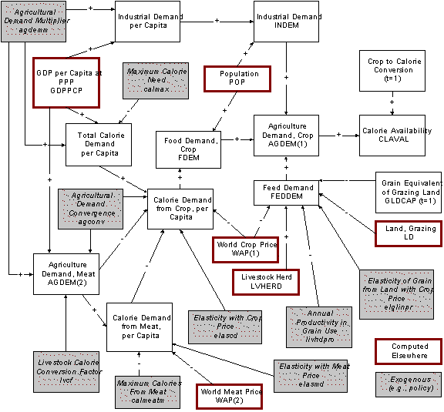

2.3 Agricultural Production: Crops
Agricultural crop production is most simply a product of the land under cultivation and the yield per hectare of land. We can compute also the global sum (WAPRO). The determination of yield is, however, rather more complex.
Agricultural yield is determined in a Cobb-Douglas type production function, the inputs to which are agricultural capital, labor, and technical change, modified by the efficiencies of capital and labor. Unlike the Cobb-Douglas function in the economic model, this one is subject to a saturation factor that is computed internally to the model - investments in increasing yield are subject to diminishing rather than constant returns to scale. Moreover, the increase in atmospheric carbon dioxide can, if the user sets appropriate parameters, affect agricultural yields. Finally, the user can rely on a yield multiplier to increase or decrease yield patterns.
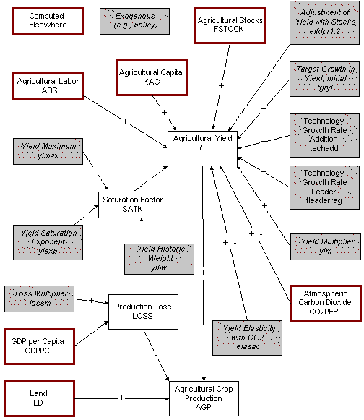

2.4 Agricultural Production: Meat and Fish
Meat production is represented far more simply than crop production: it is the product of livestock herd size and the slaughter rate. The herd size changes over time in response to the meat stocks.
Fish production has two components: wild ocean fish catch and the country/regional share of that catch; and aquaculture levels.
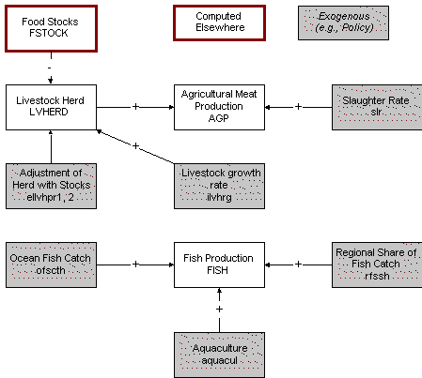

2.5 Investment and Capital
Investment in agriculture, determined largely by stock and profit levels, has two possible targets. The first is capital stock. The second is land. The split between the two destinations is a function of the relative cost of land development and capital investment. The cost of land development is, in turn, a function of remaining undeveloped land.
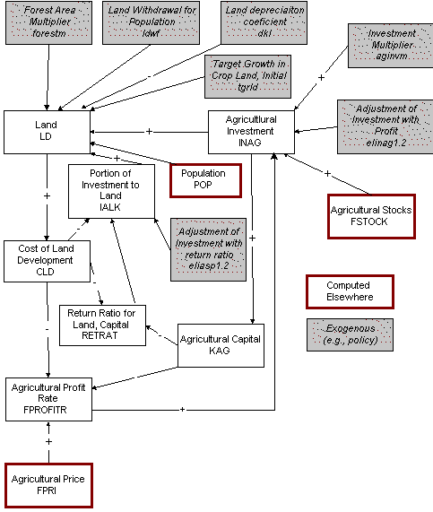

Equations
This section will present and discuss the equations that are central to the functioning of the agricultural model.

3.1 Supply
Crop and meat/fish supply have very different bases and IFs determines them in separate procedures. Crop production depends on yields per hectare of land under cultivation and on the amount of land cultivated. Yield functions are almost invariably some kind of saturating exponential which represents decreasing marginal returns on inputs such as fertilizer or farm machinery. Such functions have been used, for instance in World 3 (Meadows, 1974), SARUM, (SARU, 1977), the Bariloche Model (Herrera, et al., 1976), and AGRIMOD (Levis, et al., 1977). IFs also uses a saturating exponential, but relies on a Cobb-Douglas form. The Cobb-"Douglas function is used in part to maintain symmetry with the economic submodel but more fundamentally to introduce labor as a factor of production. Especially in less developed countries (LDCs) where a rural labor surplus exists, there is little question that labor, and especially labor efficiency improvement, can be an important production factor. "Know-how" is also important in agriculture and there is, for example, a positive linkage between educational expenditures and agricultural output.
IFs computes yield in two stages. The first provides a basic yield (BYL) representing change in long-term factors such as capital and labor. The second stage uses this basic yield as an input and modifies it based on prices, so as to represent changes in shorter" term factors (e.g. amounts of fertilizer used, even the percentage of land actually under cultivation).
The basic yield (BYL) requires capital in agriculture (KAG), labor (LABS), technological advance (AGTECH), a scaling parameter (CD),and an exponent (CDALF). In addition a saturation coefficient (SATK) introduces the behavior of the saturating exponential. Interpret AGTECH as a factor-neutral technological progress coefficient and see equations on the production function for an explanation of TECHGRO.
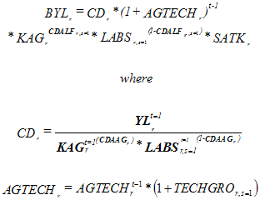
The saturation coefficient is a multiplier of the Cobb-Douglas function. It is the ratio of the gap between an exogenously specified maximum possible yield (YLMAX) and the most recently computed yield to the gap between the maximum yield and the initial yield, raised to an exogenous yield exponent (YLEXP). With positive parameters the form produces decreasing marginal returns.
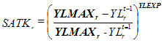
The basic yield represents the long-term tendency in yield but because agricultural production levels are quite responsive to short-term factors such as fertilizer use levels and intensity of cultivation. Those short-term factors under farmer control (therefore excluding weather) depend in turn on prices, or more specifically on the profit (FPROFITR) that the farmer expects. Because of computational sequence, we use food stocks as a proxy for profit level. The recomputed yield (YL) uses the ADJSTR function to build in response to both the absolute stock level and the recent change in stocks (the change-in-stocks term builds in some anticipatory and smoothing behavior).
The focus in IFs on yield response to prices differs somewhat from the normal use of price elasticities of supply. For reference, Rosegrant, Agcaoili-Sombila, and Perez (1995: 5) report that price elasticities for crops are quite small, in the range of .05 to .4.
There are, however, two additional factors that can influence agricultural yield. The first is global climate change and the second is a series of regional factors, including weather patterns and political/social management (such as collectivization of agriculture). IFs therefore recomputes yield one last time, modifying it by two multipliers. The first introduces the change in the level of atmospheric carbon dioxide (SCO2) compared to initial levels (ICO2), as a proxy for global climate change, and uses an elasticity (ELASAC) to indicate the regional impact of climate change (it could even be positive). The second factor is a regional yield multiplier (YLM) that allows the model user to introduce assumptions about weather patterns and other uncertain elements in the agricultural system.
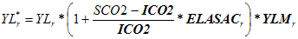
Finally, agricultural production (AGP) in the first or crop category is the product of yield and land devoted to crops (LD).
The production of fish has two components, ocean and mariculture. Total global ocean fish catch (OFSCTH) is set exogenously, as is each region's share in it (RFSSH) and the regional value of aquaculture (AQUACUL).
Livestock production (AGPLV) is dependent on the herd size (LVHERD) and the slaughter rate (SLR).
Total fish and livestock production, food category two, is the sum.
Some food production will never make it to markets, but will be lost in the field or in distribution systems to pests, spoilage, etc. That loss (LOSS) is a function of GDP per capita in a table function that captures the tendency of loss to decrease with higher income levels. A loss multiplier (LOSSM) allows scenario introduction.
Once we have computed agricultural production, it is possible to compute a production-weighted global average of agricultural prices (WAP).
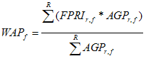

3.2 Demand
Crop demand has three components: feed, industrial and food. Feed demand (FEDDEM) depends on the live"stock herd size (LVHERD), its feed requirements per unit (FEDREQ), the amount of grazing land (LD, category 2) available, and that land's feed equivalent capacity per unit (GLDCAP). IFs computes that capacity the first year. The user can adjust feed demand and other components of total agricultural demand with an agricultural demand multiplier (AGDEMM).
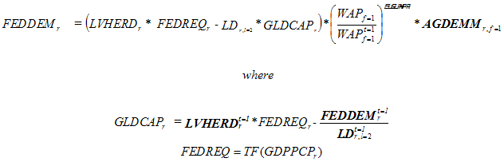
The feed requirement table function takes into account the fact that at low levels of income most meat consumption is typically poultry (with a conversion ratio of grain to meat of about 2-to-1), while at higher levels of income, pork (4-to-1) and then beef (7-to-1) become increasing portions of meat demand (Brown, 1995: 45-47).
Industrial demand (INDEM) per capita is a function of GDP per capita in purchasing power parity terms (GDPPCP), a relationship that IFs represents in table function form.
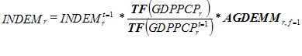
The computation of food demand begins with a determination of the number of total calories (from grain, meat, and fish) that the population would normally demand (CALDEM) at the level of GDP per capita at purchasing power (GDPPCP) of the region or country. The typical number of calories per capita (CALPERCAP) is computed in a table function and multiplied by the size of the population (POP). An exogenous maximum (calmax) prevents extreme values.
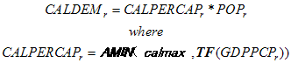
IFs then computes the demand for meat and fish (MEATDEM) in the same way, except that it adjusts that demand based on world food prices (WAP) relative to initial prices.
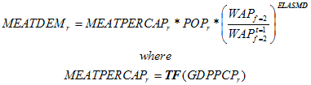
Traditionally, agricultural models have used income elasticities to predict food demand, instead of the table functions that IFs uses. For example, see the IMPACT model described by Rosegrant, Agcaoili-Sombila, and Perez (1995: 5), where income elasticities range for cereals from -.4 to .26 (high-quality grains) and for meat from .2 to .9. IFs uses table functions because elasticities lose their value with long-term forecasting over a wide range of income levels.
Meat demand allows the computation of agricultural demand in the meat category (AGDEM), which simply adjusts meat demand generated by the table function so that it is consistent with the empirically correct initial conditions.
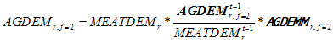
Given the total agricultural demand for meat and fish, it is possible to compute the number of calories that the population can expect to obtain from meat and fish (CALFROMMEAT), using a livestock to calories conversion factor (LVCF) and adjusting the term so that it will be consistent with the empirically known calories available (CLAVAL) the first time step. The calories from meat are bound as a portion (calmeatm) of total calories.
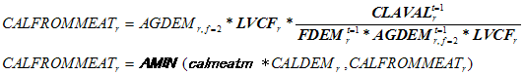
Knowing the calories from meat and fish and the total calorie demand, it is possible to compute the calories needed from grain (CALFROMGRAIN).
Food demand from grain (FDEM) is readied for the model by adjusting that calorie demand for food prices (FPRI), and assuring that it will meet empirical initial conditions.
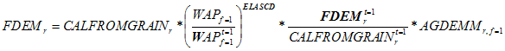
Total agricultural demand (AGDEM) in the first category (grain) is the sum of the three components, feed demand, industrial demand, and food demand.
This formulation for food and meat/fish demand has one problem that future revisions of the model should address. Consumption of agricultural product, as calculated in the economic model (CS), should be revised to be consistent with this agricultural model calculation of agricultural demand. Currently the economic model value is calculated from a linear expenditure system formulation.

3.3 Trade
The agricultural export capacity (AGXC) is a moving average portion (AXKAVE) of production.
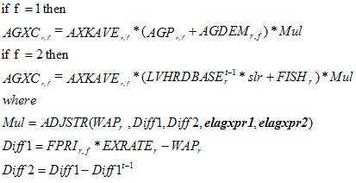
The agricultural import demand (AGMD) is a moving average portion (AMKAVE) of demand (AGDEM).
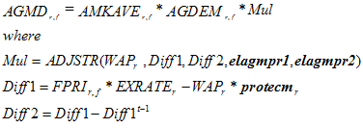
World agricultural export capacity (WAGXC) and import demand (WAGMD) are simply sums across regions.
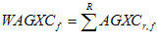
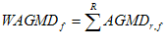
These will always be somewhat different. Actual world trade (WAGT) is the average of the two.
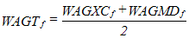
Agricultural exports (AGX) or imports (AGM) will thus need adjustment relative to capacity or demand. This adjustment normalizes exports and imports to the total of global agricultural trade.
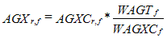
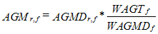
IFs can now update the moving average export (AXKAVE) and import (AMKAVE) propensities for the next time step. This requires historic weights for exports (XHW) and imports (MHW).
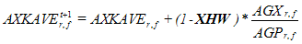
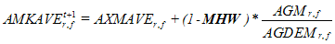
In an earlier version of the model, the computation of export capacity and import demand included a price sensitive term, in which local prices and global prices were compared. We moved to this simpler form at the same time that we enhanced agricultural prices and investment, making the first responsive to regionally-specific costs of agricultural production and making the second responsive to regionally-specific profits in the agricultural sector. These changes are key to the dynamics of the agricultural module and determine the regional contributions to the global food market. Trade simply clears that market.

3.4 Stocks
Basic stock levels (BSTOCK) increase over time with production (AGP) as adjusted for loss before reaching market (LOSS), decrease with demand or consumption (AGDEM),and adjust for exports (AGX) and imports (AGM).
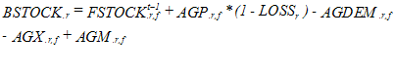
This is the basic stock level only because the actual stock value (FSTOCK) is not allowed to go negative. If the basic stock level is negative, stocks are set at zero and a shortage (SHO) exists. If the basic stock level is positive there is no shortage and stocks equal the basic level.
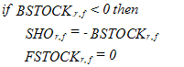
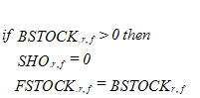

3.5 Calorie Availability
The availability of calories to a region (CLAVAL) depends on food (FDEM) and meat/fish (AGDEM) demand, the latter being converted by a livestock calorie coefficient (LVCK) into its crop equivalent. Shortages, if any, must be subtracted from the demand, although crop shortage affects calorie availability only to the extent that food demand is a portion of total crop demand. The total food availability is converted to calories by a scale factor (SCLAVF), computed the first time step.
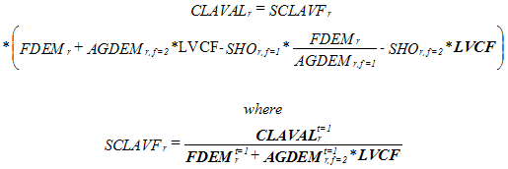
Calorie availability combines with regional calorie need in the population submodel for the calculation of possible starvation deaths.

3.6 Prices
Crop prices (FPRI) respond to the level of stocks. In the agricultural submodel we also have, however, enough detailed sectoral information to know about changes in costs. IFs thus changes prices in response to two inputs: (1) an underlying rise or fall in production costs, which determine the basic trend of prices and (2) the level of inventories or stocks, which determine the movement of prices around the basic trend or the markup of prices above costs.
Production costs (COST) for crops per unit of production depend on the cost of land and the cost of the capital investment in agriculture. The total cost of land depends on the amount of land under cultivation (LD) and the unit cost of land development (CLD).
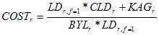
IFs uses both the first order stocks (immediate stock levels) and the second order stocks (the change in stocks over time), so as to smooth the markup response. The base against which we compare stocks is primarily agricultural demand (for stability), modified when production initially exceeds demand by the ratio of initial production to demand (this formulation provides an adequate base for both importing and exporting countries). IFs weighs first order stocks against a desired (DSTL) portion of the stock base.
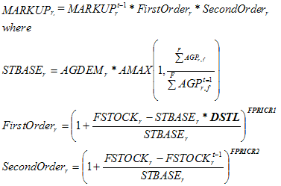
Putting together both cost information and price information, we can compute price.
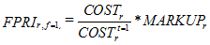
Increasingly, the long-term price of meat is a function of the price of grain, which is essential to the production of most marginal supplies of meat. We thus compute the price of meat directly from the initial price, modified by a moving average of the price of crops.
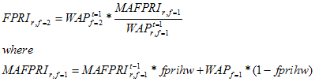
Agricultural profits (FPROFIT) depend on the rates of return to either crop or meat production relative to the costs of production. The costs of producing crops and the cost of land, priced at the cost of new land development (CLD) plus the investment in agricultural capital (KAG). The costs of producing meat are the sum of the costs of grazing land and feed (FEDDEM). Grazing land is priced at the value of the grain that it could produce (GLDCAP).
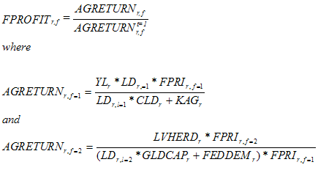

3.7 Investment
Investment in agriculture is relatively complex in IFs, because changes in investment are the key factor that allows us to clear the agricultural market in the long term. It is very similar to investment in energy, except that we do not need to compute type-specific investments.
We calculate a total agricultural investment need (INAG) to take to the economic model and place into the computation for investment among sectors. This investment involves multiple factors. The first is the historic (one-year lag) rate of agricultural investment need relative to GDP; that is applied to current GDP in order to obtain the basic estimate of investment. The seonc is a multiplier that represents changes in the global level of food stocks (MULWST).
The calculation further builds in a multiplier (AGINVM) with which users can shift investment patterns.
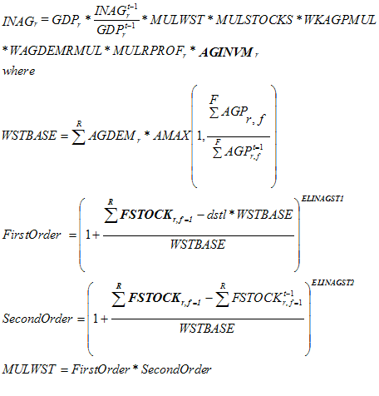
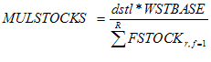
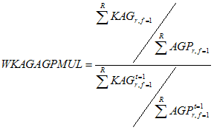
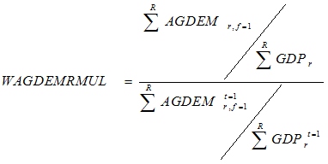
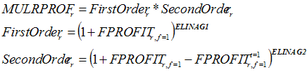
Investment need (INAG) is adjusted by an external multiplier (AGINVM), which allows a model user to shift investment into or away from agriculture. INAG enters the economic model. When that model computes investment by destination (IDS), it returns to the agricultural submodel as investment available (IAVAL).

The model links the threat indicator to an action-reaction dynamic only if the model user leaves the action-reaction switch (ACTREAON) at "1." Setting it to 0.0 will turn off action-reaction. When that switch is thrown, threat affects military spending in a process that can set up a positive feedback loop to increase or decrease the spending of acting and reacting countries or regions. The model calculates a multiplier on military spending (GKMUL) based on the level of threat (THREAT) in comparison with the initial level. Dyads have different reactivities to each other; the United States is not as concerned by an increase in British defense spending as by an increase in Chinese spending – in fact the U.S. might welcome the British increase and feel able to shave its own rather than increase it. A parameter (reac) gives the user control over this reactivity differential. In the GLOBUS modeling project, Dale Smith developed a formulation to endogenize such reactivity coefficients for dyads, in response to trade and other factors. Because the dyadic threat formulation of IFs already incorporates a very large number of dyadic and global factors, it would be redundant to build them into the reactivity parameter, which serves, instead, to provide the user some dyadic specific control over arms spending action/reaction. The addition of the number 10 to numerator and denominator in the formulation has a fundamentally technical basis – if there is a very low level of initial threat in a dyad (say Belgium and Ecuador), small changes in the numerator should not be permitted to give rise to large changes in the ratio and therefore the multiplier on defense spending.
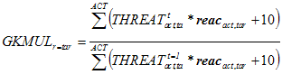
The multiplier shifts government expenditures into or away from the military and adjusts all other categories of expenditures proportionately to their size as calculated earlier, normalizing all expenditures (GDS) to the total level of government consumption (GOVCON).
The action-reaction dynamic thus works across the entire governmental expenditure and economic model. For instance, the normal "burden" term in the action-reaction dynamic is unnecessary because the economic model captures the burden of increased government spending on the military when it reduces spending on health and education.

3.8 Economic Linkages
Several variables, such as gross production, trade, stocks, prices and investment, are common to both the economic model and the two physical models. But hardly ever will the economic and physical models produce identical values, even during the first time step when both utilize "data." Thus, although we want the physical model value to override that of the economic model, it cannot simply replace it. Instead IFs extensively uses a procedure of computing an adjustment coefficient during the first time step. That coefficient is the ratio of the value in the economic model to the value in the physical model. In subsequent years IFs uses that coefficient to adjust the value from the physical model before its introduction into the economic model.
Gross production (ZS) in the agricultural sector illustrates this procedure. The value of gross production in the agri"cultural model is the sum of the products of agricultural production (AGP) and prices (WAP) in each agricultural category. Multiplying that times an adjust"ment factor (SZSF) computed in the first time stop to assure intermodel consistency produces gross production for the economic model (ZS). World average prices (WAP) are used in all the economic/physical submodel conversions because they assure that global sums (e.g. of exports and imports) will balance.
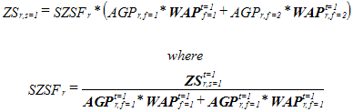
Similarly, food stocks in each category (FSTOCK) and an adjustment factor (SSF) produce stocks (ST) for the economic model.
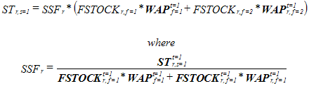
In the same fashion exports (AGX) and imports (AGM) from the agricultural model allow calculation of exports (XS) and imports (MS) for the economic model.
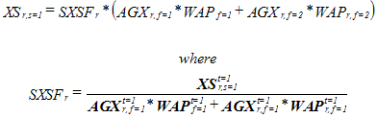
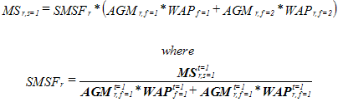
The indexed price (with a base of 1) in the agricultural sector of the economic submodel (PRI) is simply the ratio of current to initial world agricultural prices (WAP).

3.9 Capital Dynamics
IFs divides the investment available for agriculture (IAVAL) into two categories # that for land and that for agricultural capital. A coefficient (IALK) determines the portion going to land. Then the model updates agricultural capital (KAG) by subtracting depreciation as represented by capital lifetime (LKS) and adding the residual (non-land) investment.
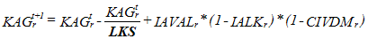
The investment coefficient changes from its initial value depending on change in the ratio of return on land (RETR) to return on capital (RETK). It uses the first and second order adjustment mechanism that we have seen before.
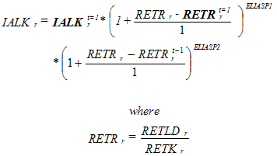
IFs calculates the return rate on land as the basic yield expected from land (BYL) divided by the cost of developing a unit of it (CLD).
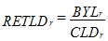
The return on capital depends on the higher yield (HYL) that could be obtained from an additional unit investment in agricultural capital.
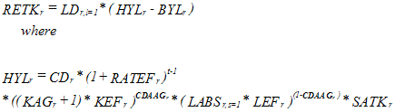
Neither of the above calculations for return rates is exactly correct. For instance, it would be better to calculate the return rate on capital using the mathematical derivative of the production function with respect to capital and to similarly compute the marginal benefit of an investment in land.

3.10 Land Dynamics
Land dynamics have three sources in IFs. First, some land is withdrawn from cultivation for urban development and industrial use. Second, investment in land development succeeds in transforming some previously unused land, or land used for grazing or in forest, to cultivated cropland. Third, some land once used for crops becomes exhausted, or on the basis of relative neglect moves into grazing, forest,or a totally unused state.
Land withdrawn from other use for urban/industrial use (NLD) is a linear function (LDWF) of the population increase, or of population (POP) times its growth rate (POPR).
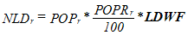
The five categories of land are: crop use, grazing, forest, totally unused, and urban/industrial. This last category can thus be incremented.
IFs computes a basic land value (BLD) prior to other alterations by assuming that the new urban/industrial land comes proportionately from all other categories, a conservative assumption because it comes in reality very heavily from cropland.
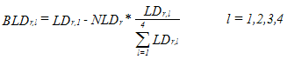
The model user can also force the land in forest area to increase or decrease at the expense of crop and grazing land via a forest multiplier (FORESTM).
The cost of bringing new land under cultivation (CLD) increases as the amount of land in that category. In computing the increased cost of adding cropland, a multiplicative factor (CLDF) carries information about land development cost from the first cycle.
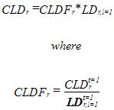
The net land developed for crop cultivation (LDDEV) in any time period has two terms. The first is the land portion (IALK) of total agricul"tural investment (IAVAL) divided by the cost of developing land (CLD). From this positive term is subtracted some portion (DKL) of land which will revert to other uses without investment # essentially a depreciation term.
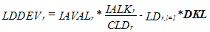
Land next year in the crop and grazing categories is the basic value plus an historic share of the net development (which may be negative).
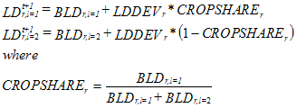
Land developed is subtracted from or added to the forest category.

3.11 Livestock Dynamics
In addition to capital and land, the other "stock" or "level" variable with important dynamics is the livestock herd (LVHERD). In IFs livestock is something of a subsidiary sector (remember that we determine its price from that of crops). There is a basic growth rate (LVHRG), but the herd size changes additionally in response to the inventories in the sector, both the first order and the second order levels of stocks. The basic growth rate varies over time in a moving average.
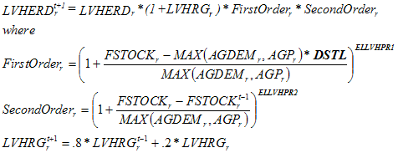

3.12 Indicators
Four global sums provide useful indicators: the global sum of regional agricultural production (WAPRO), the sum of world food stocks (WSTK), the world per capita availability of calories (WCLPC), and the global sum of forest area (WFORST).
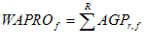
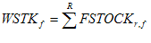
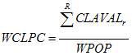
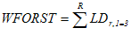
Finally, the model computes regional calories per capita (CLPC).
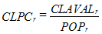

References
Brown, Lester R. 1995. Who Will Feed China? New York: W.W. Norton.
Herrera, Amilcar O., et al. 1976. Catastrophe or New Society? A Latin American World Model. Ottawa: International Development Research Centre.
Levis, Alexander H., and Elizabeth R. Ducot. 1976. "AGRIMOD: A Simulation Model for the Analysis of U.S. Food Policies." Paper delivered at Conference on Systems Analysis of Grain Reserves, Joint Annual Meeting of GRSA and TIMS, Philadelphia, Pa., March 31-April 2.
Meadows, Dennis L. et al. 1974. Dynamics of Growth in a Finite World. Cambridge, Mass: Wright-Allen Press.
Rosegrant, Mark W., Mercedita Agcaoili-Sombilla, and Nicostrato D. Perez. 1995. "Global Food Projections to 2020: Implications for Investment." Washington, D.C.: International Food Policy Research Institute. Food, Agriculture, and the Environment Discussion Paper 5.
Systems Analysis Research Unit (SARU). 1977. SARUM 76 Global Modeling Project. Departments of the Environment and Transport, 2 Marsham Street, London, 3WIP 3EB.

