
FREDERICK S. PARDEE CENTER
FOR INTERNATIONAL FUTURES
EXPLORE UNDERSTAND SHAPE

WORKING PAPER 2013.09.20

IFs POPULATION MODEL DOCUMENTATION

Authors: Barry B. Hughes and José R. Solórzano
September 2013

Note: This is a draft version.





IFs Population Model Documentation

Table of Contents

1. Introduction 2
1.1 Overview 2
1.2 Dominant Relations 2
2. Flow Charts 5
2.1 Demographic Overview 5
2.2 Fertility Detail 7
2.3 Mortality Detail 9
2.4 Nutrition 10
2.5 AIDS Deaths 11
2.6 Migration Detail 13
3. Equations 14
3.1 Age Distribution 14
3.2 Fertility Distribution 16
3.3 Mortality Distribution 17
3.4 Malnutrition 19
3.5 HIV/AIDS 20
3.6 Migration 22
3.7 Urbanization 23
3.8 Demographic Indicators 24
4. References 26

Introduction

Overview

The population sub-model of IFs uses the cohort component analysis approach of many population models, including the studies done by the United Nations (United Nations, 1956 and 1977). The structure of the IFs population model drew initially on the World Integrated Model (WIM) or the second generation Mesarovic-Pestel Model (Hughes, 1980), but has changed much over time.
The approach relies upon age, fertility, and mortality distributions for each country/region with 22 cohorts: one for infants, 20 of five-year size, and one for all individuals of age 100 or older. A major advantage of five-year cohorts is that data sources generally present demographic data in that form. Ideally, however, the cohort size should correspond to the model time step so as to avoid "numerical diffusion," the propagation of change from a five-year cohort to an adjoining cohort in a single year. To prevent such numerical diffusion, IFs actually runs an age distribution with 100 single-year cohorts and advances that over time, collapsing to 22 cohorts only for the calculations of births and deaths.

Dominant Relations
The dominant population (POP) equation is a simple addition of births (BIRTHS) at the bottom of the cohort distribution, subtraction of deaths (DEATHS) from each population cohort, and advance of people to the next cohort over time.
The following key dynamics are directly linked to the Dominant Relations:

Births are primarily a function of the total fertility rate (TFR), which responds especially to GDP per capita (PPP). The model user has direct control over TFR with a multiplier (tfrm), but also much control for low fertility countries with a parameter specifying a stabilization level for fertility (tfrmin). There is also a secular trend reduction in fertility (controlled by ttfrr).

Deaths are primarily a function of life expectancy (LIFEXP), itself a function of GDP per capita (PPP). The model user has direct control over deaths with a mortality multiplier (mortm). There is also a secular trend reduction in mortality (controlled by tmortr).

The larger demographic model provides representation and control over migration; deaths specific to AIDS; the fertility impact of contraception use rates; the mortality impact of health care spending; and malnutrition levels related to food availability.

1.3 Structure and Agent System

System/Subsystem | Demographic
Organizing Structure | Cohort-component
Stocks | Population by age-sex
Flows | Birth, death, migration
Key Aggregate Relationships  (illustrative, not comprehensive) | Life expectancy (including HIV/AIDS)  with exogenous technological assumptions
Key Agent-Class Behavior Relationships  (illustrative, not comprehensive) | Household fertility and migration

Humans as individuals within households interact in larger demographic systems or structures. The computer model should represent the behavior of such households, such as decisions to have children or to emigrate. And it should represent the larger demographic structures that incorporate the decisions of millions of such households. A typical approach to representing such demographic systems is through age-sex cohort distributions (see the figure below showing an example from the model). IFs also uses fertility and mortality distributions by age and sex and tracks migration across countries.

Demographers have widely accepted the representation of demographic systems and the development of demographic models with cohort-component structures. In fact, the United Nations, the U.S. Census Bureau, and the International Institute for Applied Systems Analysis (IIASA), pre-eminent demographic forecasting institutions, all use cohort-component modeling (O’Neill and Balk 2001).

Flow Charts

This section presents several block diagrams that are central to the population model: fertility, mortality, nutrition, AIDS Deaths, and Migration.

2.1 Demographic Overview

The demographic model represents the population of each geographic unit in terms of 22 cohorts (infants, five-year intervals up to age 99, and those aged 100 and older), separately for females and males. An age distribution records the population in each cohort and sex category. The sum across all cohorts in the age distribution and both sexes is the total population. A fertility distribution determines births, which are added to the bottom of the age distribution, while a mortality distribution determines deaths, which are subtracted from the appropriate cohort of the age distribution.

The population model is central to many dynamics of IFs. Two key feedback loops drive its own dynamics. The first is a positive feedback loop around fertility, linking population and births (causing population to drive exponentially upward), while the second is a negative loop around mortality, linking population and deaths (causing population to drop). Whether population rises or falls depends on the relative strength of those two loops. There is a third potential negative (equilibrating) feedback loop within the submodel, that described by Malthus. Specifically, population determines calorie need, which in comparison with calorie availability (from the agricultural model) determines nutritionally related infant mortality, if any. See the topic on nutrition.

The two easiest and perhaps most often used scenario handles for the population model are a multiplier on the total fertility rate (the number of children borne by an average woman in a lifetime) and a multiplier on the mortality rate.
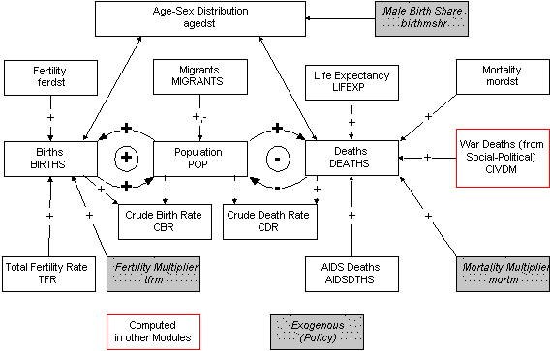

A large number of indicators are calculated in IFs from the age distribution:

population aged 15 to 65 (POP15TO65),
population above age 65 (POPGT65),
population below age 15 (POPLE15),
the potential support ratio, or the population from 15 to 64 over that above 65 (POTSUPRAT), and
an indicator of the youth bulge or the population from 15 to 29 over that from 30 to 49 (YTHBULGE).
In addition there are a number of indicators calculated from the size of country populations:
the growth rate of population (POPR),
the world population (WPOP), and
growth in the world population (WPOPR).
More description is available on the dynamics around fertility and mortality as well a several specialized topics: nutrition levels, migration, income distribution, physical quality of life, and HIV/AIDS. Please use the left rail navigation to access these topics.

2.2 Fertility Detail

The central indicator of fertility is the total fertility rate, the number of children that the average woman will bear throughout her life. Fertility generally decreases as GDP per capita (from the economic model) increases. We use a cross-sectionally estimated function to calculate that. It also decreases as the income share of the poorest 20% of the population does or with contraception use. Both income share and contraception use are, however, themselves functions of GDP per capita. The model therefore looks at the "residual" impact of them on total fertility rate, controlling for the expected values and thereby passing through any scenarios that the user applies to income share or contraception use.
The key scenario parameter in this portion of the model is a multiplier on the total fertility rate. In addition, however, there is a parameter (tfrconv) that controls the convergence time in years of the basic fertility rate in a specific country or region and the rate expected based on the GDP/Capita of the country. Finally, there is a very important parameter (ttffr) that generally lowers the fertility rate of a country over time, to represent the changes in values and technology that are not now explicity represented in the causal logic of the model. To see this phenomenon in the historic data, compare the functions relating GDP per capita and total fertility rate over time. You will see a clear shift over time towards lower fertility, independent of GDP per capita.
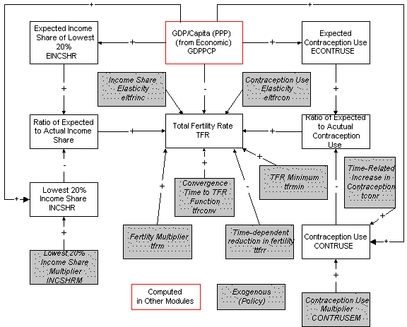

2.3 Mortality Detail

The principal driver of deaths in the model is a calculation of life expectancy. Life expectancy normally increases and mortality normally decreases as GDP per capita rises (see the economic model) or as the income share of the poorest 20% of the population increases. This initial calculation of life expectancy is imposed on the mortality distribution that provides a country-specific age and sex profile of mortality. At the same time, however, increases in life expectancy shift the mortality distribution from its initial condition towards an ultimate life (survivor) table as life expectancy approaches that built into the ultimate life table (approximately 85 in the 1998 revision of the UN population tables).
A number of often time-specific factors affect deaths incrementally around the mortality distribution and initial calculation of life expectancy. These include deaths related to warfare, to AIDS, and possibly to starvation (via infant mortality, because it is primarily the very young who are at risk). In addition, the user of the model may introduce greater or lesser mortality via a mortality multiplier.
The life expectancy is recomputed once all deaths are known. It is the recomputed life expectancy that enters into the calculations of physical quality of life and that the model displays.
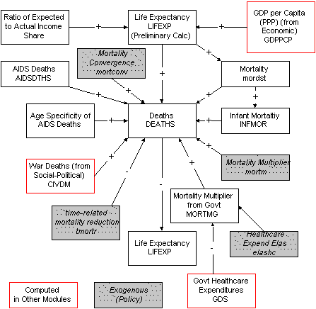

2.4 Nutrition
As noted in the overview of demographics, there is a third potential negative (equilibrating) feedback loop within the submodel. Malthus described it in terms of the balance between calories available and calories needed. Specifically, population determines calorie need, which in comparison with calorie availability (from the agricultural model) determines nutrition levels among children (using a cross-sectionally estimated function), and nutritionally related infant mortality, if any. Such starvation increases mortality and decreases population in the negative feedback loop.
In early editions of IFs this loop frequently generated starvation deaths. Historic and contemporary data do not exist, however, to support calculation of starvation (the deaths of those who are severely malnourished are normally attributed to various diseases that prey on them). Therefore the model now focuses primarily on child malnutrition (as an indicator, not part of the feedback loop). You will generate explicit starvation deaths in the model only when calories are sharply restricted, for instance through assumptions of decreased yields as a result of drought in the agricultural model or of decreased food imports as a result of capital flow restrictions in the economic model (to generate starvation purposefully for such scenarios you can raise the value for the calorie need factor (clnf) from 1 to perhaps 1.2 over a short period in Africa).
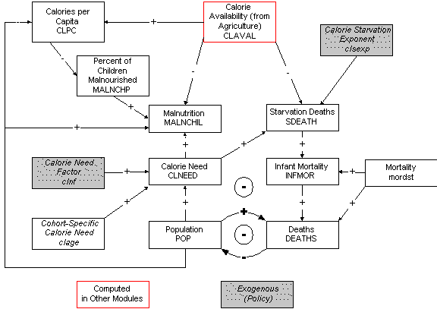

From country/region-specific calories per capita, we compute world calories per capita (WCLPC).

2.5 AIDS Deaths
AIDS deaths depend very directly on the number of HIV-infected individuals, which depends in turn on the HIV-infection rate and the size of the most heavily infected population (15-to-50 year-olds). Data on HIV infection rates in the late 1990s were used to compute a basic, country/region-specific rate of HIV infection increase (hivincrate), which the user can alter. Moving into the future beyond 2000, however, the model relies upon a global rate of epidemic advance (hiveadvr). The country/region-specific impact of that rate is shifted up or down on a cultural-region basis, using parameters in a cultural rate factor (hivculf); the initial values for the cultural shift were determined through analysis of the 1995-2000 epidemic advance. The user may also rely upon a country/region-specific multiplier to move rates up or down (hivm).
There is both a policy and medical effort underway to reduce the growth in infections. An HIV technical advance rate (hivtadvr) represents the success of that in rate of reduction in annual infection growth, and a variable (HIVTECCNTL) shows the cumulative impact of the effort. Although highly speculative, the user will recognize the long-term importance of such assumptions. Also, the user can make changes in the AIDS death rate (aidsdrate) to reflect possible progress or lack of it in reducing the deaths from HIV.
The variables and parameters around HIV/AIDS could, of course, be used to introduce other plagues.

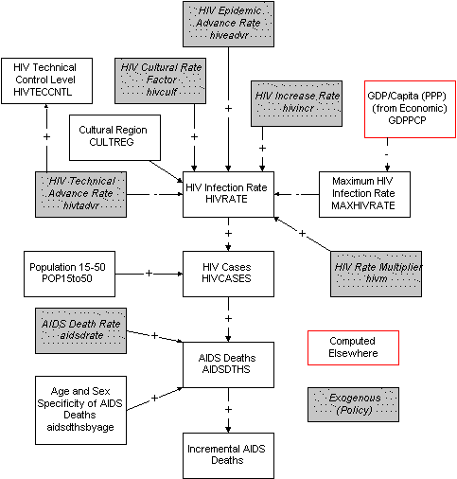

2.6 Migration Detail
Migration is dependent upon a migration rate (migrater). On a global basis immigration and emigration are required to balance, and the number of migrants (MIGRANTS) is balanced. Although data are poor, a general representation of the portion of migrants who are male (malemigr) is set as a parameter. In addition, the migration rate by age is represented.
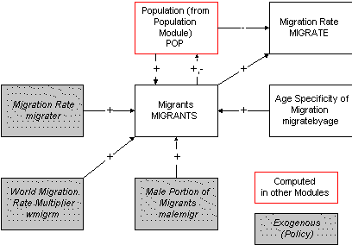

Equations
This section will present and discuss the equations that are central to the functioning of the population model.

3.1 Age Distribution
The basic model is very simple. A 5-year cohort fertility distribution (FERDST) multiplies the age distribution (AGEDST) to produce births (BIRTHS). The total fertility rate (TFR), or total number of births expected to a woman during her lifetime, modifies the fertility distribution over time. The fertility distribution itself moves from the initial empirical, country-specific pattern to an ultimate fertility distribution as GDP per capita (PPP) moves towards a specificed level (uftrans, currently $30,000). We will see the computation of TFR in our discussion of fertility.
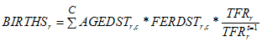
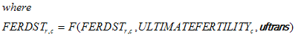
Deaths are similarly a product of a mortality distribution (MORDST) and the age distribution. As with fertility, the mortality distribution itself moves from the initial empirical, country-specific pattern to an ultimate mortality distribution as life expectancy moves towards a specified level (umtrans, currently 85 years). [After analysis of multiple age distributions, it was found that it would be possible to compute a changing basic infant mortality rate as function of GDP per capita and income distribution, and to impose those changes on the entire mortality distribution. In fact, analysis showed (somewhat surprisingly) that mortality in adult and aged categories rose or declined proportionately with infant mortality across income levels. Thus the proportional changes in the infant mortality rate relative to initial conditions could be used to change mortality rates across the age distribution. Nonetheless, we use the more standard movement towards an ultimate mortality/survivor table for all age cohorts.
We will see details on the calculation of life expectancy in our discussion of mortality.
The full or annual age distribution (FAGEDST) is used to advance from year to year, in order to avoid diffusion of births or deaths too quickly up the distribution. One-fifth of cohort deaths reduce the appropriate age category and those in each age category advance to the next year (all infants advance to age 1). We also add one-fifth of net migration.
Births enter the infant category of the age distribution.
Once the full age distribution has been advanced for the next year, it can also be collapsed into the 5-year cohorts of the age distribution (AGEDST), which is used for the calculations of births and deaths in the next year and for display in the model. The population (POP) is, of course, a sum across this distribution.
This core of the model is fundamentally an accounting system. The key to long-term dynamics lies within change in the fertility and mortality distributions.

3.2 Fertility Distribution
Change in fertility centers on the current level of the total fertility rate (TFR). IFs determines the TFR and then imposes that on the fertility distribution of the region/country.
IFs incorporates five mechanisms for determining change in the TFR from the initial condition: change resulting from a function of GDP per capita, change resulting from income distribution, change resulting from contraception use, an exogenous multiplier on the rate, and shift in that function with technological or cultural change. The full equation is represented below, and we will explain each term.
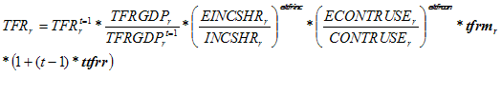
The primary factor that affects TFR over time is change in the GDP per capita at PPP (GDPPCP). The computed TFR based on GDP per capita (TFRGDP), relative to the computed TFRGDP in the initial year, multiplies and adjusts the initial total fertility rate for a region. TFRGDP is computed in IFs with an analytical function that captures a nonlinear relationship between GDP per capita at purchasing power parity and TFR.
You can see the approximate form of that relationship by examining a scattergram of TFR as a function of GDP per capita at PPP (GDPPCP) in the initial model year, or you can look at the relationship that IFs actually uses (in CHANGE - FUNCTION). In addition, however, that function has shifted over time and may in the future. Its shift with time is controlled by a total TFR rate change parameter (ttfrr).
Not shown in the above equations is a further dynamic that moves the total fertility rate over time towards the values expected in the analytical function. Without that dynamic, the use of the function would maintain the initial relationship of each country/region TFR to the function. One of the other things that the scatterplot shows (as does much study of development processes) is that there is convergence around the function at higher levels of GDP per capita. We use a tfr convergence paramter (tfrconv) to specify the years over which the convergence will occur.
Similarly, the use of contraceptives (CONTRUSE) depends heavily on GDP per capita at purchasing power parity. Look also at a scattergram of CONTRUSE against GDPPC in the initial year. We therefore again control for GDPPC by computing an expected level of contraceptive use (ECONTRUSE) and pass through to TFR only the residual change in contraception use. The "actual" level of contraception use depends not only on GDPPC, but on an exogenous multiplier (CONTRUSM), and on a temporal (t) upward drift in contraception use related to (1) technological innovation and diffusion (controlled by TCONR) and to (2) global policy shift towards support for their use.
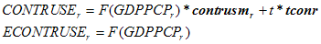
Total fertility rate is, however, unlikely to shift indefinitely toward zero. In fact, it requires a value of about 2.0 simply to maintain a steady population (unless life expectancies are growing). TFR is therefore bound by a minimum that responds to a global parameter (tfrmin). We have experimented with making regional minimums also responsive to the density of population on crop land via an elasticity (eltfrden), but that linkage is not currently functional.
Once we have computed the total fertility rate (TFR), the number of births in a given year is a simple function of the fertility distribution and the TFR.

3.3 Mortality Distribution
The process of changing fertility is to compute an initial estimate of total fertility rate, to impose that on an initial fertility distribution, and then to modify the fertility rate based on a variety of specific factors.
We do something very analogous for mortality, calculating an initial life expectancy based on long-term development (GDP per capita and income distribution). The income share comes from the socio-political module.
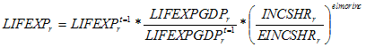
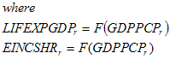
The analytic functions for life expectancy and income distribution as a function of GDP per capita (PPP) come from cross-sectional analysis.
We impose this initial calculation of life expectancy on the mortality distribution (with the movement towards an ultimate life table that is discussed in connection with the overall logic of the age distribution), by calculating a mortality factor (MFACTOR) that, when applied to all cohorts of the mortality distribution would generate the calculated life expectancy. The multiplier is computed so that the cumulative mortality to the age of life expectancy will ultimately be 0.5.
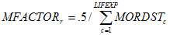
We then further modify the mortality distribution and therefore the life expectancy (which we will need to recompute below) by the specification of several additional mortality factors. These include three of the four horsemen of the apocalypse, which tend to have a more immediate, shorter-term impact: starvation deaths, plague or in this case AIDS deaths (AIDSDTHS), and war deaths (using the civilian damage variable, CIVDM, calculated in the social-political module). We build starvation deaths in a recalculated infant mortality (INFMOR), because the youngest are most vulnerable to calorie shortages.
The additional mortality factors also include a multiplier on mortality reflecting changes in rates of expenditures on medical care, calculated in the social-political model (MORTMG). They further include a parameter that reflects a time-related shift in mortality from medical advance (tmortr); long-term development (as reflected by GDP per capita) does not capture this additional influence on mortality. Finally, it includes a multiplier on mortality (mortm) that the user can set as desired to introduce further factors into a scenario.
In the second stage of mortality calculation we compute deaths by cohort.
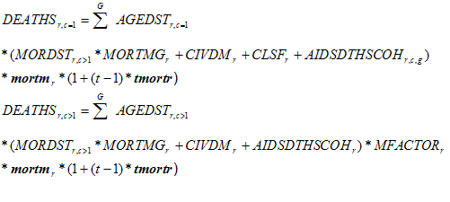
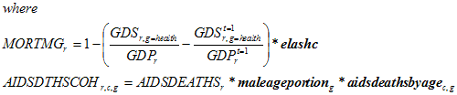
The computation of civilian war damage/deaths (CIVDM) is shown in the international political module.
One of the factors above that effects infant deaths is a calorie starvation factor (CLSF). It depends on the ratio of calories available (CLAVAL) from the agricultural model to the calories needed (CLNEED). Details are available with the discussion of nutrition/malnutrition.
Relatively few models attempt to close the loop between food availability and mortality. (See, for example, Meadows, et. al., 1974 and Mesarovic and Pestel, 1974). IFs does so, while recognizing that little is actually known about the linkage. IFs treats calories as the basis for severe malnutrition- or starvation-related deaths. Regional calorie need (CLNEED) is computed by a sum across the age distribution (AGEDST), considering age specific calorie require"ments (CLAGE) and an exogenous factor (CLNF) with which the user can intro"duce regional variation in needs (or assumptions of regional differences in ability to respond to calorie shortages).
We can now recompute the actual infant mortality, based on the actual infant deaths:
Finally, we recompute life expectancy based on the entire patterns of deaths.

Malnutrition
IFs has estimated a relationship between calorie availability per capita (CLPC) and the percentage of children (MALNCHP) between the ages of 0-5 who are malnourished. In some countries, notably India, Bangladesh, and Nepal, initial values for this percentage are far from the value predicted by the analytical function representing this relationship. IFs assumes that outliers will converge towards the table function relationship over time (as controlled by the conversion parameter, polconv).
IFs uses that relationship to update the percentage malnourished over time and to compute the actual number of malnourished children (MALNCHIL) in population cohorts 1 (infants) and 2 (0-4 years of age).
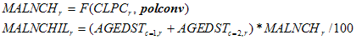
Relatively few models attempt to close the loop between food availability and mortality. (See, for example, Meadows, et. al., 1974 and Mesarovic and Pestel, 1974). IFs does so, while recognizing that little is actually known about the linkage. IFs treats calories as the basis for severe malnutrition- or starvation-related deaths. Regional calorie need (CLNEED) is computed by a sum across the age distribution (AGEDST), considering age specific calorie requirements (CLAGE) and an exogenous factor clnf) with which the user can introduce regional variation in needs (or assumptions of regional differences in ability to respond to calorie shortages).
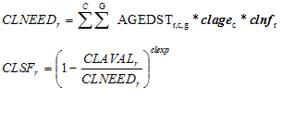
Once the calorie-based starvation factor (CLSF) is computed, with admitted arbitrariness in specification, it is possible to compute actual starvation death levels (SDEATH) in the youngest two cohorts,
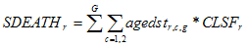

HIV/AIDS
The ultimate objective of the calculations around HIV infections and AIDS is to obtain a value for the number of annual deaths from AIDS (AIDSDTHS) to carry to the mortality calculations.
We begin, however, by calculating a country/region-specific value for the HIV infection rate (HIVRATE), that is the portion of most vulnerable population (15-50 year olds) infected. That calculation depends on the time period. For the period from 1995-2000 we have reasonably good data on the infection rate and have used those data to calculate a rate of increase (hivincr) in the infected portion of the population. It is only necessary to apply the increase rate to the infection rate from the previous year. We allow, however, scenario specification via an exogenous multiplier on that infection rate (hivm).
Trajectories of infection rates can change very quickly, however, making forecast beyond 2000 difficult. We posit a global average rate of advance in the epidemic’s infection rate (hiveadvr), which is net of those who die of AIDS in any given year. We further posit that gross cultural/geographic regions have significant differences in propensity for the spread of the epidemic that can be represented by an HIV cultural region factor (hivculf). We applied the global rate between 1995 and 2000, experimenting with values for the cultural region factor, until we came up with values that we now use in the true forecast period. We also posit that advances are being made against the epidemic, both in terms of social policy and technologies of control, at a speed that reduces the total infection rate a certain percent annually (hivtadvr). Of course, if the virus were to mutate and increase its spread rate, negative values could be used to represent that phenomenon. There is an accumulation of the advances (or lack of them) in a technology of control factor (HIVTECCNTL) that we can apply to the infection rate. In addition, we again allow a user-specific multiplier (hivm) to affect rates of any country or region in the future.
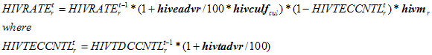
The rates of infection will not grow indefinitely in populations, even in the absence of social or technical progress against them. We use a table function to relate the maximum rate of infection to GDP per capita (at PPP). Roughly speaking that maximum drops (as can be seen in current empirical rates of infection) with increasing levels of GDP per capita from about 40 percent, as Botswana is approaching, to about 2 percent in the most developed countries. This is, of course, highly speculative for forecasting, and the user can change the table function.
The calculation of country/region-specific numbers of HIV infections is simply a matter of applying the rates to the number of people in the most vulnerable category, those between 15 and 50 years of age.
The rate of death to those with HIV could benefit from a complex model in itself, because it varies by the medical technology available and the cohort structure of infections. We have simplified that here to a simple global death rate as a portion of HIV cases (aidsdrate).
When we actually apply this calculation of AIDS deaths to the mortality pattern, we take into account the portion that are likely to be male or female and the age cohorts into which they are likely to fall. We use a table function to determine the male portion as a function of GDP per capita (at PPP), estimating that the male portion rises from .5 to .9 with higher GDP per capita. The user can change this table function. To specify the age cohort of deaths, we examined data from large numbers of studies on infections by cohort in Brazil and Botswana (in a U.S. Census Bureau data base) and extracted a rough cohort pattern (aidsdeathsbyage) from that data. Surprisingly, the variation across the 15 to 50 year period is not that great.

Migration
Migration is treated with a pooled approach. It is driven by an exogenous parameter (migrater) specifying the net percentage of the population migrating each year (negative values indicate immigration and positive values indicate emigration). The first step is to swap that value into an internal model calculation of the migration rate (MIGRATE).
The full global set of migration rates is unlikely, however, to provide a balanced global total of immigrants and emigrants. The next step is thus to calculate those totals, even though they are likely to be unequal.
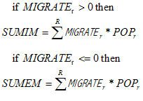
After calculation of the world sums of immigrants and emigrants, the total world migration is assumed to be the average of the two. Then that total world migration is imposed on net immigrant and net emigrant regions through normalization.
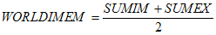
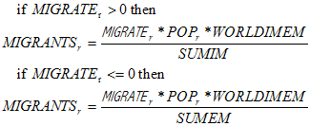
Although the above equation assures that the global sum of migrants will be zero (immigration equals emigration), it is important to recompute the actual migration rate, so that it represents the true inflow or outflow of migrants after that balancing. Note that the computed migration rates (MIGRATE) will almost certainly be a bit different from the input parameter (migrater).
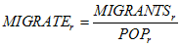

3.7 Urbanization
The size of urban population (POPURBAN) in the very near future is probably best forecast by using a growth rate computed from historic data (POPURBANGR). But in the longer term future, urbanization must saturate as the portion of the population urbanized approaches 100%. A function estimated cross-sectionally against GDP/capita at PPP was used to provide a target (PopUrbanTar) for urbanization that could gradually replace the use of the initial growth rate – countries with very high levels of GDP/capita have already begun to approach saturation.
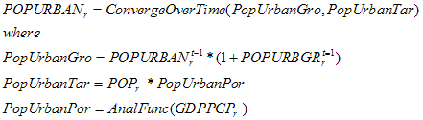
Once the urban population has been updated, it is possible to compute the actual growth rate (POPURBGR).
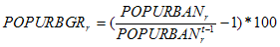

3.8 Demographic Indicators
Among the indicators computed in the population submodel of IFs are the crude birth rate (CBR) and crude death rate (CDR).
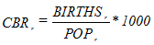
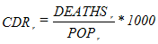
Population growth rate (POPR) follows easily from crude death and birth rates.
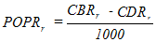
Regional population (POP) is simply a sum across age cohorts.
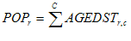
For information and use elsewhere in the model, three computations of sub-portions of the population by age are made (POPLE15, POP15TO65, and POPGT65). [Note: each one of these is slightly misnamed.]
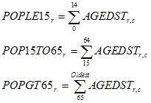
Another useful indicator is the youth bulge (YTHBULGE), defined as the ratio of the population between ages 15-29 to that aged 30-49. In general, a ratio of more than 1.2 suggests a particularly youthful society and may indicated potential for social instability.
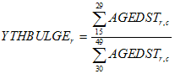
World population (WPOP) and world population growth rate (WPOPR) are simple functions across countries/regions.
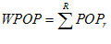
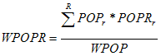

References

Hughes, Barry B. 1980. World Modeling. Lexington, Mass: Lexington Books.
Meadows, Dennis L. et al. 1974. Dynamics of Growth in a Finite World. Cambridge, Mass: Wright-Allen Press.
Mesarovic, Mihajlo D. and Eduard Pestel. 1974. Mankind at the Turning Point. New York: E.P. Dutton & Co.
United Nations, Department of Economic and Social Affairs. 1956. Methods of Population Projections by Sex and Age. New York: United Nations, ST/SOA Series A.

