Procedure for Overriding Historical Data for Peru*

The IFs model keeps its historical data series in a master database file named IFsHistSeries.mdb located in the Data folder in the IFs main installation folder (IFs\Data). The data in this file are taken from standard multi-country sources such as the World Bank’s World Development Indicators and the Food and Agriculture Organization’s FAOSTAT database.

Users wanting to use their own data for Peru instead of what is in the IFsHistSeries.mdb, e.g. INEI informal labor statistics instead of ILO-based statistics, can do so via a newly added Extended Feature in IFs that allows users to override IFsHistSeries.mdb with historical data from other sources without affecting the master database’s original contents.

The following is a step-by-step guide to the override process. You will need Microsoft Access to open the required database files.

- To begin, locate the project database file IFsHistSeriesProjectPeru.mdb in the IFs ProjectData folder (IFs\Data\ProjectData). The project data file is designed to hold the data series that will override those in IFsHistSeries.mdb. Each table in the project data file must have the same name and general structure as the series you want to override in IFsHistSeries.mdb but should only contain rows for Peru (the project tables can, however, contain fewer or additional column years—see below). By default, the Peru project data file contains Peru-only tables for some of the pre-processor series used in the model, including so called “essential series” like GDP, GDP per capita, and total population, as well as the main series related to the informal economy. While any series can technically be overrode, it only makes sense to do so with data series used in the model’s pre-processor to rebuild the Base Case as replacement only occurs during the rebuild process (see #3 for instructions on adding other tables to this file).

- Using MS Access, you can add/edit/remove Peru-specific data points and country-rows from the data tables in the project database file (IFsHistSeriesProjectPeru.mdb) as needed. You can also bring in new country-rows from the master database (IFsHistSeries.mdb) and then edit those data cells. If you have data for years not covered in IFsHistSeries.mdb you can add the missing years (in the proper order) via the add column function in the design view of the Access table. After saving the design changes to the table, you can add data to the new column. Keep in mind that your new data series will completely replace the existing series of the same name, regardless if the two series cover different periods of time (i.e. if the original IFs series SeriesGDPInformal%Blended has data for years 1990—2010 and your replacement series has data for 2007—2012, only the 2007—2012 data will be kept).

- To add a data series table to the project data file, you will need to copy the corresponding table from the master database, IFsHistSeries.mdb, and paste it into the project database, using the “structure only” option during pasting. You must keep the table’s structure and name the same. You will be asked to provide the database password data4ifs12 (all lower case) on pasting. Once the table itself is copied, copy only those country-rows you want to change (i.e. Peru) into the project database. You can then edit the data points as needed. You can also add additional year columns if needed (following the same procedure described in #2).

- Once you have added all the data tables you want to the Peru project data file, you will need to read that file into the IFs historical database. To do so, select IFs Main MenuExtended FeaturesManage Country DataHistorical Data File ProcessingProject DataLoad Project Data (see figure 2 below). Select IFsHistSeriesProjectPeru.mdb in the popup dialogue box and click the load button.
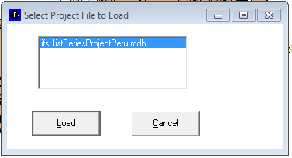
Figure 1: load project file

- IFs will then create a file with the augmentations/changes to IFsHistSeries.mdb called IFsHistAugment.mdb and place it in the IFs/Data folder. It will also place a flag in the country field of the ProjectDataCountryLOad table within IFsInit.mdb, namely the name of the country for which data have been augmented/changed (normally that table is empty). Once your data changes are loaded, IFs will prompt you to begin the Rebuild Base process (click Ok in the first dialogue box, Rebuild Base in the second, and Ok in the third and fourth. The model will then rebuild the Base using the new IFsHistSeries.mdb. IFs will also create in the Data folder a backup version without changes named IFsHistSeriesOriginalNoProjectData.mdb for restoring the original, unaltered master database. Finally, the model will ask you to rerun the Base Case to 2100. Click Start Run. Once the model has finished running, you are set to go.

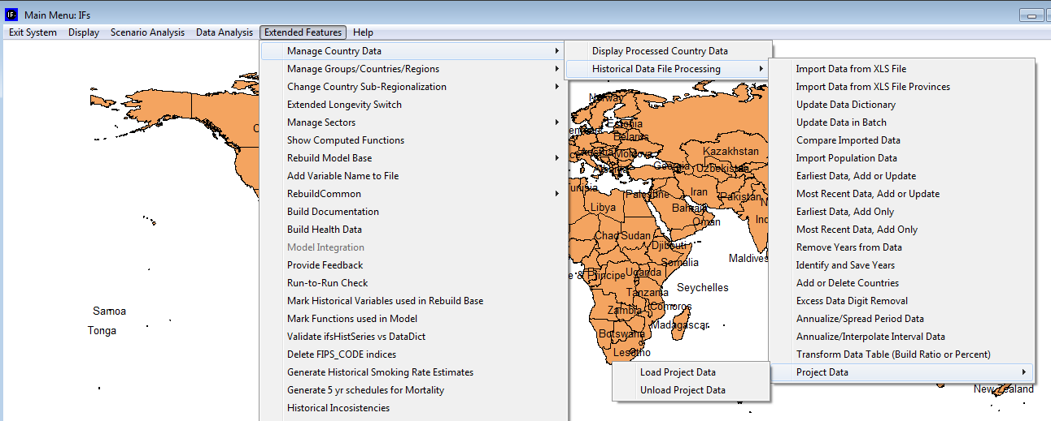 Figure 2: menu-path to load/unload project data file

- To revert to the original, unaltered version of the master historical database, select IFs Main MenuExtended FeaturesManage Country DataHistorical Data File ProcessingProject DataUnload Project Data. This will take you through the Rebuild the Base process again. Once complete, you should completely exit the IFs model and re-launch to ensure that the original model is completely restored.

*note, while these instructions focus on Peru, they are applicable to any country (and any project file). You can create a new project-file for any country by creating an Access database named IFsHistorySeriesProject(x).mdb in the IFs\Data\ProjectData folder where the x is the particular name chosen for the project.

Note concerning the building of installations for countries/projects with augmented or changed data. Those installations should be sure to include:

New files: (1) IFsHistSeriesProject[country/projectname].mdb under IFs/Data/ProjectData, (2) IFsHistAugment.mdb under IFs/Data and (3) IFsHistSeriesOriginalNoProjectData.mdb under IFs/Data.

Normally distributed but changed files: (1) IFsHistSeries.mdb under IFs/Data and (2) IFsInit.mdb under IFs.

It is important to bring in entire country-rows form that database. If you were to create a country-row that was shorter than that in IFsHistSeries.mdb, your changes would not alter values for years that that you have not included.

