A “Protectionist World” Narrative

**Introduction**

2016 saw a growing backlash by those feeling left behind by globalization in Western countries. This backlash is perhaps best represented by the victory of Donald Trump—who will be inaugurated US President tomorrow. Many of Trump’s votes came from workers blaming international trade for the economic stagnation in their hometowns. This backlash against globalization has occurred in Europe as well.

Since 2015, the G-20 Trade Alert analysis has warned that the “level playing field (has been) taking a battering” with countries increasingly resorting to protectionist measures even more so that after the 2008 Great Recession. Last September IMF officials warned that the uptick in trade barriers was already causing damage and worried that rising protectionism could help push the global economy into a downward spiral.

In this briefing we want to examine scenarios in which protectionism increases, showing the broader implications for the global economy and world order.

We want to differentiate between short and long term effects; map out not just the impacts on US, China, and Europe but also the implications for many of key achievements of globalization over the past three decades, such as reductions in poverty, conflict and state fragility.

We also want to pay particular focus to the US-China dynamic that has been at the center of the globalization phenomenon. A contraction of bilateral trade and investment could lead over the long run to separate areas of influence that have potentially serious political fallout for the global order.

Just a word on how we derived the quantitative findings for this presentation. They are based on the International Futures (IFs) forecasting system, run by the University of Denver’s Pardee Center for International Futures (pardee.du.edu). The IFs model represents 186 countries in different stages of socio- economic development and adoption of ICT technologies. It encompasses a set of heavily integrated and rich models: demographic, economic, human development (education and health), physical (energy, agriculture, and infrastructure), and socio-political (governance and government finance). The judgments we make in this presentations are data-driven, based on the results of our work with the IFs model.

**The Big Picture**

We start with a conceptualization of how to think about changing trade and capital protectionism.

Proponents of trade openness have justified their policies using the economic theory of comparative advantage. This theory—originally promoted by David Ricardo in the early 19th century—states that each country has a relative advantage in producing one good relative to another. If countries engage in open trade policies, they will enhance their ability to consume, earn more revenue from production, and see the overall size of their economy grow.

The underlying truths of the theory of comparative advantage have not changed. However, proponents of open trade policies may have missed other fundamentally important theories that explain why trade is currently under attack. For example, while the theory of comparative advantage works at the national level, other theories better explain who will benefit and who will be hurt by more open trade policies at the sub-national level.

Each country has either relatively scarce or plentiful factors of production, namely the relationship between capital and labor as well as skilled to unskilled labor. In Europe, for example, countries have a relative surplus of capital to labor as well as skilled to unskilled labor. Therefore, in a position of trade opening, capital will benefit as will skilled labor. Unskilled labor—the relatively scarce factor of production—will be disadvantaged with increasing trade openness.

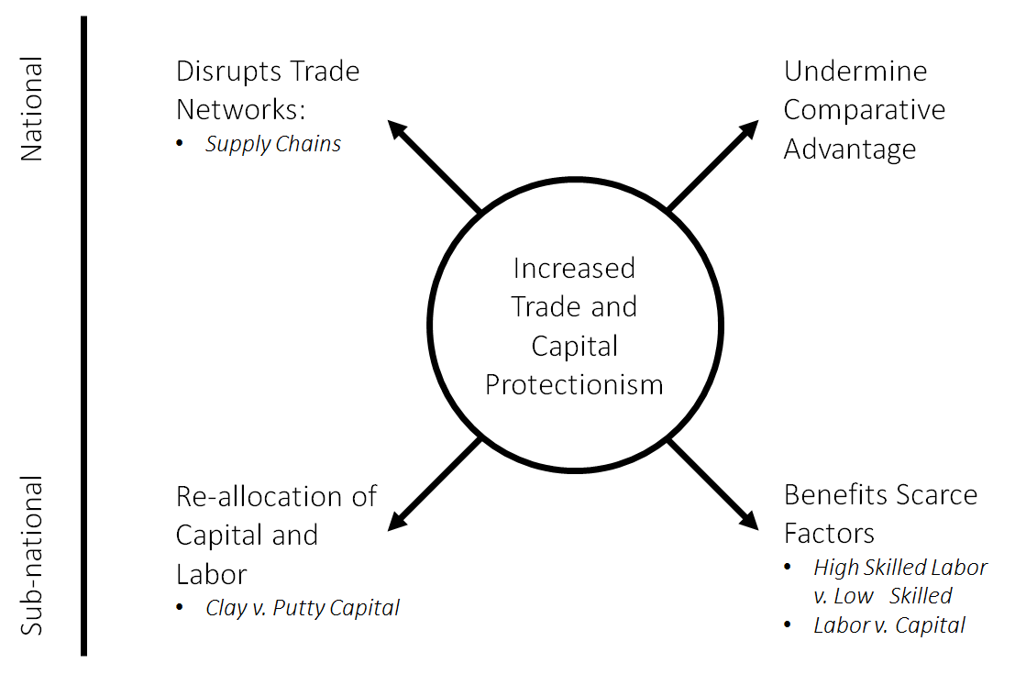

Because proponents of increased trade openness focused on comparative advantage as a justification for reducing tariffs but neglected the importance of relatively scarce and plentiful factors of production sub-nationally (and the implications on these factors of increasing trade openness), there has been a growing backlash among the losers from globalization. As noted above, more protectionist trade policies can benefit the scarce factors of production, though they will also likely reduce growth when compared with a scenario with higher trade flows.

Closing borders to trade and capital flows can help relatively scarce factors of production (like low-skilled labor in the US and Europe), but only after capital is re-allocated and production processes are transferred. The creation of new manufacturing spaces in the US and Europe will take considerable time, and disrupting capital and labor allocation by changing trade policies introduces new inefficiencies on the way to a new steady-state. In addition, with the rise of automation, robotics, and artificial intelligence, protectionist policies will have less impact on increasing scarce factor jobs than they would have previously. In fact, a move towards increasingly protectionist policies could accelerate investments in automation and further speed a transition to automated production (impacting both unskilled and skilled workers).

The lessons learned from the current backlash against globalism should be taken forward. Instead of a singular focus on comparative advantage as an explanation for why trade openness should be pursued, advocates should also focus on the sub-national scarcity and plenty of factors of production. The next two decades will continue to be characterized by relatively scarce unskilled labor to skilled labor in developed countries, as well as labor to capital more generally (also, as noted above, with an increase in the importance of automation in the production process). The most significant long-term transition in the distribution of these factors is occurring in China, which is forecast to transition rapidly from a country with relative abundance of labor to capital to a country with a relative abundance of capital to labor. Over the next twenty years expect this transition to characterize Chinese positions regarding trade openness.

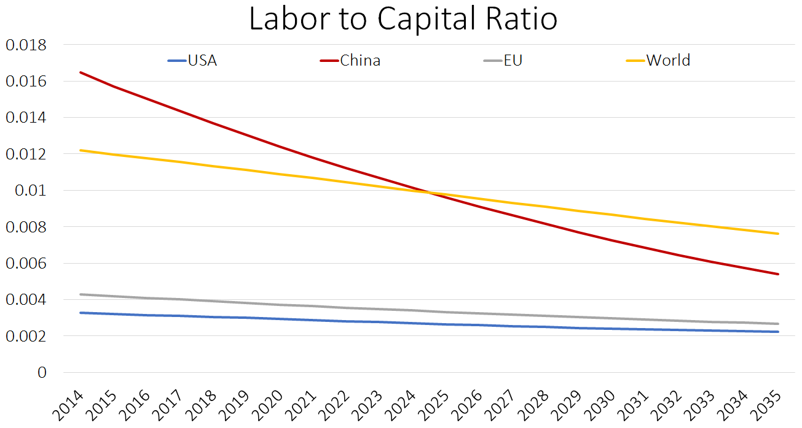

**Impacts on Trade**

With that as the conceptual basis for what is happening, let’s drill down on how this next phase of a more protectionist world could unfold.

Since 2000 global exports have doubled, from $10.2 trillion - approximately one-fifth of global production in that year - to nearly $21.5 trillion in 2011 - nearly one-third of global production. High-income economies still account for around 70 percent of global exports and imports. However, their share has been in decline since the mid-1980s, as upper- and lower-middle income economies continue to grow and integrate into the global economy. In recent years, there has been a stagnation in the value of exports as exhibited by a slight decline in value since 2011.

The ratio of total trade relative to GDP is a standard measure of trade openness. Trade openness has grown in fits and starts across time. It grew slowly in the 1960s, more rapidly in the 1970s, slowly again in the 1980s, and then quite rapidly at the end of the Cold War. – a trend which continued until roughly 2009. Since then there has been an overall stagnation in the growth of openness and even specific instances of contraction in trade (in particular with Upper Middle Income countries—see the Figure below). Since the end of the Cold War, the European Union openness has increased by around 50 percent, China by nearly 75 percent, and India by over 140 percent.

Trade Openness

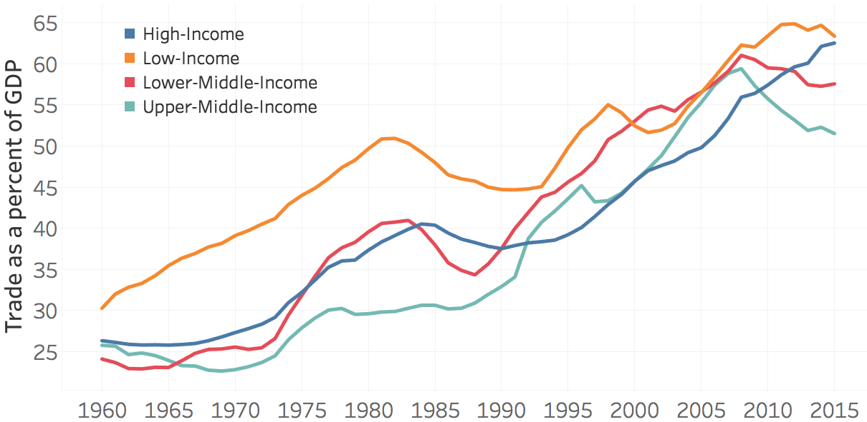

The patterns of trade openness over the past decades have been paralleled with increasing density of trade relations. In 1980 the average country had 49 trade partners. By 2014, that figure and risen to 116. Furthermore, China’s meteoric rise as a major trade partner during this period has played an important role in the rewiring trade patterns over the last two decades. Since the mid-1990s, China’s centrality in economic networks has risen dramatically. Today it is the most central country in the world.

With the rise in economic importance of China, many countries that were more closely aligned with other western countries are increasingly reliant on Chinese trade[1]. In 1980 there were only a handful of these pivot states (Zimbabwe, Sri Lanka, Singapore, and Myanmar to name a few). By 2014 there were more countries that have similar economic dependence on US and China than those that are closely aligned with one or the other.



ABOUT HERE FOR THE GESTALT NETWORK DIAGRAMS

**Different Paths Forward**

We explore three scenarios: 1) **Globalism Resurgence**, an ambitious global growth in trade and FDI that could include modified versions of TPP and TTIP; 2) **Trade Stagnates**, a global flattening of trade flows and FDI as a share of GDP; and 3) **Nativist Victory**, a significant reduction in trade and FDI as a share of GDP.

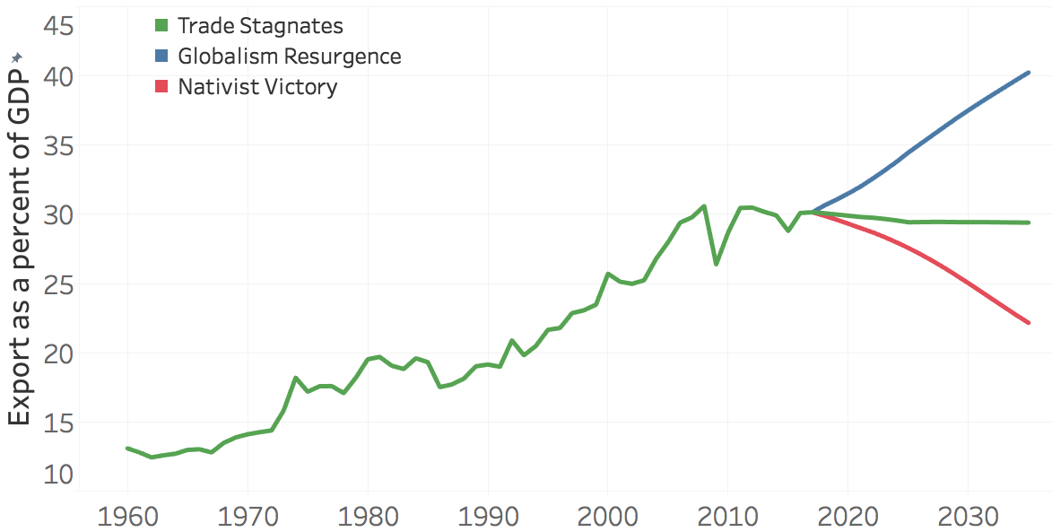

Trade Assumptions

Foreign Direct Investment Assumptions

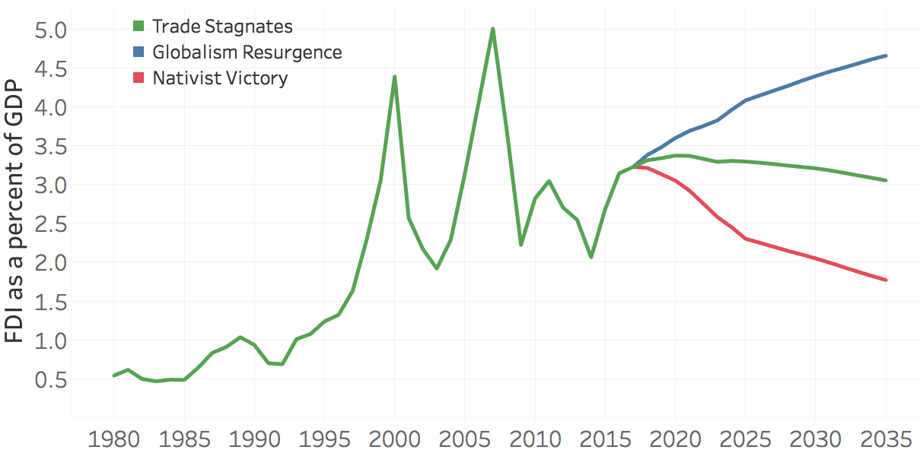

**Growth Implications**

At the national-long-term level, Globalism Resurgence, though unlikely now, significantly increases the overall size of global economic output to 2035 leading to cumulative $52 trillion more GDP output compared with Nativist Victory.

More trade protectionism could—at least in the short run—benefit relatively scarce factors of production, like low-skilled labor in the EU and US. This is in contrast to the relative benefits that globalization has conferred on relatively plentiful factors in high-income countries, notably capital and high-skilled labor, by giving those factors global reach, while exposing relatively scarce low-skilled labor in those countries to competition from abroad.

With slower globalization, however, the developing world would pay a price. The difference in the number of people living on $10 or more between the Beyond TPP/TTIP and Nativist Victory scenarios would be 150 million people by 2035, or roughly the size of Russia’s population today. While the middle- and upper-class in high-income economies remains largely the same across these scenarios, increased global protectionism undermines the growth of a middle class more so in the rest of the world, with the vast majority of those that are unable to graduate from a state of economic vulnerability (income less than $10 per day) due to protectionism coming from non-OECD countries. In the Beyond TPP/TTIP scenario, the non-OECD middle-class (defined as the population living on between $10 and $50 per day) grows from 1.2 billion today to 2.3 billion in 2035, whereas in the Nativist Victory the non-OECD middle-class in 2035 is 100 million less.

The probability of violent domestic conflict increases by 8.3% in the Nativist Victory scenario (compared with a 3.1% increase from Trade Stagnates to Nativist Victory), with low-income economies experience roughly a 1.2 percentage point greater risk of state failure. This increase in the probability of violent conflict is driven by poorer development in governance capacity and lower levels of human development. India, Egypt, the Philippines, and Thailand would be among those that experience an increase in risk of instability under the Nativist Victory scenario.

**Differentiated Impacts Across Country Income Groups**

The foregone gains seen in the Nativist Victory scenario are felt more strongly in countries that have not yet been able to take full advantage of the global economy. In that scenario, GDP per capita (at PPP) is 8.9 percent lower in low-income economies compared with the Beyond TPP/TTIP scenario (compared with a 5.4 percent difference in high-income countries).

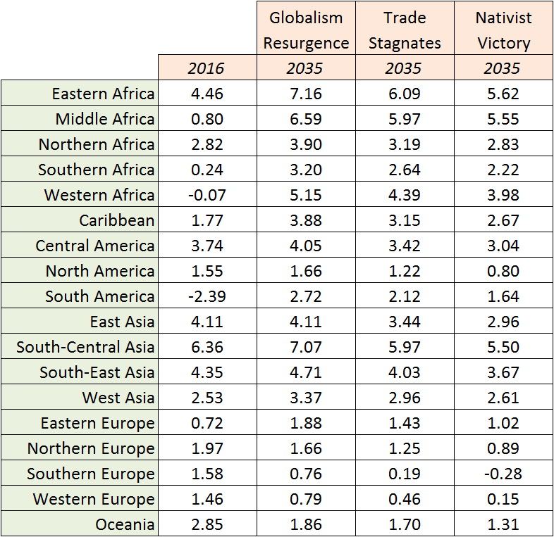

The table above shows the economic growth rates across UN sub-regions. Eastern Africa and South Central Asia appear as the most sensitive to long-term protectionist policies, with a difference in GDP growth rates of 1.6 and 1.5 percentage points respectively between the Beyond TPP/TTIP and Nativist Victory scenarios. With some European countries forecast to see lower levels of growth over the coming decades, an increase in global protectionism on the scale simulated in the Nativist Victory scenario could translate into an economic recession. In this scenario, Germany, Netherlands, and Italy are forecast to experience negative average growth between 2025 and 2035.

**US-Chinese Dynamic At Risk**

Turning to the US-China dynamic which has been at the heart of globalization, we want to unpack the implications of slapping high US tariffs on Chinese manufactured goods and possible Chinese retaliation. We recognize that the new Trump Administration might not implement its highly charged campaign rhetoric, but the analysis illustrates what might be considered an outer boundary of risk. Today, imports from China are valued at 2.3 percent of the US's GDP (manufacturing imports from China valued at 1.3 percent of US GDP), and exports to China are valued at 0.6 percent of the US's GDP (manufacturing exports to China are valued at 0.4 percent of US GDP). Imports from the US are valued at 8.8 percent of Chinese GDP (manufacturing imports from US valued at 0.7 percent of Chinese GDP), and exports to the United States are valued at 18.9 percent of Chinese GDP (manufacturing exports to US are valued at 2.2 percent of Chinese GDP). China is nearly twice as dependent on US trade as the US is on Chinese trade.

The ability of each country to adjust to the shock of much higher US tariffs is determined partially by their relative trade dependence, and how easily capital and labor can be reallocated given new consumption and production patterns.

* In the short-run, the greatest potential gains that the US could experience from imposing a 45 percent punitive tariff on Chinese manufactured goods is a 2.5 percent increase in manufacturing production, 400 thousand additional jobs, and a 0.5 percent increase in GDP. This however assumes that China does not retaliate with a similar (or more commensurate) tariff on US exports, that the US does not offset surplus demand with imports from other trade partners, and that the US is able to quickly and efficiently mobilize the necessary labor and capital to produce all surplus demand domestically. If instead we assume that the opposite is true (China retaliates[2] with a similar tariff and US imports from other partners or is unable to quickly reallocate its factors of production), the country experiences a 0.1 percent reduction in manufacturing production, a loss of 140 thousand jobs, and a 0.2 percent reduction in GDP.
* In the long-run, trade between the two countries declines by a cumulative $5.7 trillion by 2035 relative to the Base Case. In this scenario, cumulative GDP is $5.5 trillion lower in the US, and $4.2 trillion lower in China relative to the Base Case by 2035. Household consumption in the US would decline by an annual $550 billion relative to the Base Case by 2035. While household consumption in China would increase initially due to cheaper domestic prices, by 2035 it is roughly $120 billion lower than in the Base Case.

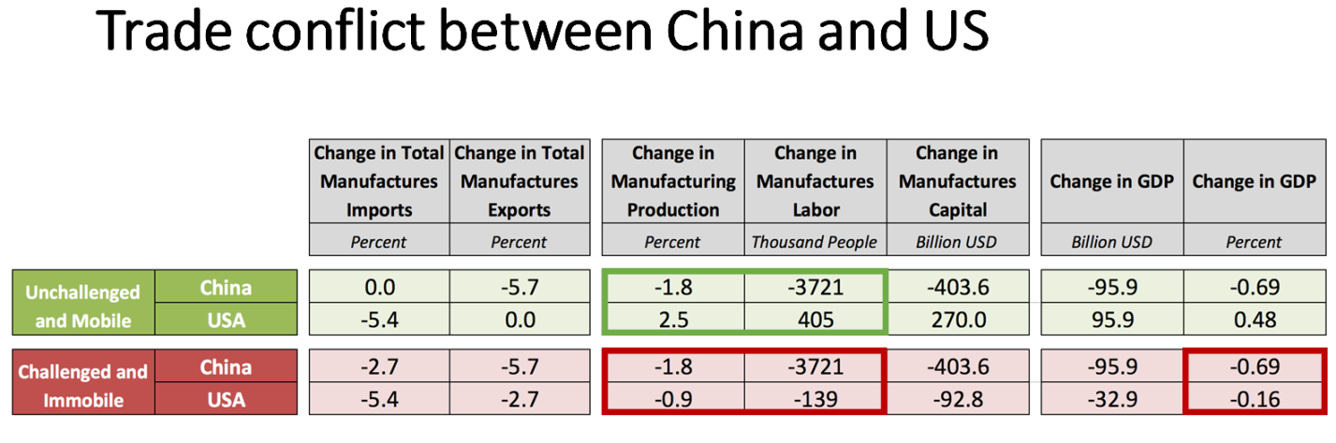

However, a significant trade tariff on Chinese goods sold to the US met with a strong reaction from China that could take many forms. The most likely scenario would be the creation of separate spheres of Chinese and US economic activity. This would rewire trade networks and could significantly disrupt supply chains.

**Conclusion: World of Growing Risks**

Even if Nativist Victory is not fully realized, the world seems set to diverge from what we all assumed would be the pathway of increasing globalization. Slower global growth will in the end hurt all countries, but developing countries appear most vulnerable. Risks that have been increasing in recent year—such as state failure and spread of conflict in some regions—could grow even faster in this more protectionist world. Beggar-thy-neighbor politics would be increasingly likely as protectionism spins out of control and the global economy goes into a downfall spiral.

We at Zurich, the Atlantic Council and Pardee Center are committed to tracking the growing risks and warning and advising decision makers about ways to reduce them.

The above is one of five scenarios which we are examining for our study of geopolitical risk. The full study will be available in April 2017.

1. Measuring trade dependence is complicated. A better measure of dependence would calculate country level centrality in the production process of particular goods. Overall volume of trade is a proxy for trade dependence due to data availability.
2. The Chinese retaliation simulated is limited to trade tariffs and does not include sovereign debt.